De-anonymise a Turnitin submission
It may be necessary to de-anonymise an individual submssion in Turnitin, e.g. suspected bad academic practice. To do so:
1. From the Turnitin assignment submission list in your module, click on the Anonymous Marking Enabled button that corresponds to the submission you wish to de-anonymise
2. Insert your reason for de-anonymising the submission and click Submit.
FYI - academic staff are trusted to have legitimate reasons for de-anonymising, as such there is no formal monitoring of reasons for de-anonymising. It is just stored as a data record requirement.
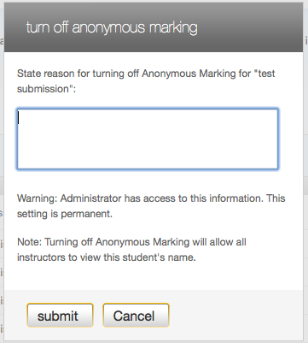
3. The submission will now be de-anonymised

