Blackboard – Course Copy
The Course Copy feature copies course materials from one course site to another.
The Course Copy area can be accessed via the Control Panel menu in your Course Management section, by clicking the arrow to the left of the Packages and Utilities menu item and then selecting Course Copy from the dropdown menu.
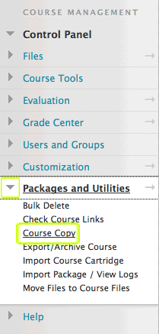
1. Select Copy Course Materials into an Existing Course
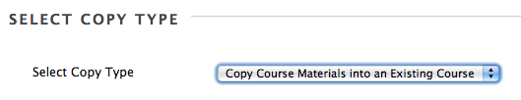
2. Click on the Browse button next to the Destination course field.
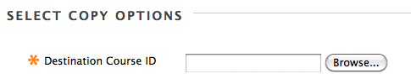
3. From the list of courses, select the destination course that you want to copy the materials into by clicking on the button next to the course, and then click Submit. Having done so you will see the course destination ID added to the Destination Course ID field.
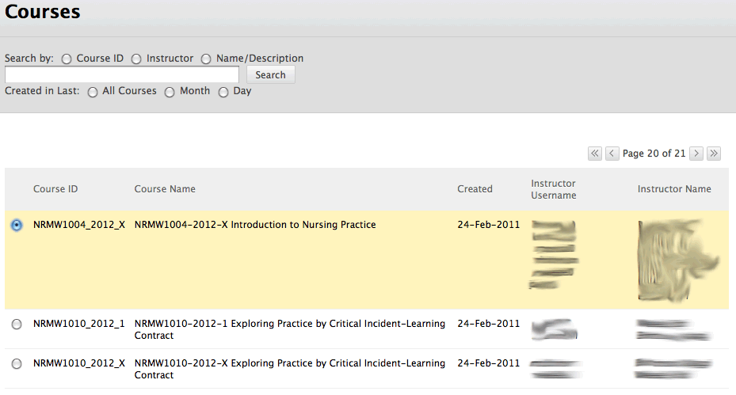
4. Under Select Course Materials - choose the Content Areas that you want to copy.
We recommend that you DO NOT use the Select All button.
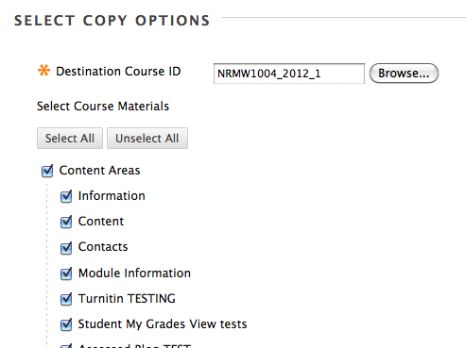
DO NOT SELECT Grade Centre Columns and Settings
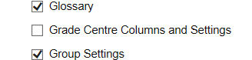
DO NOT SELECT the Settings option as this will adversely affect DMU Replay and will change the default template for the module.
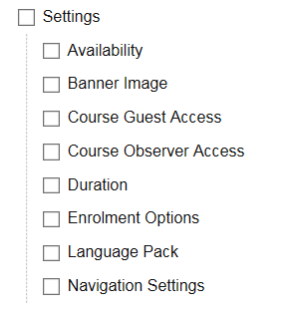
5. The default setting for File Attachments is to Copy links and copies of the content. This will copy across all attached files (e.g. word docs, PDF, PowerPoint, etc.) that have an active link in the Blackboard module shell. Any files that are not actively being used/linked to WILL NOT be copied across.
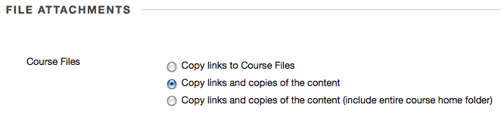
IMPORTANT NOTE: If you use content such as Articulate or Camtasia or have embedded websites (html) in your module shell you MUST select the third option in File Attachments (see below), as this will accurately copy across all of your required files.
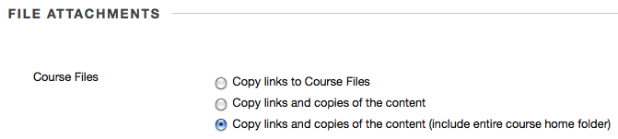
6. DO NOT select Include Enrolments in the Copy. Enrolments will be added by the system according to the data held on QLs.
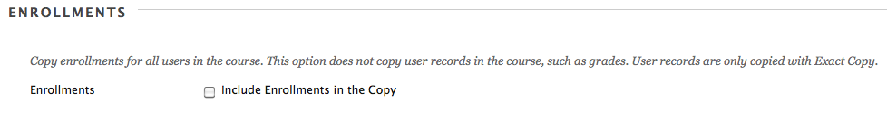
7. Click the Submit button.
(an email will be sent to you once the course copy is complete. This can take up to an hour to receive)
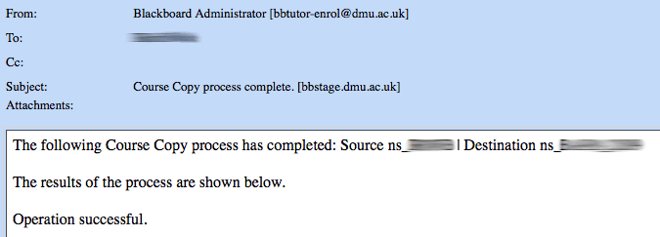
FAQ
The Course Copy function does not overwrite content items in the destination course.
For example, if you copy an Announcements item from one course to a destination course that already has an Announcements item there will be two Announcements items that appear in the destination course. You will then need to delete the old Announcements folder, as well as any other old folders that have been duplicated.
Q: Can I copy Turnitin submission links from last year's module shell?
A: No. If you Course Copy a Turnitin submission link it will not work. You need to create new Turnitin submission links in your new module shell.
Q: Can I copy DMU Replay recording links from last year's module shell?
A: No. If you copy a DMU Replay recording link in Blackboard from one module to another, it will not work. To copy a DMU Replay recording into a module, click this link to view the guidelines.
Q: Can I copy individual documents from one course to another?
A: No. Using this feature, you can only copy whole sections of material, based on the following categories: Announcements, Assessments and Pools, Gradebook, Calendar, Categorical Information, Content, Discussion Board, Users and Groups, Settings, and Staff Information. The Content category refers to all content areas—such as Course Information, Course Documents, and Assignments.
Q: Can I copy content to multiple courses at one time?
A: No, you can only copy to one course at a time.
Q: My Articulate content doesn't work in my new module shell after I copied it across?
A: When copying Articulate content into a new module shell you MUST select option 3 - Copy links and copies of the content (include entire course home folder) - in the File Attachments section

