Guidelines for creating accessible and inclusive web content for teaching and learning
When developing online content for teaching and learning it is essential that the content be presented in such a way as to make it as accessible as possible to persons with disabilities and learning differences.
In some cases, persons with identified learning differences will have access to assistive technologies for engaging with online content. They may also be versed in how to set their web browser in order to accommodate their needs. Nevertheless, there are some steps that should be considered when presenting teaching and learning content online to ensure that the accessibility of the content is maximised.
This Web Accessibility Quickguide offers a basic overview of ways in which you can make your online teaching and learning content accessible – with a particular focus on the use of digital media (images, audio, video and animation). The guidelines are based on the minimum recommended requirements (Level A) of the Web Content Accessibility Guidelines (WCAG) 2.0, which cover a wide range of recommendations for making Web content accessible.
Click this link for more detailed information about the WCAG

Accessibility when using digital media
Recommendation: All non-text content such as images, audio and video/animation should have a text alternative
Images
If you are using images in your online teaching and learning materials you should ensure that the images are tagged with text information – usually a title and a description and sometimes ‘Alt’ text. This text information can then be read by a screen reader for the visually impaired. It is important that the information clearly describes what the image shows.
A Blackboard example
When embedding and image in a Blackboard page add an image description and a title where prompted.
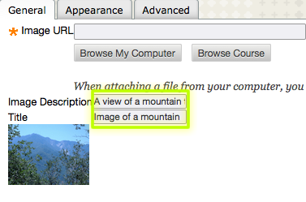
A non-Blackboard example
In this instance, text information about the image has been added where appropriate
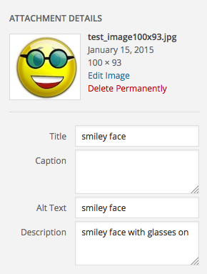
Audio
If you are using audio recordings in your online teaching and learning materials:
1. You should include a transcript of the audio for the hearing impaired
Click this link to see an example of an audio recording with a transcript
2. Ensure that there are controls by which the user can pause the playback
3. Ensure that there is a volume control
For example
Most online audio playback plugins have default pause/play controls and volume controls.
Video
If you are using videos or animations in your online teaching and learning materials:
1. You should consider including a transcript or captions for the hearing impaired
Click this link for an example of a video with a separate transcript
Click this link for an example of a video with integrated captions
2. Ensure that there are controls by which the user can pause the playback
3. Ensure that there is a volume control
For example
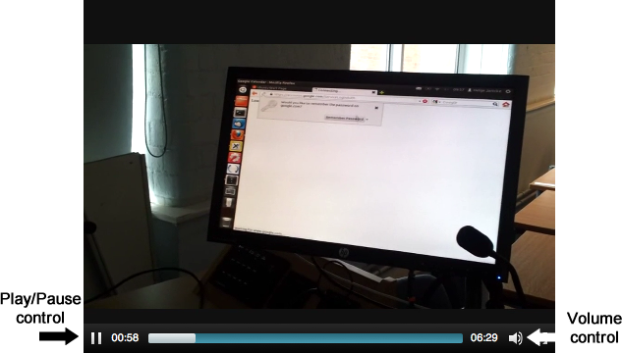
Most online video playback plugins have default pause/play controls and volume controls.

Other considerations when using time-based media (audio or video/animation)
- If your audio or video contains spoken text with background music - ensure that the background music can be muted separately to the spoken text, or that the background music is at least 20db below the level of the spoken text.
- Be mindful of not using video for teaching and learning in such a way that makes it difficult for a visually impaired person to achieve the same learning outcomes (as a non-visually impaired student) just by listing to the audio soundtrack of the video.

Other general recommendations and guidelines
- For text, ensure that colour is not used as the only visual means of conveying information, indicating an action, prompting a response, or distinguishing a visual element.
For example – try to avoid this kind of thing:
The use of red text in the following paragraph indicates the key themes. The use of green text indicates the key argument.
Etiam sit amet ornare arcu. Praesent eleifend neque orci, id consectetur augue viverra ut. Mauris dictum lectus augue, a consectetur metus ornare nec. Maecenas tempor est in libero ultrices, ac pretium erat porttitor. Sed vulputate nibh dapibus vehicula finibus. Maecenas tincidunt lorem tortor, eget vulputate nisl gravida eget. Fusce id interdum odio. Vestibulum pellentesque vitae tellus ac faucibus. Donec sit amet ipsum quam. Integer dapibus ornare purus, aliquet efficitur massa cursus eu. Sed lacinia varius egestas. Nunc tincidunt ornare consectetur. Praesent sed purus iaculis, porta neque in, scelerisque nisi.
- Try to limit the use of coloured text and coloured backgrounds.
For example – avoid this kind of thing
Etiam sit amet ornare arcu. Praesent eleifend neque orci, id consectetur augue viverra ut. Mauris dictum lectus augue, a consectetur metus ornare nec. Maecenas tempor est in libero ultrices, ac pretium erat porttitor. Sed vulputate nibh dapibus vehicula finibus. Maecenas tincidunt lorem tortor, eget vulputate nisl gravida eget. Fusce id interdum odio. Vestibulum pellentesque vitae tellus ac faucibus. Donec sit amet ipsum quam. Integer dapibus ornare purus, aliquet efficitur massa cursus eu. Sed lacinia varius egestas. Nunc tincidunt ornare consectetur. Praesent sed purus iaculis, porta neque in, scelerisque nisi.
Always try to use black and white, and hues of black and white for text and text backgrounds.
- Ensure that any web pages on which you are presenting content can be changed via the web browser such as:
  - altering the contrast, brightness and background colour
  - text can be re-sized/zoomed
- Where possible try to provide a modifiable version of any documentation – MS Word documents are such a modifiable format. This allows users the freedom to change the formatting to suite their individual needs.
- Do not design content in a way that is known to cause seizures. In particular the use of content that flashes. As a recommendation, web pages should not contain anything that flashes more than three times in any one second.
- When creating hyperlinks ensure that there is a title given for the hyperlink. For example - hover your cursor over this hyperlink
In Blackboard when creating hyperlinks in pages you can add a title in the hyperlink editor window
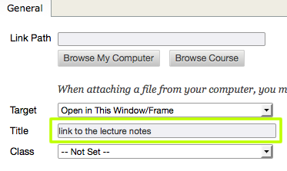
This is how the hyperlink appears in Blackboard when the cursor is hovered over the link
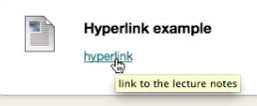

General accessibility information concerning Blackboard
Blackboard is configured in such a way as to present its basic content in an accessible format.
However, one thing to be aware of is when using the Mashup function to embed YouTube videos in a Blackboard page, as there is no transcript or subtitles automatically provided with the video.
YouTube does have an automated subtitling system that can be activated by toggling the Subtitles/CC button when viewing the video in the YouTube site.
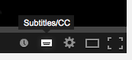
However, be aware that the automated subtitling in YouTube is not always accurate. Some YouTube videos have manually added accurate subtitles, whereas others haven’t and have left it up to the automated system.

A brief note about online assessments
If you are using summative or formative online tests or quizzes which include images, video, animation or audio, you must ensure that any questions that include such content can be presented in an accessible and inclusive format. No particular student(s) should be advantaged or disadvantaged in their ability to access and complete the test to the best of their ability. This may require creating an alternate test for any students on your module who have an identified learning difference. Academic staff are advised to consult with their Faculty Disability Co-ordinator if there are students on their module with identified learning differences that may require alternate assessment formats.

This document has been created in reference to the Web Content Accessibility Guidelines (WCAG) 2.0

