Viewing a student submission in Turnitin
1. From the Course Tools menu in the module select Turnitin Assignments
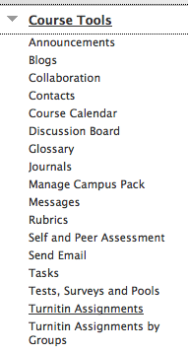
2. Click the assignment for which you wish to view the student submissions
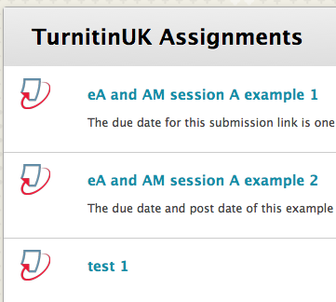
3. Select the submission that you wish to view by clicking the Title of the submission
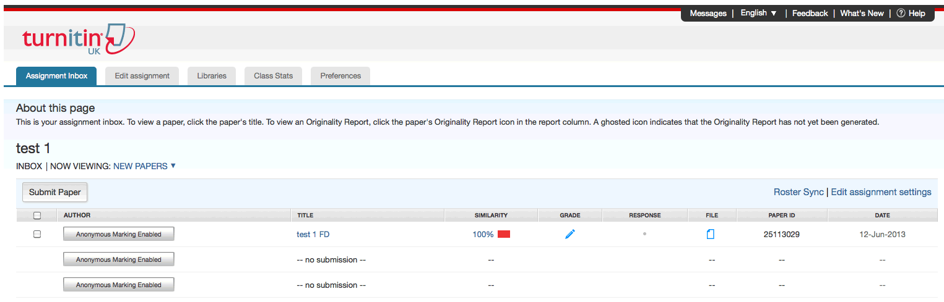

Tell me more about using Turnitin for plagiarism detection and online assessment and feedback

