View a module as a student
1. To activate the Student Preview Mode click the Student Preview icon to the top right of your Blackboard shell
2. An orange banner will indicate that you are logged on as a student.
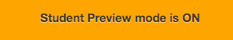.
3. To Exit Student Preview Mode, click the Exit Preview button in the orange banner.
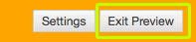

Tell me more about Student Preview mode

