Using the out of office email function in Blackboard
When a student sends an email to an instructor using the Blackboard email tool, in order for an automated out of office message to be sent to the student from the instructors DMU email account, the instructor must ensure that they have correctly setup their DMU out of office email message. As follows:
If you are using Microsoft Outlook as your DMU email client, you must activate the ‘Send replies outside my company to’ option (highlighted below):
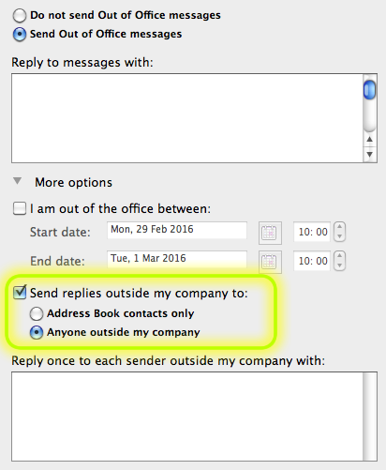
If you are using the Webmail email client (webmail.dmu.ac.uk), you must activate the ‘Send automatic reply messages to senders outside my organisation’ option (highlighted):
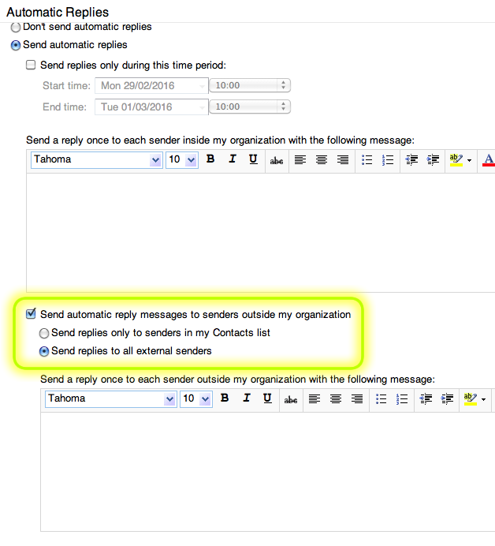
It is important to note that using this setting will mean that any emails received that are from non-DMU persons will generate an out of office reply.

