Add a (non-DMU Replay) video or audio recording that I have on my computer desktop to a Blackboard module
1. Identify the module in which you want the video/audio to be viewed
2. Navigate to http://panopto.dmu.ac.uk and sign in
3. Click Browse and locate the Folder to which the video will be uploaded
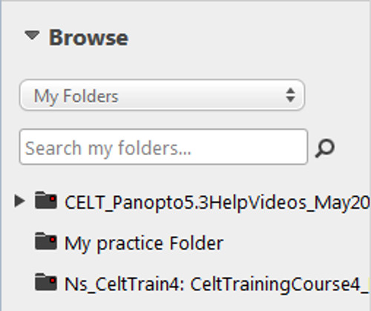
4. Click the Create button and select Upload media from the menu (you use the same button when uploading audio-only recordings)
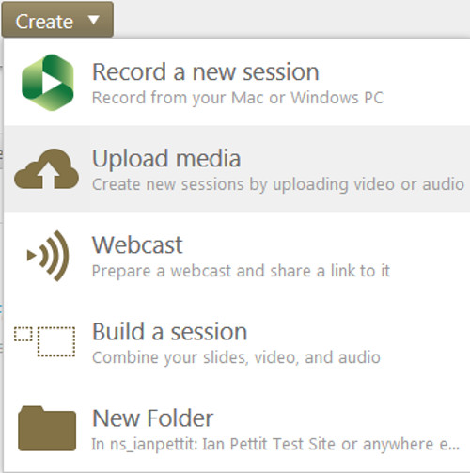
5. On your computer desktop, locate the video/audio that you wish to upload, drag and drop it into the drag and drop area
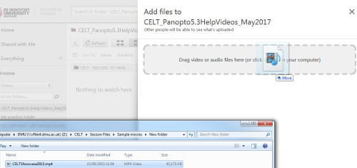
6. Your video/audio will upload to DMU Replay – this may take some time depending on the duration/file size of your video/audio
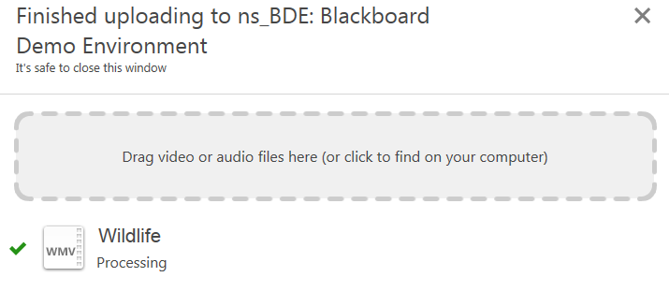
7. Click here to see the guide about how to add a video in to Blackboard

