Sharing digital image files via Grade Centre
In this scenario - students have produced an electronic poster as part of their assessment. You want to be able to share these digital posters with the assessment moderators and external moderators via Blackboard. This can be done via the GradeCentre - as follows:
1. In the Blackboard module open the Full Grade Centre
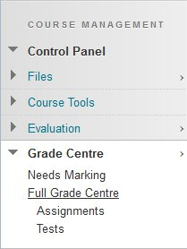
2. Create a new column (click Create Column)
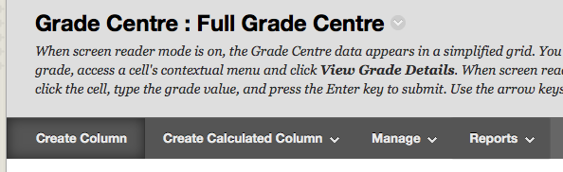
3. Name the column
4. You must add Points Possible (just add 1 as students will not be able to see anything in this column nor will the score be included in any total grade calculations)
5. You MUST set all options to No
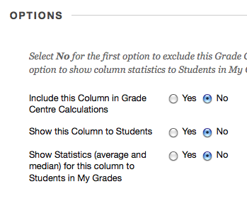
6. Click Submit
7. In the grade centre - click the grey icon in the cell of the student for whom you want to upload a digital image, and select View Grade Details
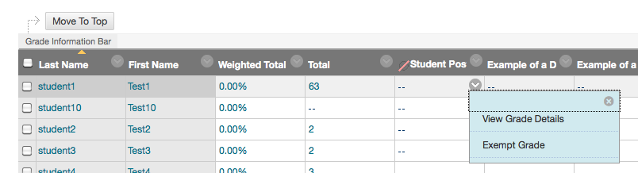
8. In the Grading Notes section, click the add file icon (the one that looks like a paperclip)
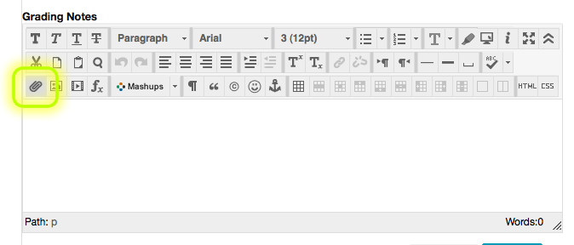
9. In the Select Content Link panel, select Browse My Computer and locate the digital image file on your computer that you want to upload
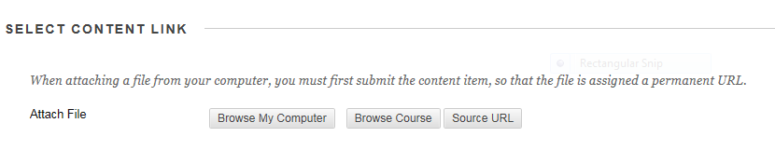
10. When the image file (e.g. Penguins.jpg) has been selected the file information will appear in the insert content panel, then click Submit
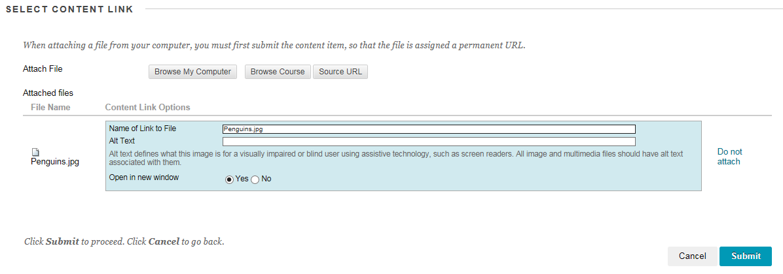
11. A link to the file should now appear in the Grading Notes area
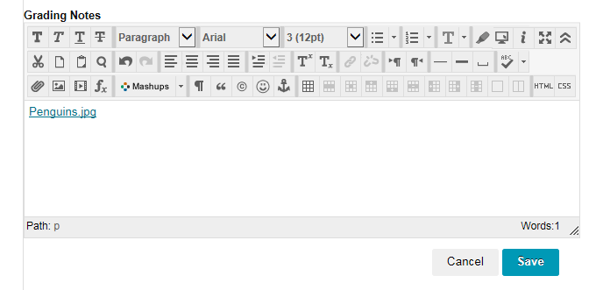
12. In the Current Grade Value box insert a 1 (this must be done), and then click Save
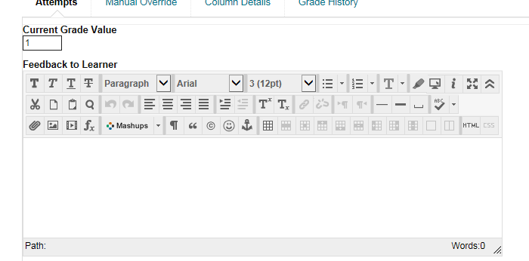
Any instructor on the module can now view the image file by going into the grade centre, in the new column clicking the grey icon in the cell that corresponds to a particular student, and selecting View Grade Details
Then in the Grading Notes column click on the image file link to view the image
