Setting up a Turnitin submission link for GradeMark
1. In your Blackboard module shell, navigate to a content area where you want to add a Turnitin assignment submission link, and using the Assessments button, select TunrnitinUK Assignment
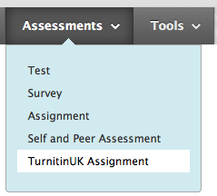
2. When the Turnitin application opens, select Paper Assignment and click Next Step
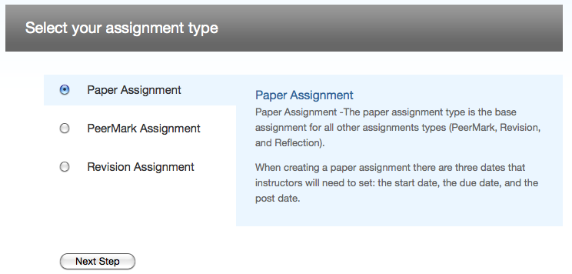
3. Give the assignment a title and point value.
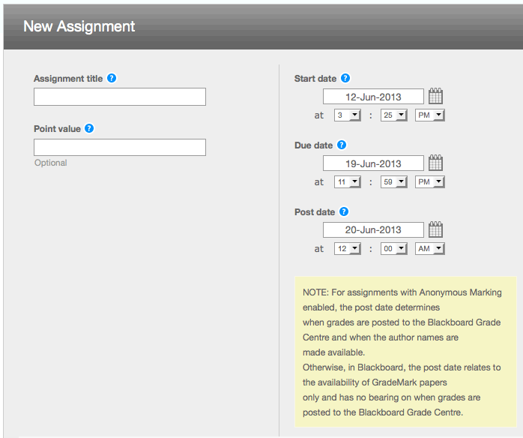
The set:
Start date - this is when the submission link becomes visible to students in the Blackboard module shell)
Due date - the submission due date
Post date - the 'Post Date' is a critical setting, as it is the date when student identities are revealed to the tutor (i.e. anonymous marking is switched off) and when marks/feedback are revealed to the students. It is mandatory to have a post date for GradeMark.
4. Open the Optional Settings window by clicking the plus (+) sign.
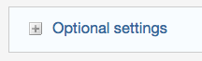
The option ‘Reveal grades to students only on post date’ provides you with the ability to control when grades are revealed to students.
Select ‘Yes’ to reveal grades to students on the post date of the assignment (via MyGrades)
To create a Turnitin submission link for essays that are to be marked anonymously you must ensure that Anonymous marking has been enabled
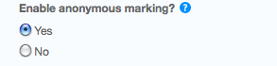
5. When completed click Submit
A Turnitin submission link will be created on your Blackboard page. This is the link that students click in order to submit their work.
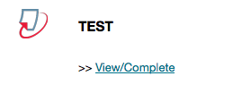

Tell me more about using GradeMark for online assessment and feedback

