Rubrics and grading forms in Turnitin Feedback Studio
This guide outlines the process for using rubrics and grading forms (aka. marking grids) for assessment feedback in Turnitin.
The guide is in 6 parts:
Part 1 – creating a rubric
Part 2 – creating a grading form
Part 3 – students viewing the rubric/grading form template before submission
Part 4 – grading a submission with a rubric
Part 5 – grading a submission with a grading form
Part 6 – students viewing their feedback

Part 1 – creating a rubric
An example of a rubric.
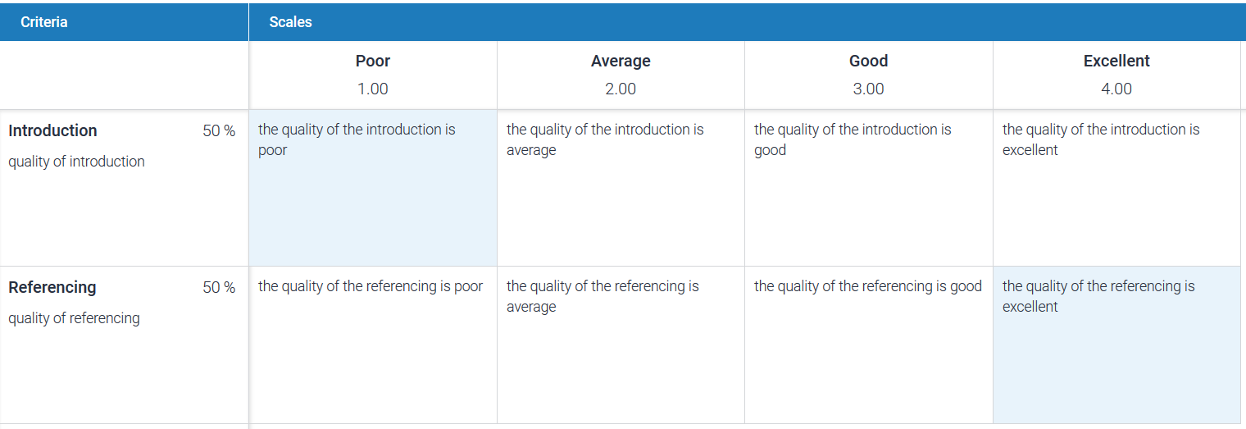
1. When creating a Turnitin submission link (as normal), in the option section scroll to the bottom of the screen, and click the Launch Rubric/Form Manager link
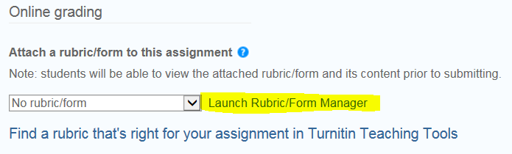
2. Click the icon at the top left of the panel and select Create new rubric
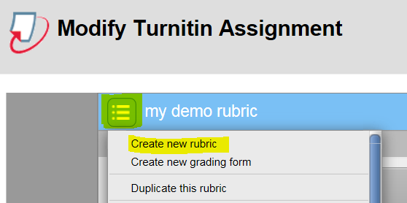
3. Give the rubric a title and click the return key on your keyboard
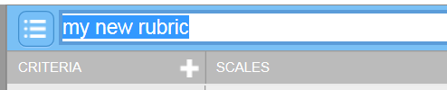
4. Choose the type of rubric:
One that automatically generates an overall score
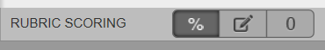
This type of rubric calculates an overall score (percentage) based on the weighted criteria against which the assignment is assessed
One that automatically generates a score with scale values visible in each cell
This means students will see a score in each cell of the rubric grid, rather than only at the top of the grid
One with no scoring - (no explanation required!)
This how to guide uses a scored rubric.
Down the left side of the rubric are listed criteria, these are the main criteria against which the submission will be assessed.
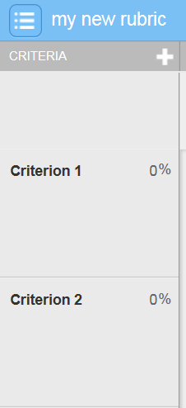
Across the top of the rubric is the scale, this is a scale against which each criterion will be scored.
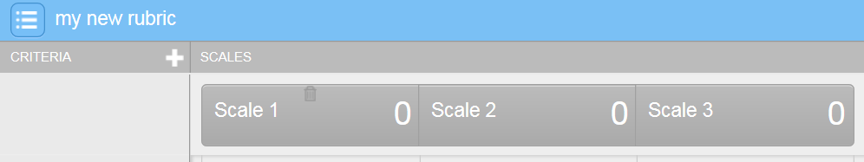
Extra criteria can be added by clicking the plus sign icon at the top of the screen
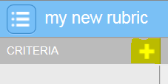
And can be deleted by clicking the trash icon.
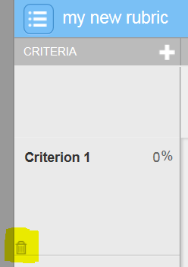
Likewise, extra scale columns can be added by clicking the plus sign icon
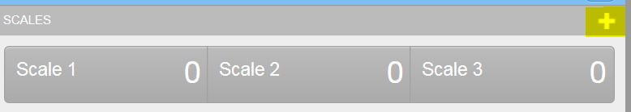
And can be deleted using the trash can icon
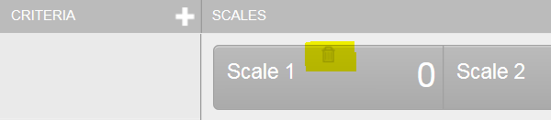
5. Name each criterion
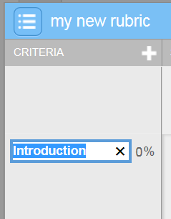
And give a description for each criterion
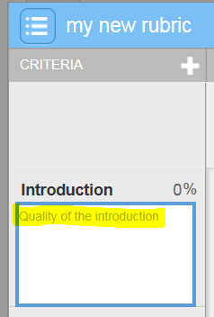
6. If using a scored rubric give each criterion a weighting
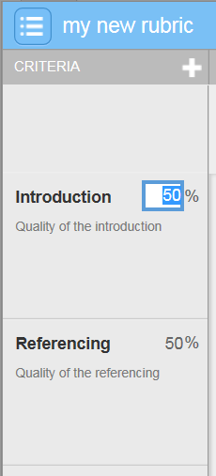
In this example each criterion is weighted at 50%. NOTE: all criteria must total 100%
7. Give each scale point a name
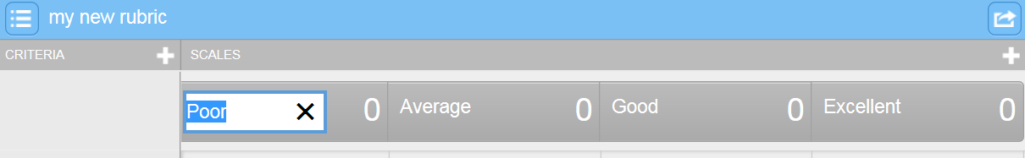
8. If using a scored rubric, give each scale a point score.
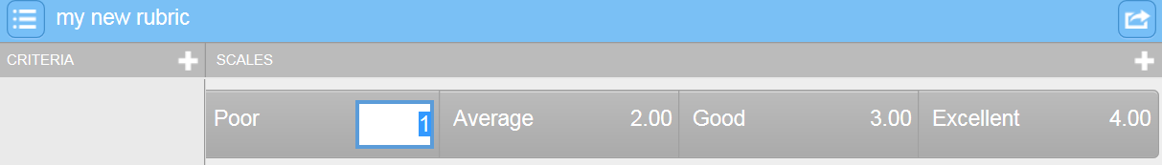
In this example scale 1 is poor and its score is 1, scale 2 is average with a score of 2, scale 3 is good with a score of 3 and scale 4 is excellent with a score of 4. So in this rubric each criterion is scored on a scale from 1 to 4
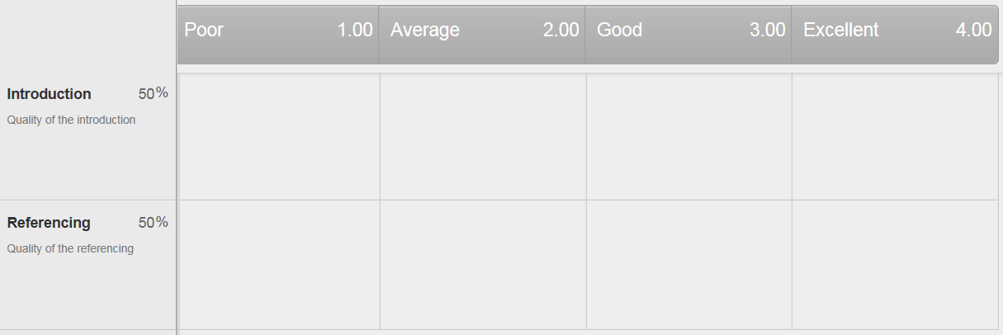
9. Add a description for each scale point in relation to each criterion (i.e. in each cell)
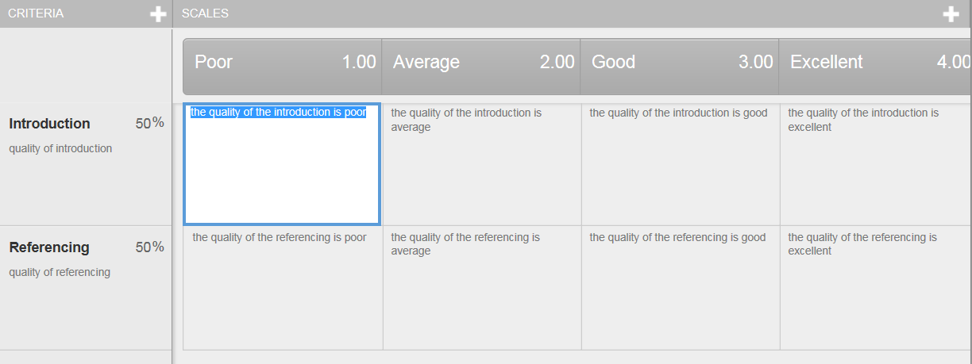
10. At the bottom right of the panel, click the Save button and then click Close.
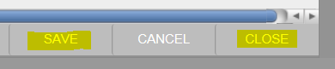
11. You will now need to select your rubric from the rubric drop down menu, which appears when clicking the small arrow
12. Click the Submit button
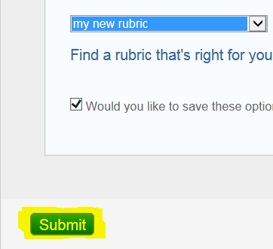
13. Then click OK
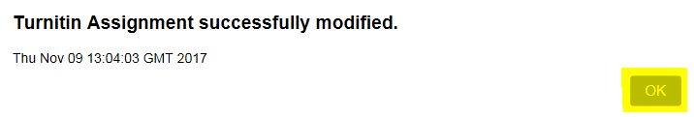
Your rubric will now be associated with the Turnitin submission

Part 2 – creating a grading form
An example of a grading form
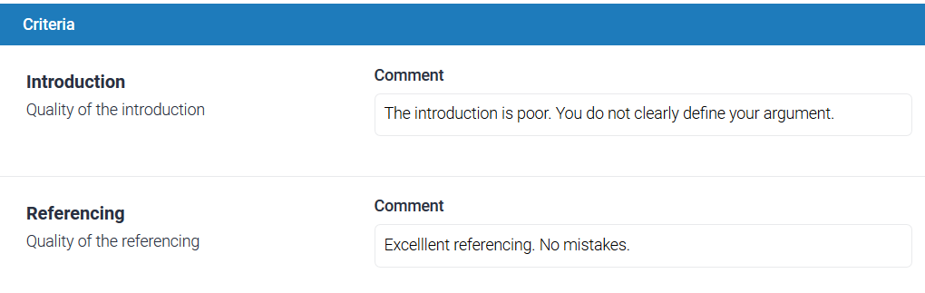
A grading form allows free text feedback to be entered about each criterion when marking. There is no scoring.
1. Launch the Rubric/Form manager as described above
2. Click the icon at the top left of the panel and select Create new grading form
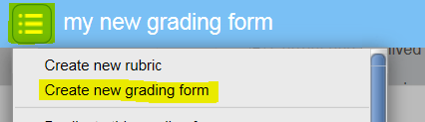
3. Give the form a name and click return on your keyboard
You will notice that there are only criteria and no scale.
Extra criteria can be added by clicking the plus sign icon at the top of the screen
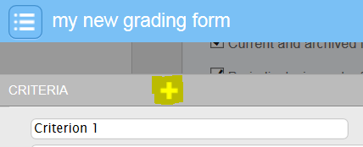
And can be deleted by clicking the trash icon.
4. Name the criteria
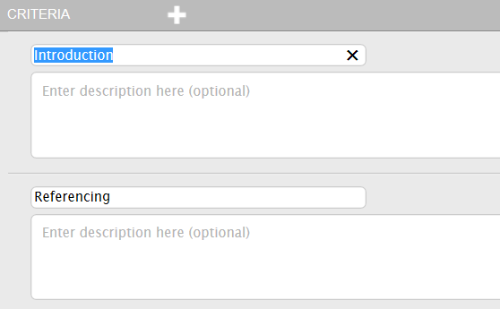
5. Add a description for each criterion
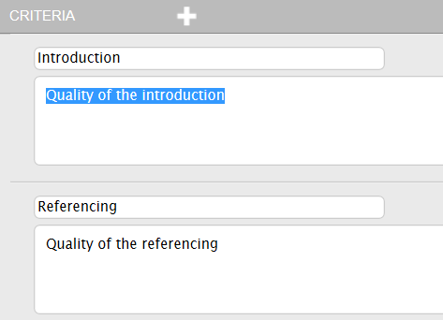
6. Choose whether or not to enable scoring using the check box in the bottom left of the panel. Scoring allows each criterion to be given a score of your choosing when marking
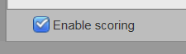
7. At the bottom right of the panel, click the Save button and then click Close.
8. You will now need to select your grading form from the drop down menu, which appears when clicking the small arrow
9. Click Submit
10. Then click OK
Your grading form will now be associated with the Turnitin submission

Part 3 – students viewing the rubric template before submission
When a student clicks on the Turnitin submission view/complete link
the submission portal appears. A student can view a rubric or grading form associated with an assignment by clicking the rubric icon
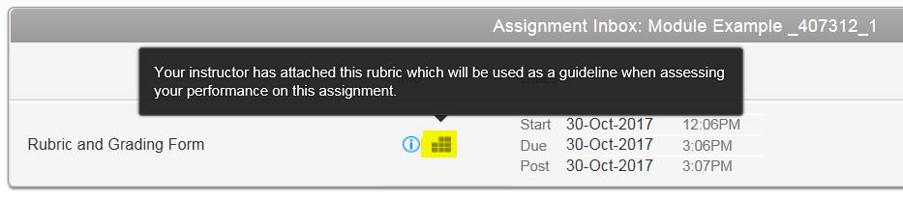
The student will submit their assignment as normal

Part 4 – grading a submission with a rubric
Accessing student submissions for marking with a rubric is the same method as usual. See: http://celt.our.dmu.ac.uk/accessing-a-student-submission-in-turnitin/
1. With the student submission open - to access the rubric panel, click the rubric/form icon on the right side of the panel.
2. Use the sliding scale to grade each criterion.
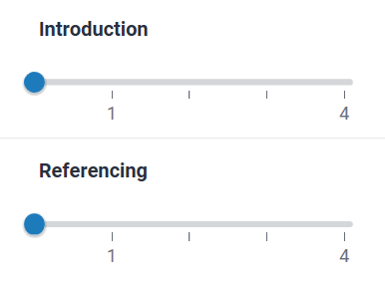
If using a scored rubric. Given that each criterion (in this example) was weighted at 50% of the total mark. If I score the Introduction criterion at 1 (poor) and the Referencing criterion at 4 (Excellent) the overall calculated score is 2.5 out of 4. Which equates to 62.5%.
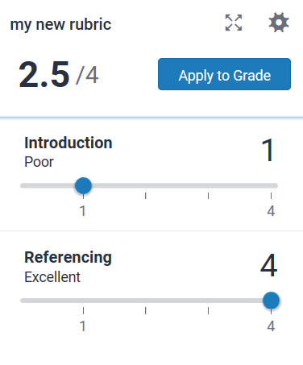
I can choose to apply this score (62.5) to the overall grade for the submission by clicking Apply to Grade
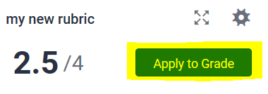
Note that the score is rounded up
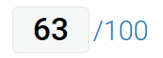
I can choose to add a manual grade that is different to the rubric score if I wish, by typing directly into the grade area

Part 5 – grading a submission with a grading form
Accessing student submissions for marking with a grading form is the same method as usual. See: http://celt.our.dmu.ac.uk/accessing-a-student-submission-in-turnitin/
1. With the student submission open - to access the grading form panel, click the rubric/form icon on the right side of the panel.
2. Feedback for each criterion can be typed into the corresponding panel
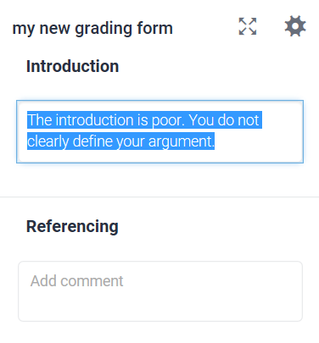
3. Manually add a grade for the submission.

Part 6 – students viewing their feedback
1. Via the My grades link in their Blackboard module
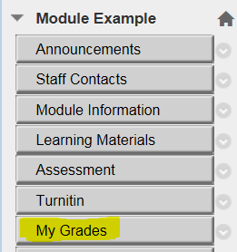
2. the student clicks on the assignment feedback they want to view
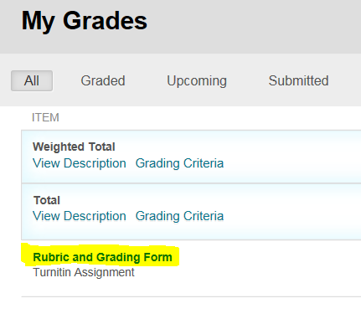
3. then clicks the My Paper icon
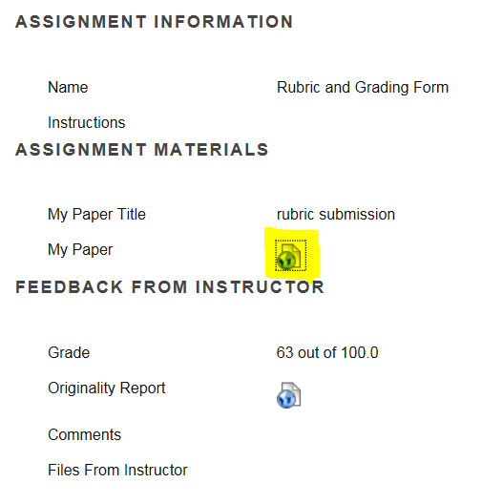
4. When feedback studio launches they click the instructor feedback icon (on the right side of the page)
5. followed by the view rubric button
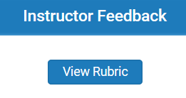
6. Their scores/feedback are indicated by the highlighted areas.
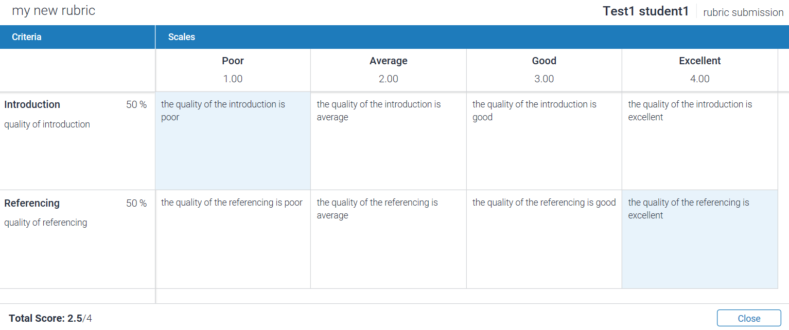
Students access and view a grading form in exactly the same way.
