Manually add grades to Grade Centre
This is a 2-step process . . .
STEP A - Create a column in Grade Centre
1. In the module control panel, open the Full Grade Centre
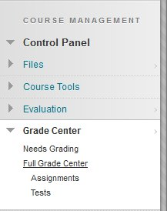
2. Click Create Column
3. In the Column Information panel - give the column a name
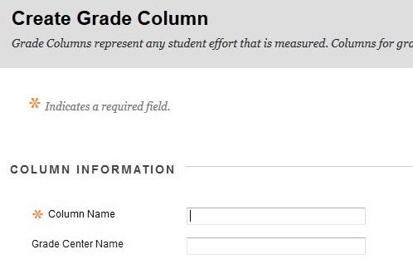
4. Set the Primary Display to Score
5. Set the Points Possible
6. Set the options - for students to be able to see their mark in Blackboard you must select Show this Column to Students.
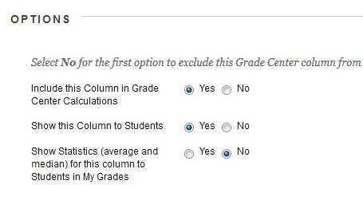
7. Click the Submit button
The column will now be created in the Grade Centre ready to accept manually inputted grades.

STEP B - Manually adding student grades
1. In the module control panel, open the Full Grade Centre
2. Find the column which you would like to enter a grade. Click within the cell that corresponds to the student for whom you want to add a grade.
3. Once you click on cell, a text field will appear. Simply enter in the mark that a student received and hit Enter or Return on your keyboard. The grade entered will be automatically saved.
4. Students will immediately be able to access these marks via the usual My Grades link in your Blackboard shell

