Make a PowerPoint presentation file available for students in Blackboard
1. In a content area on your Blackboard shell click the Build Content button and select File
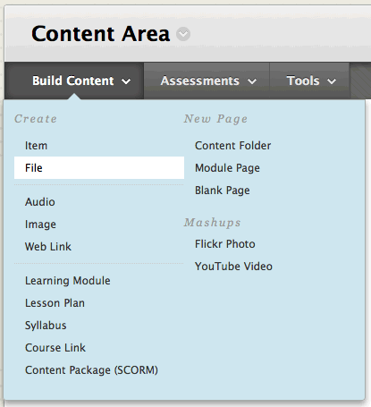
2. In the Create File panel - give your file a Name and click the Browse My Computer button
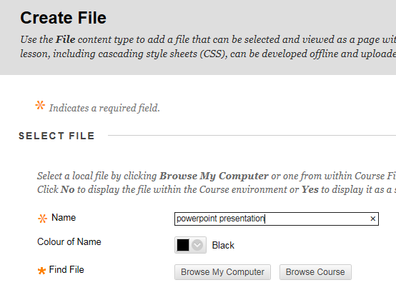
3. Locate the PowerPoint file on your computer, select it and click the Open button.
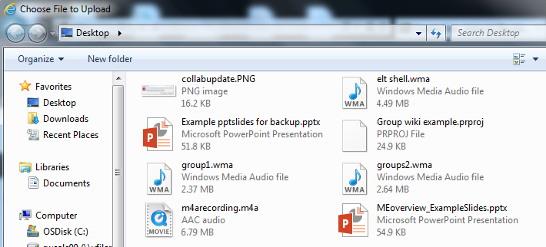
4. The file will be uploaded into the Create File panel - click the Submit button and the file will be accessible to students via a clickable link in the content area.
