How do I set up a Blackboard community shell?
To set up a Blackboard community shell you will need to request one from ITMS.
Email the request to the ITMS service desk (itmsservicedesk@dmu.ac.uk). Include the phrase Blackboard Community Shell in the subject line of the email, provide a name for the community shell, and the name(s) and username(s) of the staff member(s) who need to be enrolled on the community shell.
ITMS will email you when the site has been created.
Community shells appear in the My Communities panel on the Blackboard landing page.
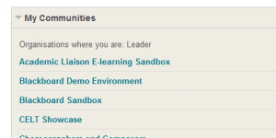
NOTE: A community shell is not linked directly to the staff and student database, so any student enrollments on a community shell will need to be carried out manually by whomever has ownership of the shell, as follows:
- In the Community Shell - from the organisation management menu select Users and Groups > Users
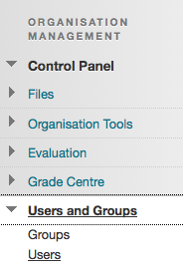
2. Click the Find Users to Enroll button
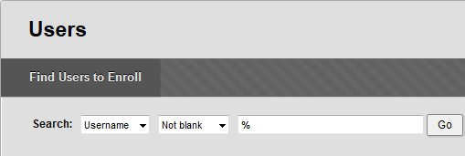
3. Add the Username of the person you want to enrol - multiple users can be added by separating their username with a comma + space (e.g. jbloggs00, bjoggs00, jsmith00).
If you want the user to have the same access privileges as a student in a normal module shell set the role to Participant.
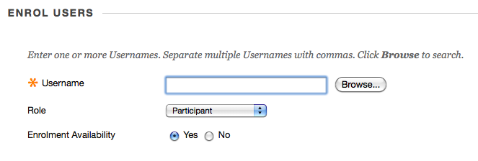
If you want the user to have the same access privileges as an instructor on a normal module shell set the role to Leader.
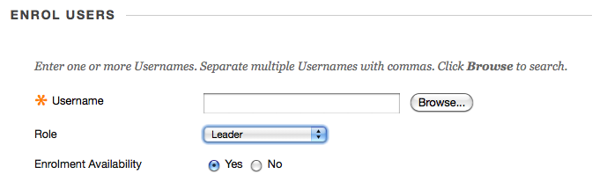
4. Click the Submit button, and the user(s) will be enrolled on the community shell
Community shells can be populated with content in exactly the same way as Blackboard module shells.

