Grades Journey - academic staff guide
If you are currently transferring marks from the Blackboard Grade centre into the Marks Entry Template without any problems or difficulty then there is no requirement for you to follow the process outlined here. You should use whatever process you are most comfortable with.
This guide explains how to configure your Blackboard Grade Centre to export a final grades spreadsheet which matches the information required to be entered into the Marks Entry Template. This process may facilitate an easier transfer of final grades on to the Marks Entry Template before sending the template to your course administrators.
In the example used there are three assessment components with the following titles in Blackboard:
11th November ABCD1001 assessment
10th February ABCD1001 assessment
24th April ABCD1001 Phase test [which is scored out of 20]
Important note: All assessment components must be marked out of a score of 100 in order to be added to SAP.

If all of your components ARE marked out of 100 you can skip to the Exporting a final grades spreadsheet section on page 4

If you have created an assessment component which is not marked out of 100, before exporting the grades you must change the component score to a Percentage. As follows:
1. In the module control panel navigate to the Full Grade Centre
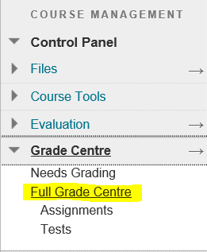
2. Click the grey circle next to an assessment column that has not been set to be marked out of 100
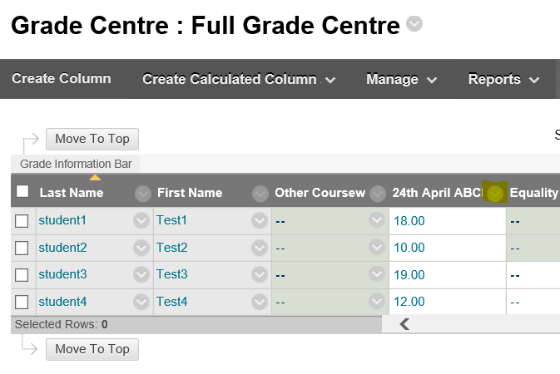
and then click Edit Column Information
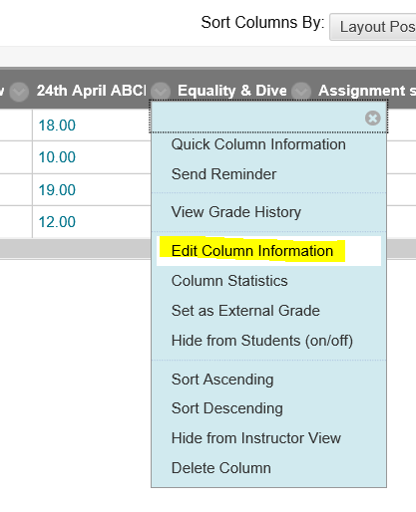
3. Set the Primary Display to Percentage, and then click Submit
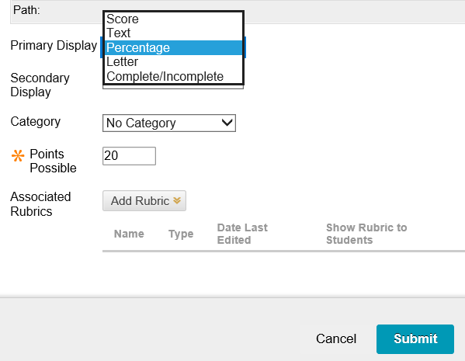

Exporting a final grades spreadsheet

STEP 1
A. Create your Assessment submission links (e.g. Turnitin or Online test) as normal (this must be done prior to the next steps)
B. Create a Category for each assessment component
1. In the module control panel navigate to the Full Grade Centre
2. From the Manage menu click Categories
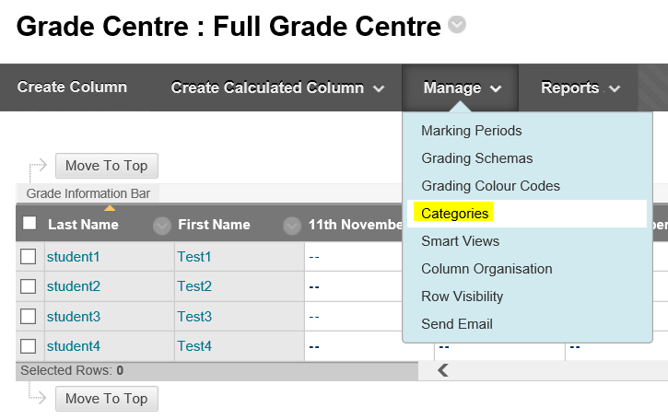
3. Click Create Category
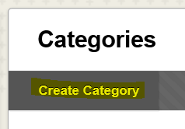
4. Give the category a name (this can be any name of your choosing) and click Submit
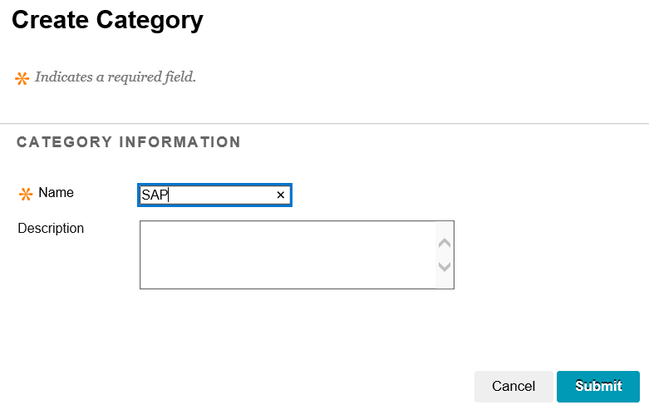
5. Navigate back to the full grade centre and click the grey circle next to an assessment column that needs to be included in the final grades list
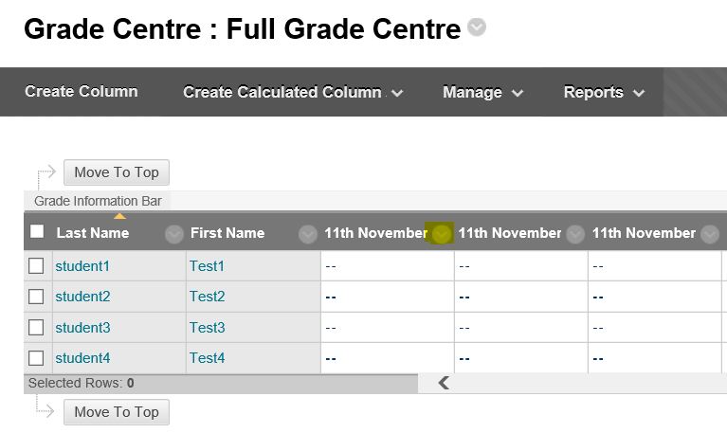
and from the menu which appears click Edit Column Information
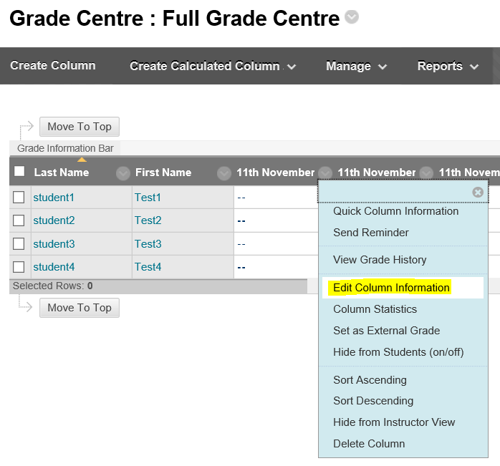
6. Scroll down the screen a little way and from the Category menu click the category that you created in step 4. Then click Submit.
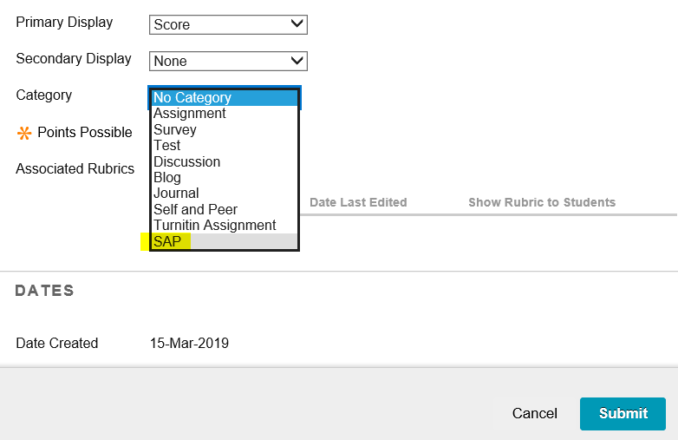
7. Repeat this process (steps 5 and 6) for each assessment column that needs to be included in the final grades list.
IMPORTANT NOTE: You MUST include any assessment extension and/or assessment deferral columns.

In this example there is an assessment extensions column
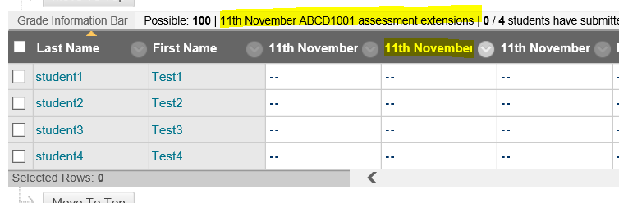
And a deferrals column
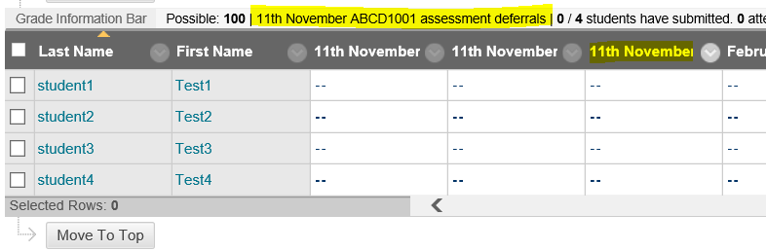
BOTH of these will need to be categorised to be included in the final grades list.

STEP 2
Create a Smart View
1. Navigate to the full grade centre and from the Manage menu click Smart Views
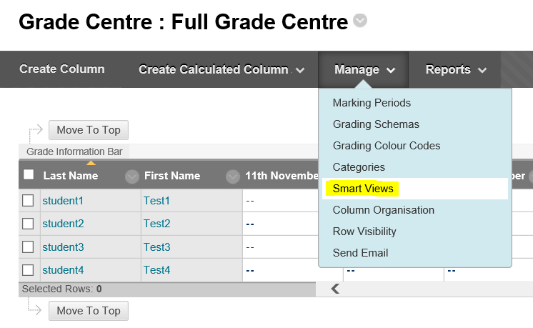
2. Click Create Smart View
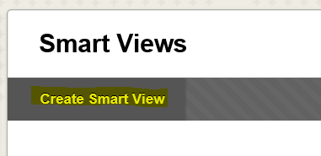
3. Give the smart view a name (this can be anything you like) – it can be the same as the category.
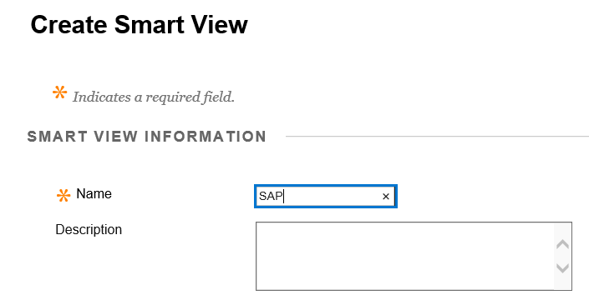
4. Change the selection criteria to Category and Status
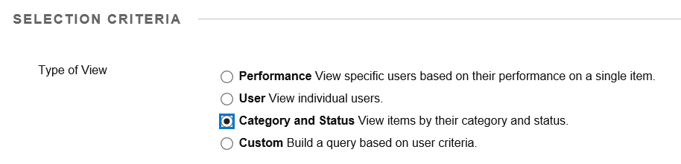
5. In the select criteria > categories menu click the category that you created
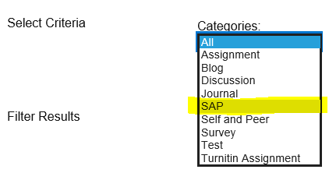
6. From the users menu select All Users, and then click Submit
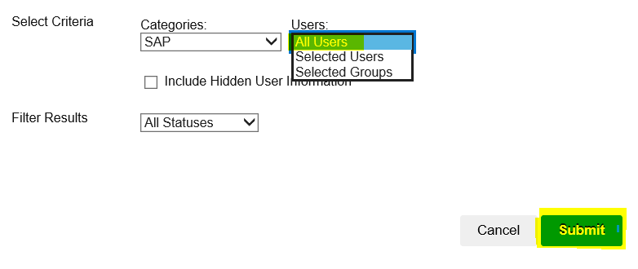

STEP 3
Rename assessment titles
1. Navigate to the full grade centre
2. Click the grey circle next to an assessment column that is to be included in the final grades list
and from the menu which appears click Edit Column Information
3. In the Grade Centre Name box enter the title of this assessment component as it appears in your module specification documentation (e.g. Essay 1, Other Coursework 1, Other Course work 2) and click Submit.
This is a very important step as it will assist the programme administrator in accurately transferring the grades into the SAP system
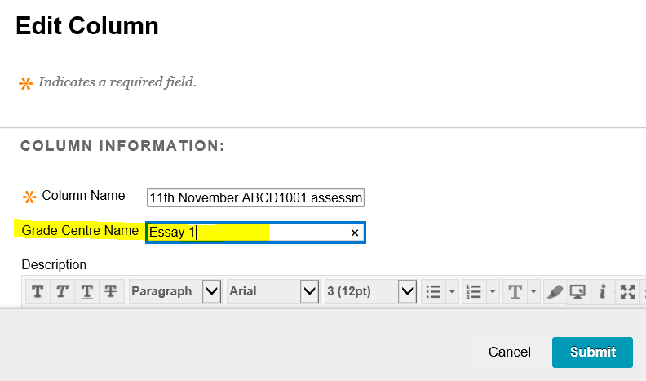
When you have done this you will notice that the Grade Centre names for the assessment columns will have changed.
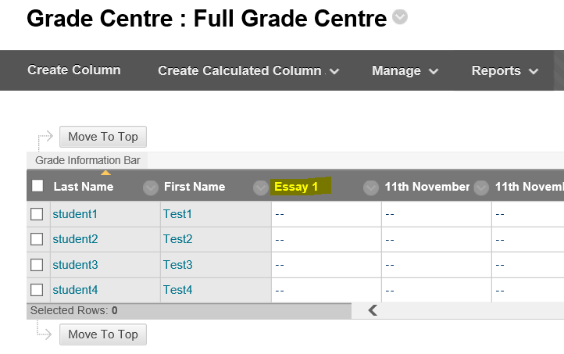
Important note: you must change the Grade Centre names of all the columns that need to be included in the final grades list – including any extension and deferral columns.

STEP 4
Export a final grades spreadsheet
1. Navigate to the full grade centre
2. From the Manage menu select Smart Views
3. From the Smart Views list click the smart view that you setup in Section C (above).
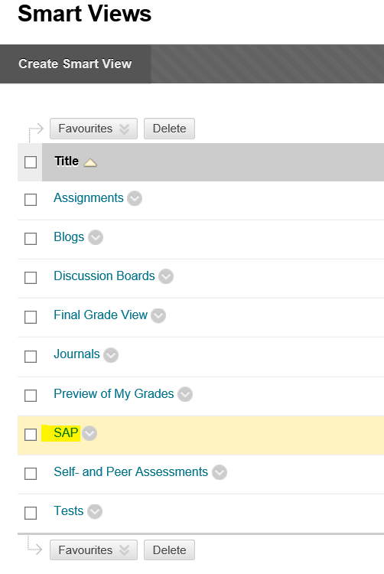
4. The Grade Centre should now display only those columns that you categorised
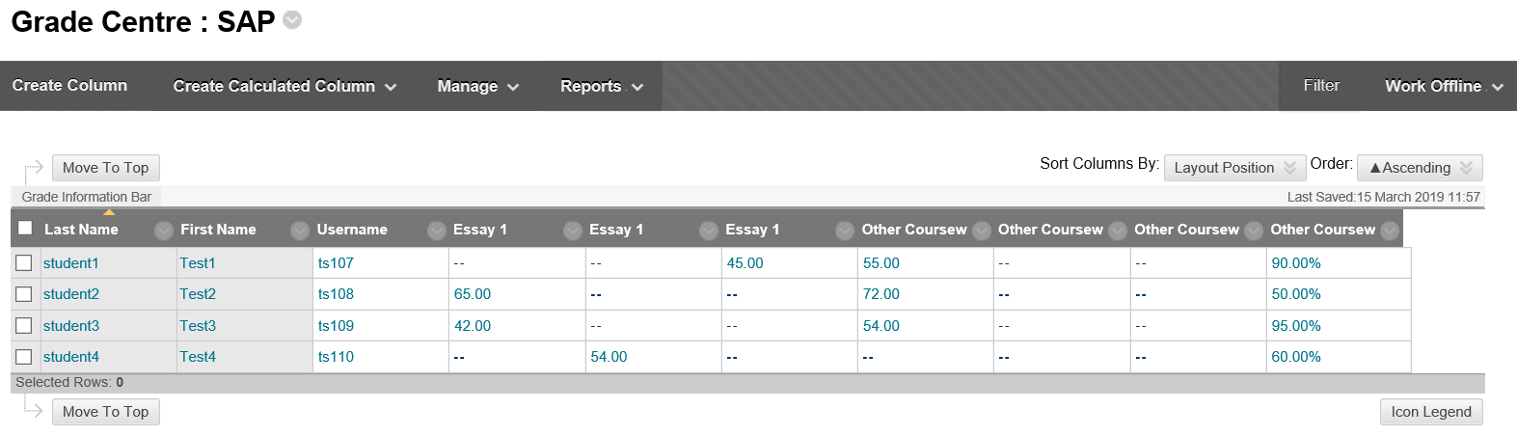
5. From the Work Offline menu select Download
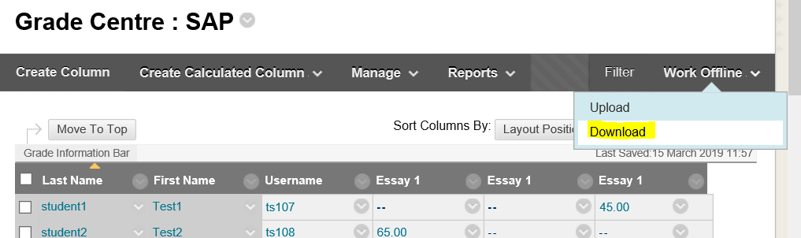
6. Click Submit
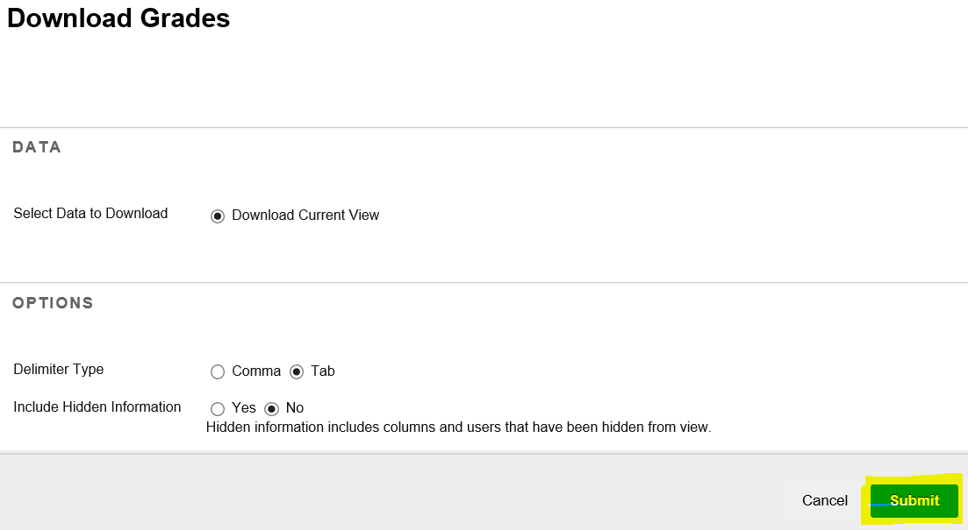
7. Click Download
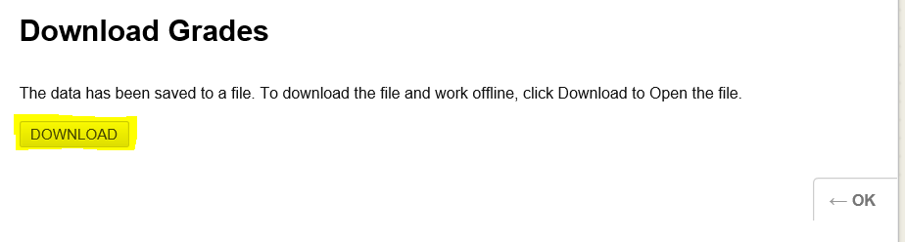
8. A message will appear
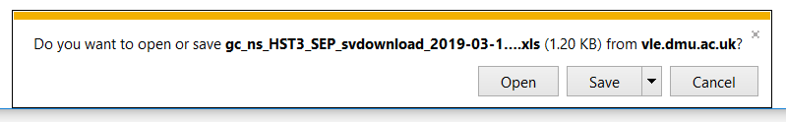
9. From the Save menu select Save As
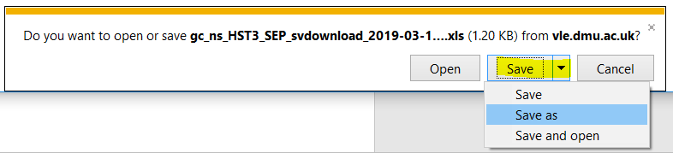
10. Save the file to an appropriate place on your desktop computer
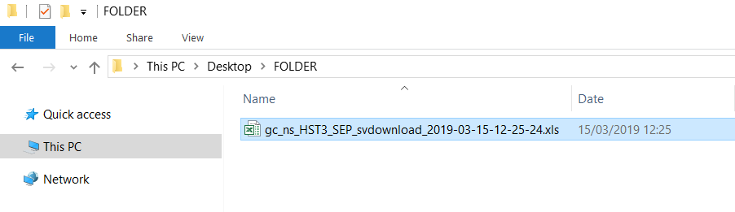
11. You can view the spreadsheet by clicking Open
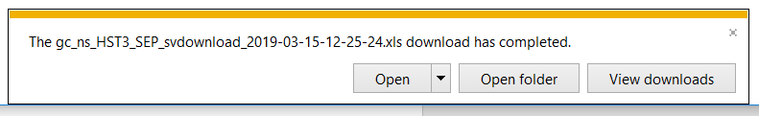
12. This is the spreadsheet file that you can use as a reference when transferring the grades to the Marks Entry Template (which should have been sent to your by your course administrator).

