Enabling the My Grades Tool Link
1. Hover over the 'Add new menu item' icon and select 'Tool Link'
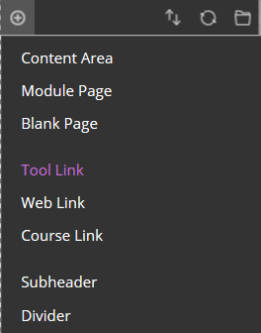
2. In the 'Type' dropdown select 'My Grades'
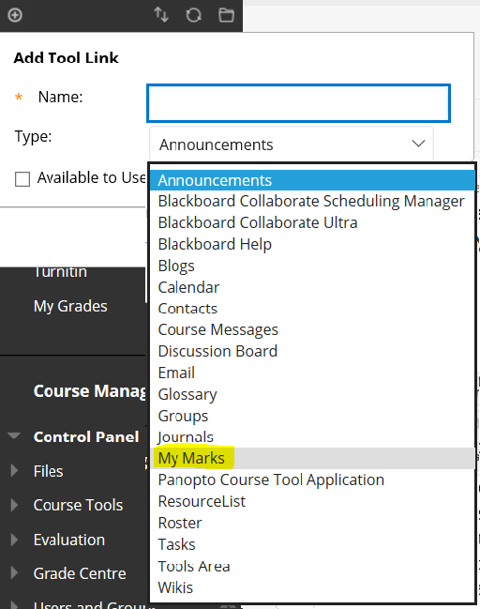
Note: it is important that you give the link a meaningful Name - although the Blackboard name for this link is 'My Grades' you can name the area anything
Note: to make the link visible to students, you will need to check the 'Available to Users' box but you may not wish this area to be available until there is grade information populated
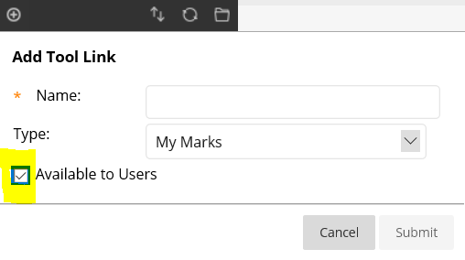
3. Click the 'Submit' button
The new link to the My Grades area for students will now appear at the bottom of the main navigation - this can be moved around by re-ordering the navigation menu.

Tell me more about online assessment and feedback

