Embed a self-created website in a Blackboard module
It is possible to create a basic website that operates within a module in Blackboard. The process involves importing all of the files that have been used to build the website into the Course Files area, and then creating a File Item in a course page that opens the website when clicked.
NOTE: This procedure is aimed at persons who have a basic understanding of how to build a website using HTML.
This is the example website that we are going to import into a course and embed in a Blackboard page. NOTE: This example website is only available to DMU staff via the Single Sign On system.
How to import a website to a Blackboard course
1. Identify the folder(s) in which all of the files that have been used to build the website are contained.
In this example the folder is named html_example and contains the following files:
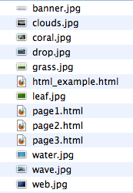
2. Navigate to the Blackboard Course into which you want to import the website.
3. Enter the Course Files area via the Control Panel menu in your Course Management section by clicking the arrow to the right of Files
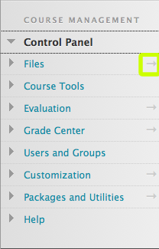
4. Click the Upload button and select Upload Files from the dropdown menu
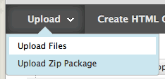
5. Select the Multiple Files option in the new window. Then drag and drop your website folder into the upload files window.
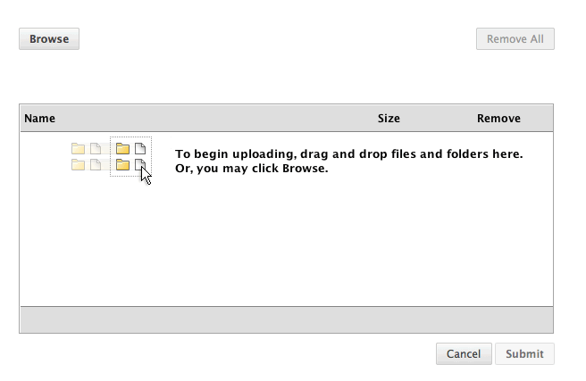
The folder will be unpacked in the window and will list all of the files contained within it.
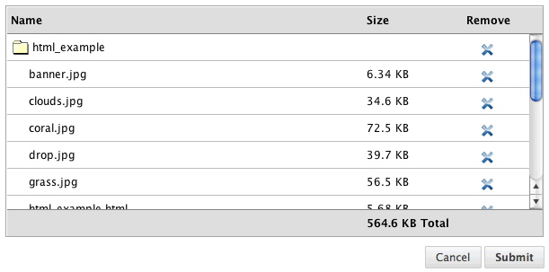
6. Click Submit and your website folder and all of the files it contains will be uploaded to your course files area.
Adding the imported website to a course page:
It is now possible to embed the website into a course page
1. Navigate to the Course Content area into which you want to add the website. Hover over the Build Content button and select File from the dropdown menu.
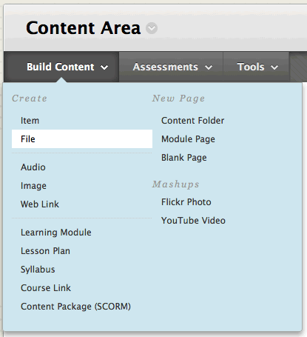
2. In the Select File section, click the Browse Course button.
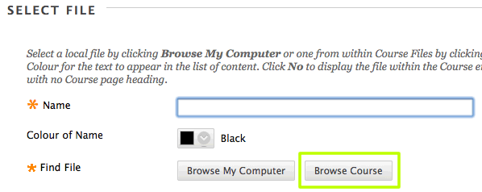
3. In the window that pops up click on the name of the folder in which the website files are contained (e.g. html_example) - this will be the website folder that you have just imported.
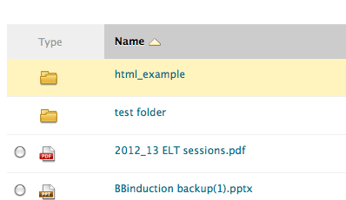
4. In the list of files that now opens select the file (using the check button) that corresponds to the landing/home page that opens when a user normally visits the website (e.g. html_example.html)
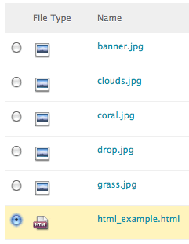
5. Click Submit
6. In the next section:
a) name the file
b) ensure that the Manage Access setting is set to Give users access to all files and folders in the folder.
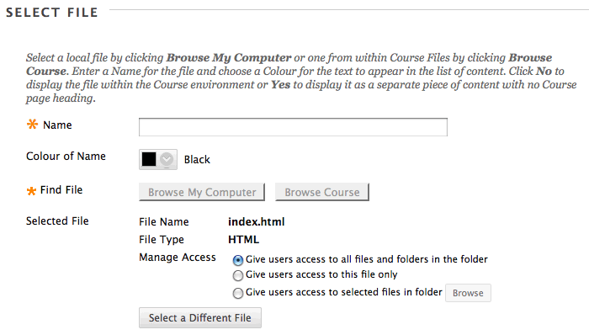
7. In the File options section, ensure that Open in New Window is set to No if you want the website to open 'inside' the Blackboard environment. You can ignore the Add alignment to content setting.
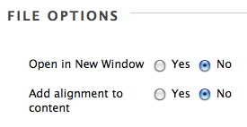
8. Click Submit
An item should now appear in your Content area.
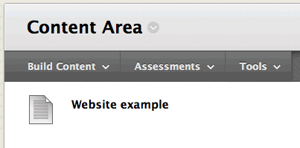
Clicking on this item should open the website, embedded within your Blackboard module environment.
