Adding the Safeguarding Essentials resource to a Blackboard module shell
IMPORTANT NOTE: The Safeguarding Essentials resource has been developed and is maintained by a company external to DMU. As such, the Centre for Enhancing Learning through Technology (CELT) is not able to offer any advice or support regarding the content of this resource.
To add a Cyclix resource package to a Blackboard module:
1. In your web browser go to: http://customerzone.cylix.co.uk
2. Enter the Username and Password that was given to you by your administrator. (These details are not known by CELT)
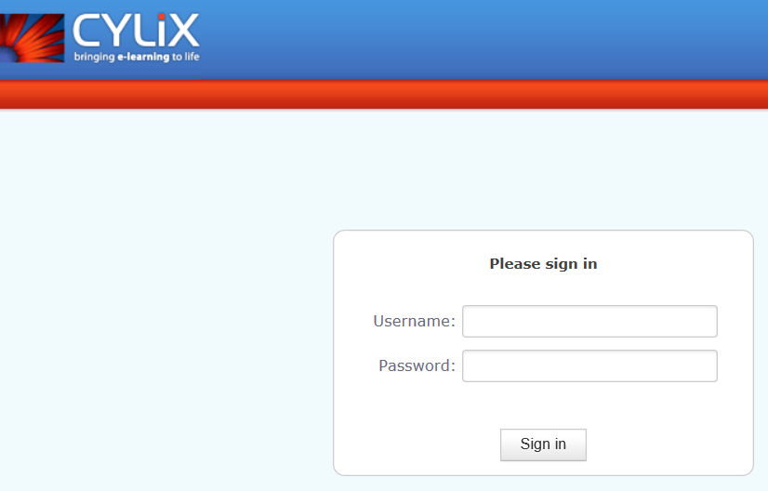
3. From the Customer zone panel, locate the Safeguarding Essentials package (make sure you choose the version that was updated 22-May-2018) and click the Download button.
4. A message will appear asking if you want to Open or Save the resource, click Save
5. A new message will appear, you can ignore and close this message by clicking the X
6. Go back to your web browser, log in to Blackboard, and go into the module into which you want to add the resource
7. Go into the Content Area where you want to add the resource. E.g. Learning Materials
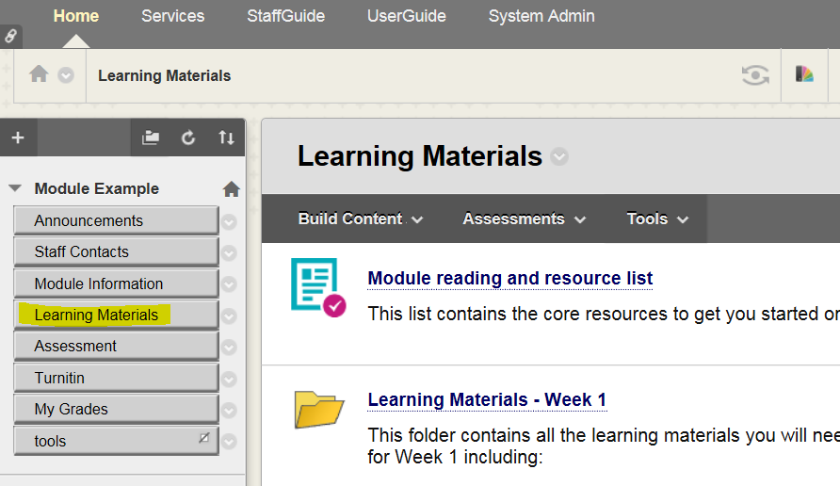
8. Click Build Content, and from the menu select Content Package (SCORM)
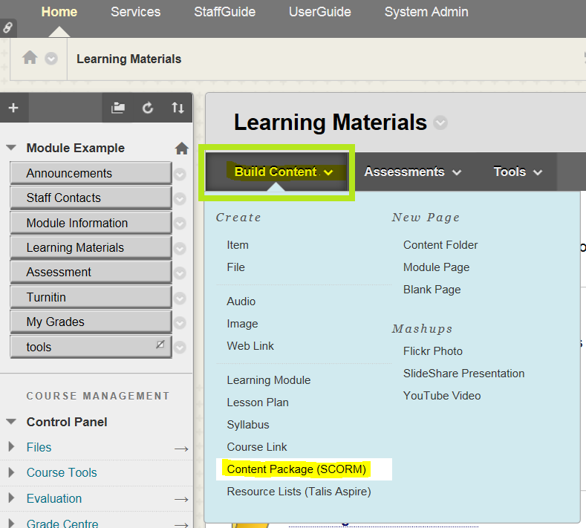

9. In the Add Content Package (SCORM) panel, click Browse My Computer
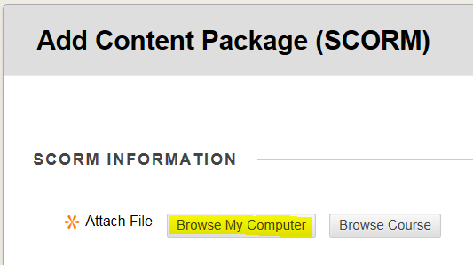
10. Click on your Downloads folder, click on the content package that you downloaded, and click the Open button
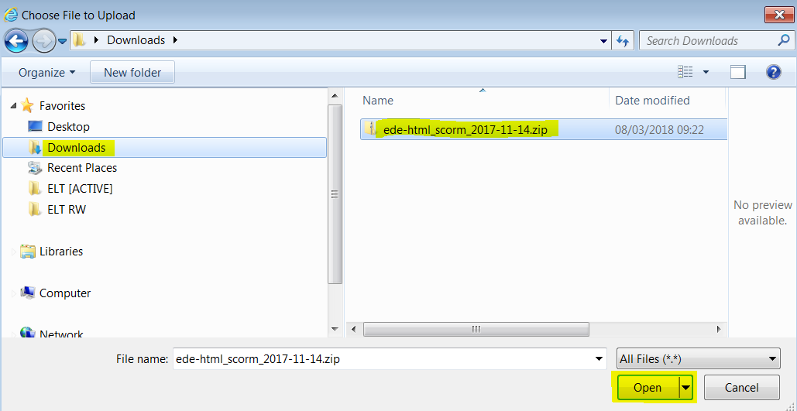
11. Click the Submit button in Blackboard
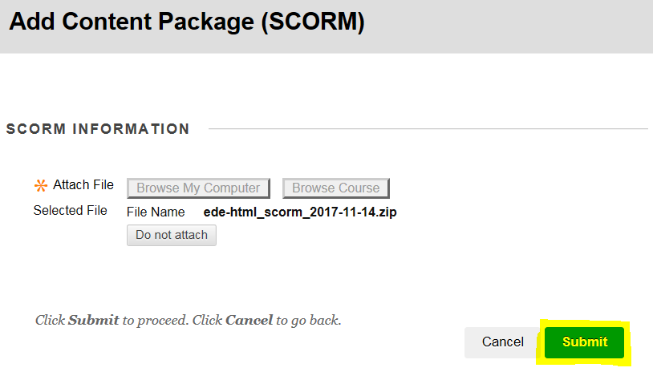
Be patient as it can take several seconds for the package to process.
12. Set the availability options for the resource. To enable students to see the resource - set the Make SCORM Available option to Yes. Then select how many attempts students have at completing the resource.
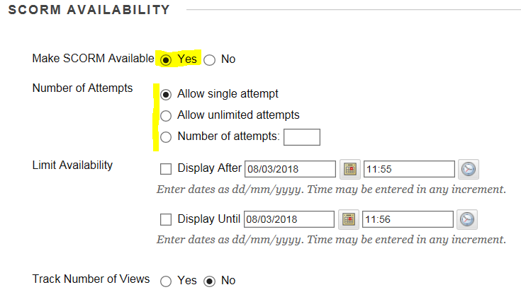
13. Set the grading options for the resource.
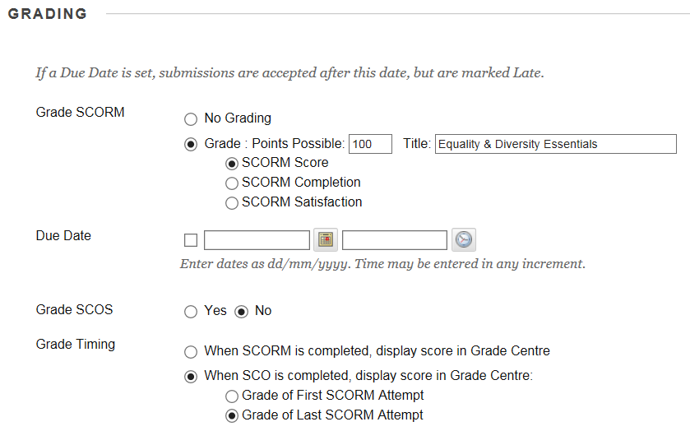
14. Click the Submit button
15. A link to the resource will be added. Students click this link to launch the resource.
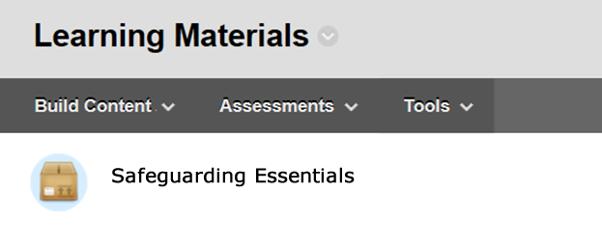
Scores given to students who have used the resource can be found in the Blackboard Module Grade Centre. To view a student’s attempt, click the grey icon next to the students score and select the Attempt option.
