Student IT Induction
Welcome to the Student IT induction for De Montfort University, or DMU for short.
DMU website
The university website is located at http://dmu.ac.uk and contains all the information you need during your time with us.
To access your personal information portal – called MyDMU - from the DMU website.
1. Click Current Students

2. Click MyDMU
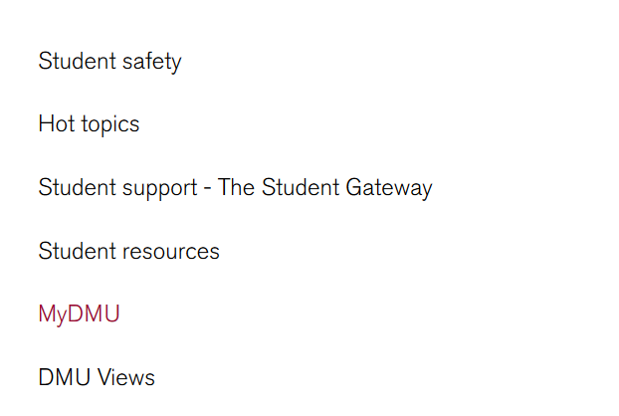

3. Click Student [Students who require an accessible version of the MyDMU hub should click the Student (Accessibility) link
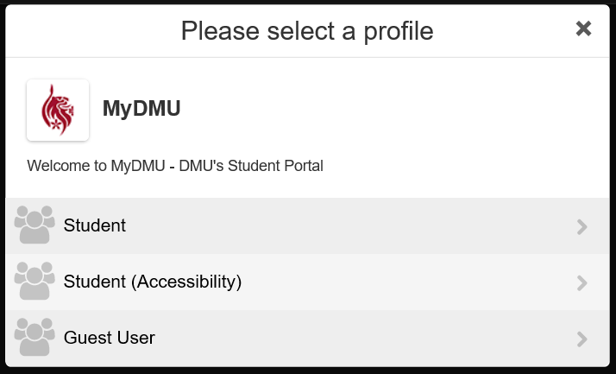

4. Click the Accept button
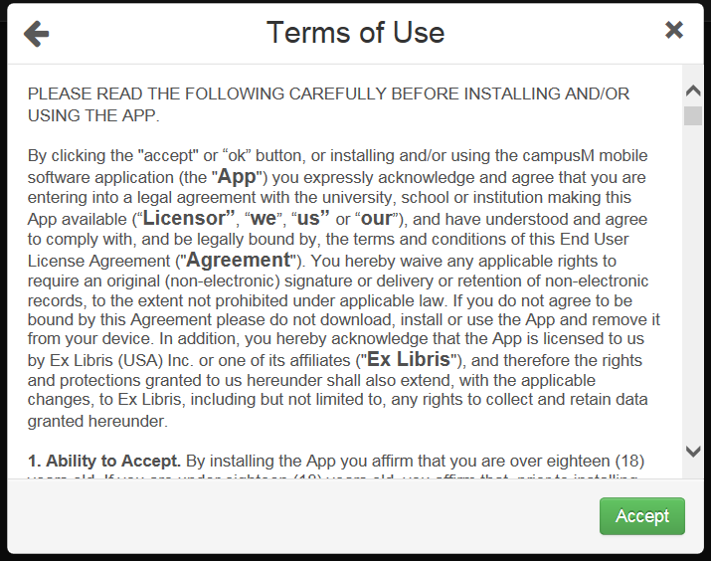

5. Log in with your student username (student id) and password
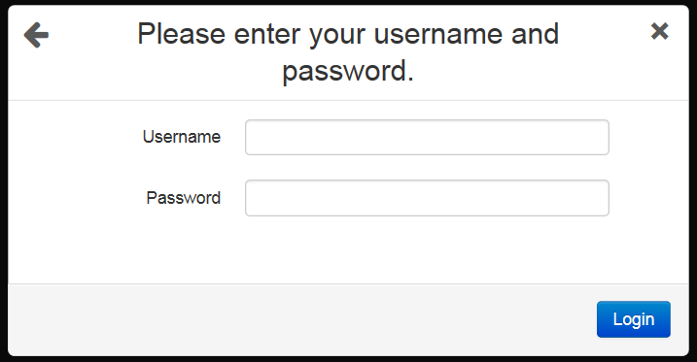
Your username and password will have been communicated to you as part of your induction. If you do not know what your default login details are; contact the ITMS Service Desk via email itmsservicedesk@dmu.ac.uk or by telephoning Ext: 6050
6. The MyDMU home page will launch
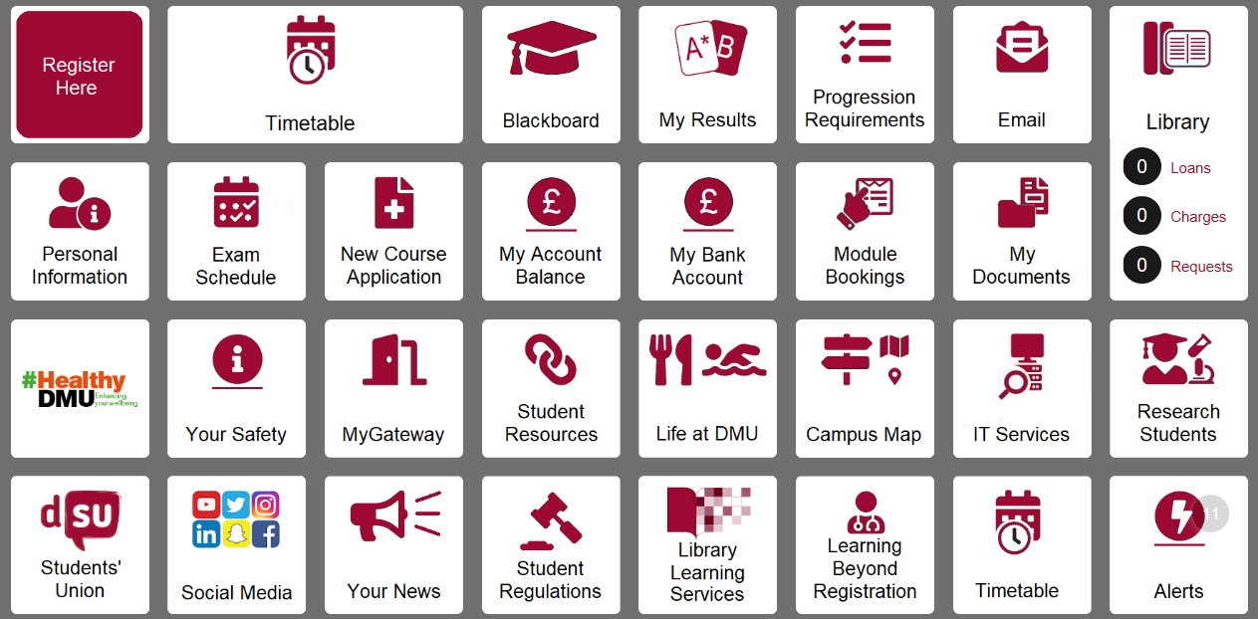
myDMU
https://my.dmu.ac.uk
myDMU contains personalised information; e.g. your timetable, personal details , course details, and so on. This information can only be accessed by you.
Your home screen also gives you quick access to your emails, Blackboard, social media, and more.

Password self-service site
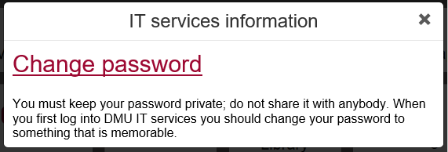
It is recommended that you change your default password via the IT Services tile.
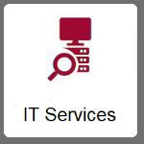
Alternatively you can type http://password.dmu.ac.uk in your web browser to access the Password Self Service. You will be required to login again using your student username and password.
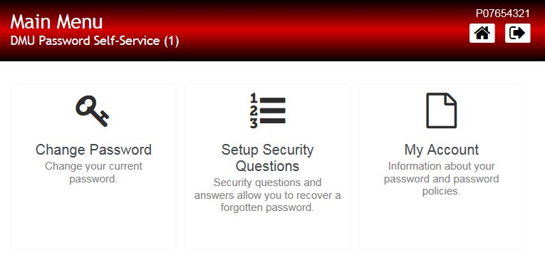
Here you can also set security questions which are used to recover a forgotten password.
Student email
You can access your student email account via the Email tile in MyDMU
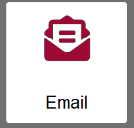
You email address is your student id number@my365.dmu.ac.uk.
E.g P0123456@my365.dmu.ac.uk
Students should use this account for all university email communication. Academic Staff are not able to respond to emails from personal accounts.
Questions about the email system should be emailed to office365feedback@dmu.ac.uk

Blackboard
Blackboard is a web-based virtual learning environment (VLE) used at DMU to support teaching, learning and assessment. Blackboard provides access to online learning materials from any compatible computer with internet access. It enables you to continue your learning activities, collaborate and access resources away from the classroom.
There are two ways you can access the main Blackboard site:
a) Click the Blackboard tile in MyDMU
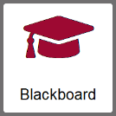
b) or type https://vle.dmu.ac.uk directly into your web browser.
You will then need to:
1. Click the Continue button
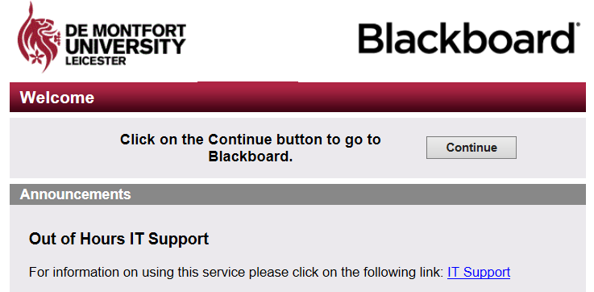
2. Login using your student id and password
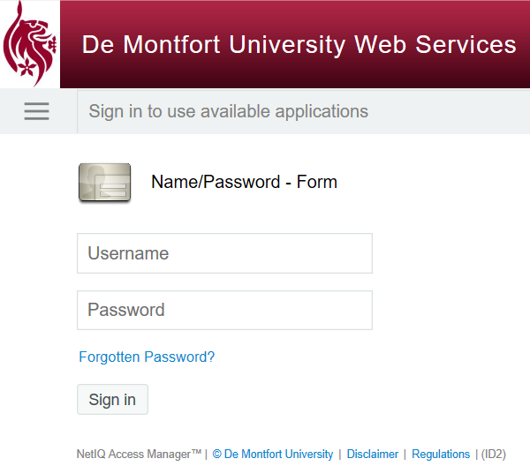
This is the Blackboard landing page, it is personalised to your enrolment details.
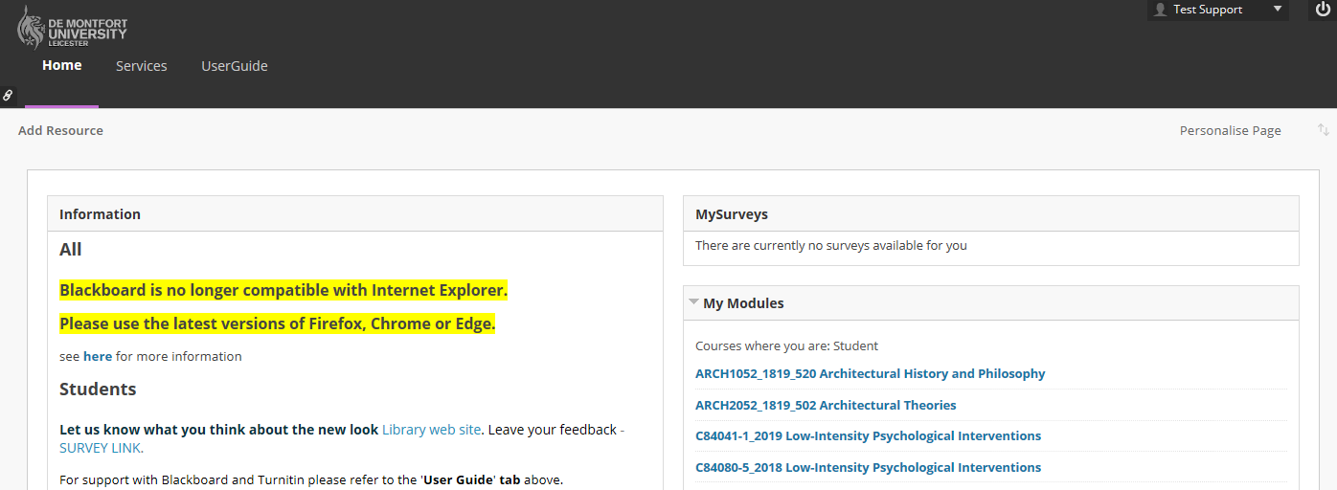
Each module on which you are enrolled has its own online space which can be accessed from the My Modules panel. When you click on the module name you will be taken to the virtual learning environment for that specific module.
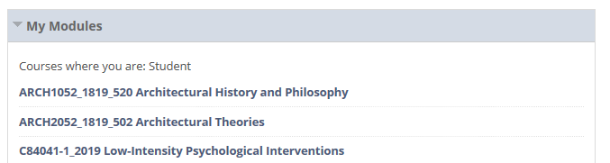

Your module tutors will explain how you will be expected to use the Blackboard learning environment in each of your modules.
For more detailed information about the basic functionality of Blackboard click the UserGuide tab, which will take you to the Student Support for Learning Technologies site.

Student support site
The Student Support for Learning Technologies site contains basic ‘How to’ guides concerning the core functions of Blackboard and associated teaching, learning and assessment technologies.
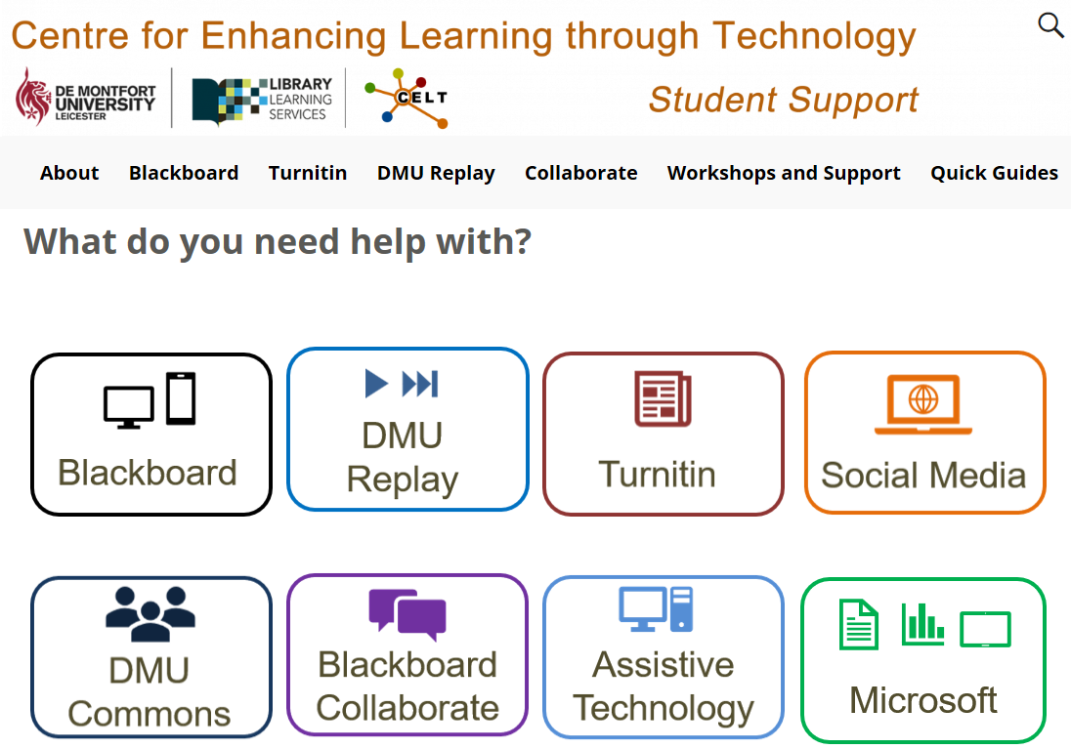
Turnitin
You may be required to submit your written work electronically through Turnitin. This software assists academic staff in identifying potential plagiarism, collusion or other academic offences. It may also be used to grade your work and provide feedback.
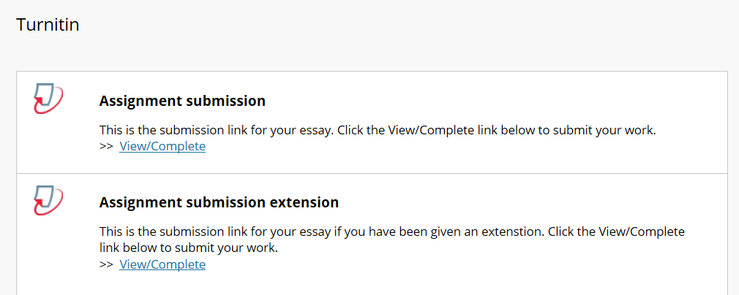
Your module tutors will advise you on the procedure for submitting your written work, and for viewing your feedback and grades in each of your modules.
DMU Replay
All staff led teaching sessions will be recorded, so that you can revisit them. This system is called DMU Replay.
Your module tutors will explain what DMU Replay means in practice.
DMU Replay recordings can be viewed by clicking the DMU Replay links in your module.
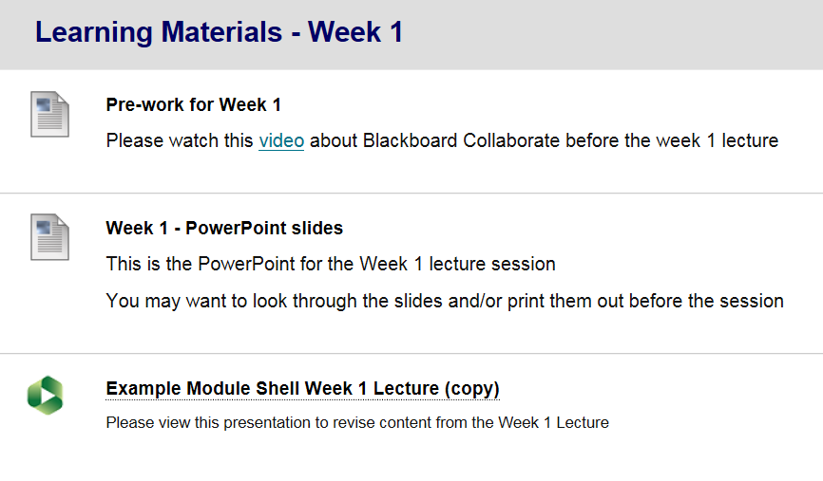

Kimberlin Library
http://library.dmu.ac.uk/
The Kimberlin Library has a range of IT services available.
- WiFi across all spaces
- Hundreds of computer workstations with a wide range of software installed
- Assistive technologies
- Syndicate rooms with digital multimedia hardware
- Laptop loans
- IT Help Desk – on 1st Floor (available during office hours)
Printing services
- Printers are available in all student areas
- You can use your student card to print from any machine on campus
- You can manage your printing and print top-up online at http://printing.dmu.ac.uk
- You can also print content from your mobile device. For information about mobile printing: http://mobileprint.dmu.ac.uk
- For more information on how to print or top-up your print credits, see the printing help sheet which can be found in the Kimberlin library
Campus Wide wifi
De Montfort University’s campus wide wifi is provided by Eduroam. It is completely free to access and use, with a one-time only sign on. It is compatible with a broad range of devices and operating systems. Eduroam wifi is available anywhere you see the Eduroam logo, this includes other universities and educational locations.
Paper-based help guides are available to show you how to connect to Eduroam. These can be found in all student learning zones and the Kimberlin Library.
Online help can be found at: eduroam.dmu.ac.uk
Microsoft Office 365
All students have access to Microsoft Office 365, which is a suite of Microsoft software tools – such as Word, PowerPoint, Excel, and so on.

You can access your account from the Student Resources tab in MyDMU
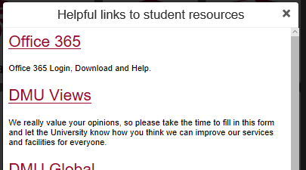
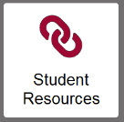

You can download Office 365 software for free on up to 5 computers and 5 mobile devices. Your copy of Office 365 will remain active until you graduate
Microsoft Office 365 Information and Training
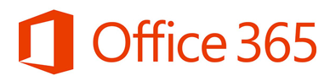
There are a number of resources to help you download and set up Office 365 - available at: https://demontfortuniversity.sharepoint.com/sites/support365/SitePages/Home.aspx
You will need to sign in using your usual account details to access these resources.
Online training resources can be found at:
https://support.office.com/en-gb/office-training-center
If you have any problems accessing Office 365 you can email office365feedback@dmu.ac.uk
Or contact the ITMS service desk by phone or email.
IT Support
There are several ways in which you can access IT support at DMU.
The main IT support portals are:
- The IT Services tile on MyDMU
- The IT Induction and support for learning technologies guide:
http://libguides.library.dmu.ac.uk/c.php?g=654033
- The ITMS service desk: itmsservicedesk@dmu.ac.uk

- The Kimberlin Library 1st Floor Helpdesk

