Exporting and Importing Turnitin Rubrics and Marking Grids
The Turnitin rubric manager is accessed via an existing Turnitin submssion link:
1. Navigate to a Turnitin submission link in any module and select the Edit option
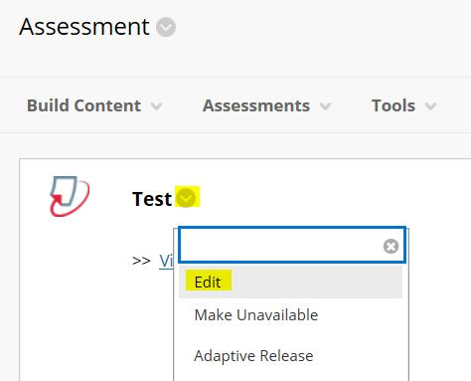
2. Expand the Optional settings panel
3. Scroll to the bottom of the screen and click Launch Rubric/Form Manager
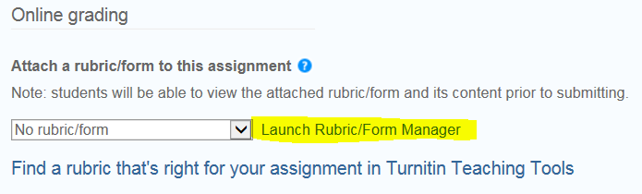
4. Click the rubric menu button and selet the rubric or grading form that you want to export
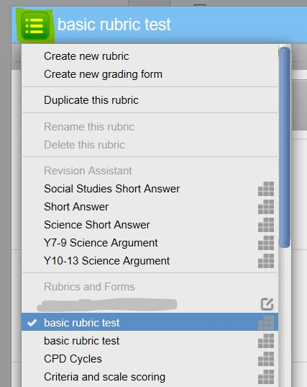
5. To Export the selected Rubric. Click the Export/Import button and select the Export option.
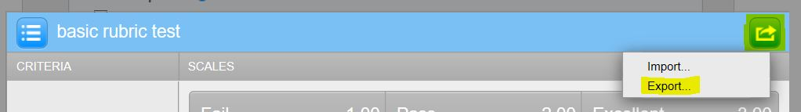
6. Save the Rubric file (which will be in a .rbc fornat) to your computer desktop
7. To Import a Rubric that has been exported. Click the Export/Import button and select the Import option.
8. Click the select files button
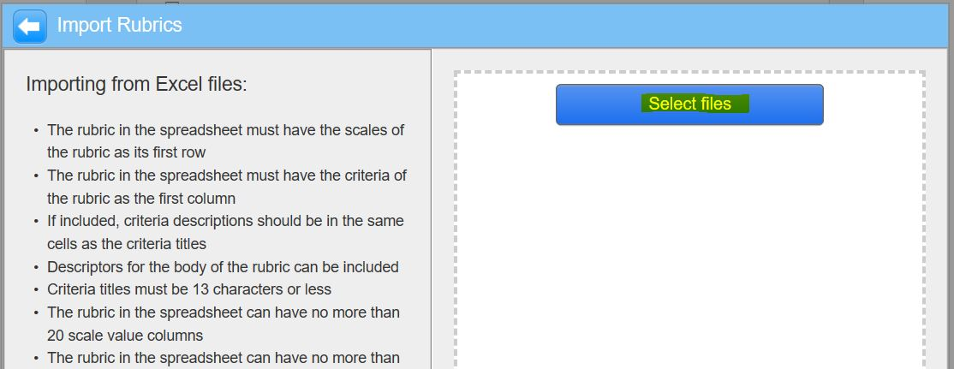
and locate the rubric file on your computer (it will be a .rbc format) - click Open to import it.
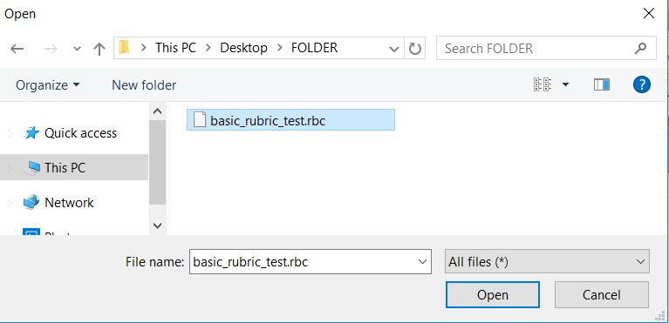
9. You will see an import complete message - the rubric will now be available in your Rubric manager list
