Adding an Office 365 Class Notebook link in a Blackboard module
In order for students to be automatically enrolled on a Class Notebook space that you are using as part of your teaching, they MUST access it via a Class Notebook link in the associated Blackboard module shell.
Only those students who have clicked on the link in Blackboard will be able to see the Class Notebook space.
IMPORTANT NOTE: The Class Notebook space MUST be setup by the instructor using the Class Notebook tool in Blackboard in order for the automated enrolment to occur. Class Notebook spaces that have been setup outside of Blackboard will require students to be added manually by the instructor.
To use Class Notebook via Blackboard
1. Navigate to a module and enter a content area where you wish to add the Class Notebook link. Click the Tools tab, and from the More Tools menu select Onenote Class Notebook.
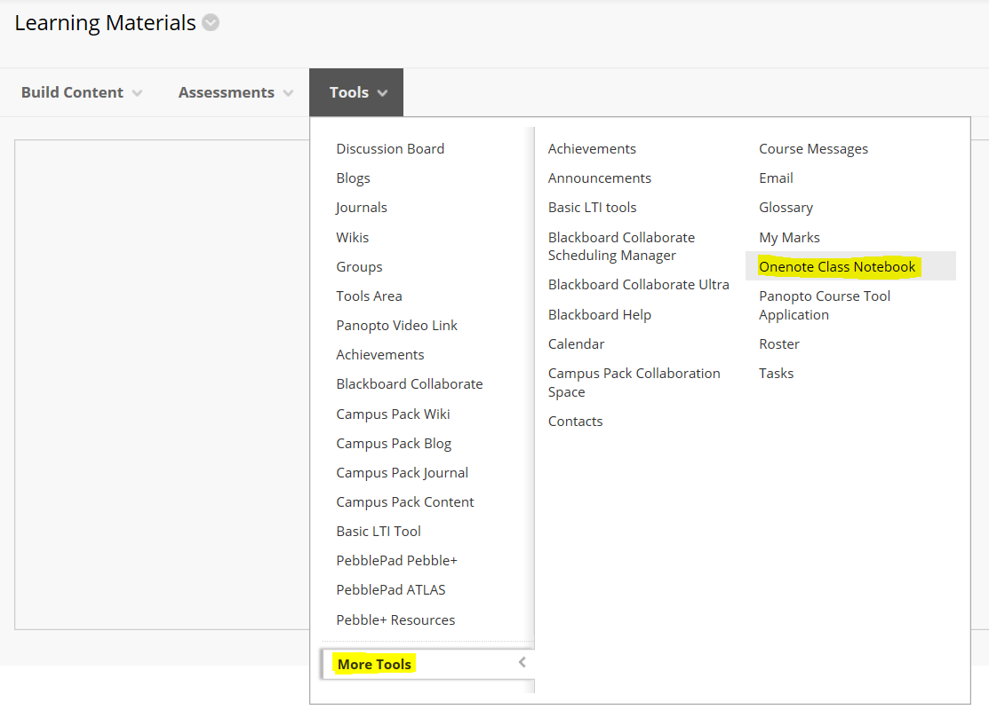
2. You can give the link a different name, and add some descriptive text if required. Then click the Submit button.
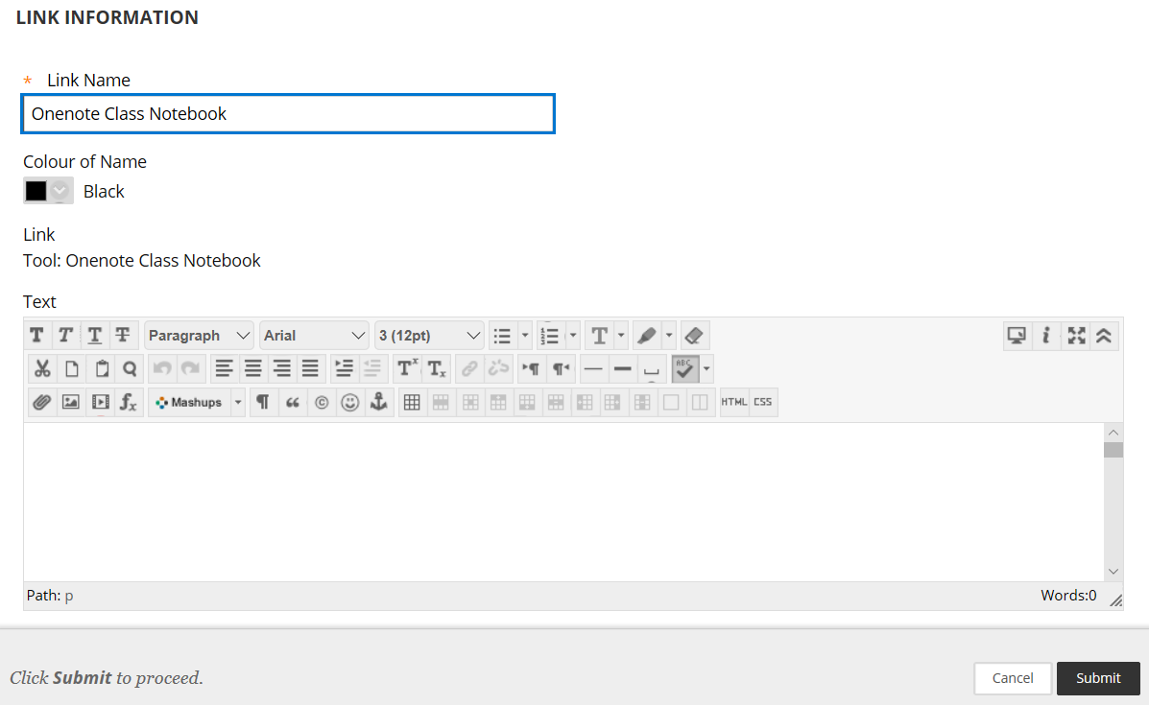
3. A link will be created.
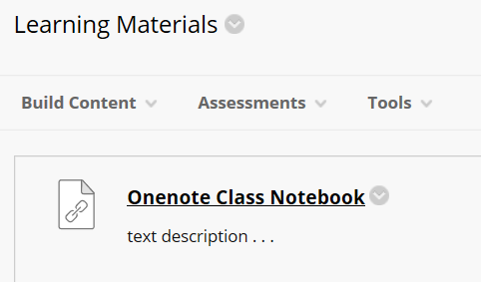
4. It is essential that you now use this link to create your Class Notebook space for this module. If you do not do this students will not be enrolled onto the Class Notebook space and you will have to enrol them manually.
5. Click on the link and sign in to your Class Notebook account.
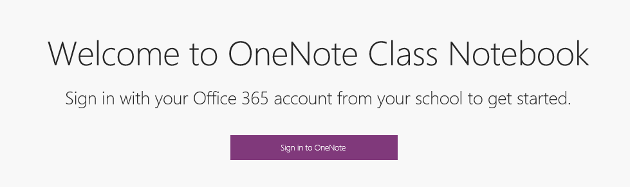
6. When the launch panel appears, open the LMS access settings menu and make sure that the box is checked.
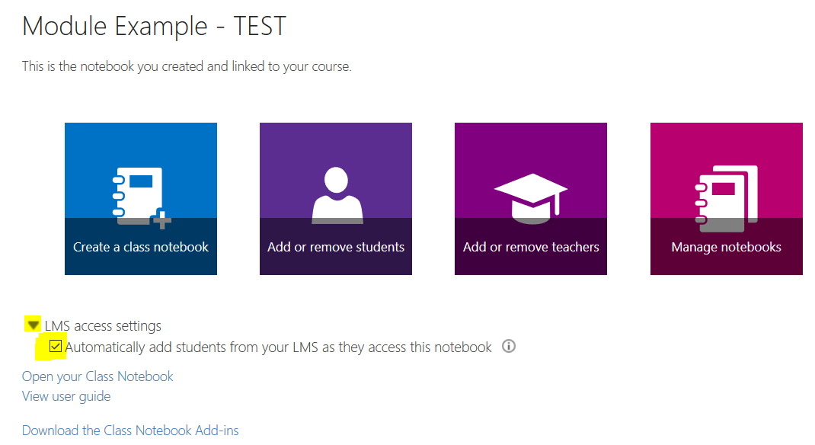
7. Click the Create a class notebook button
7a. If you have already associated a Class Notebook with this module you will see a message. Creating a new Class Notebook will delete the previous one.
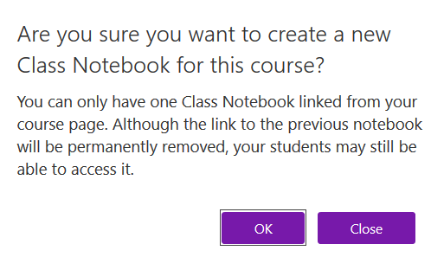
8. The Class Notebook space will launch and you can now organise the space as necessary for your teaching
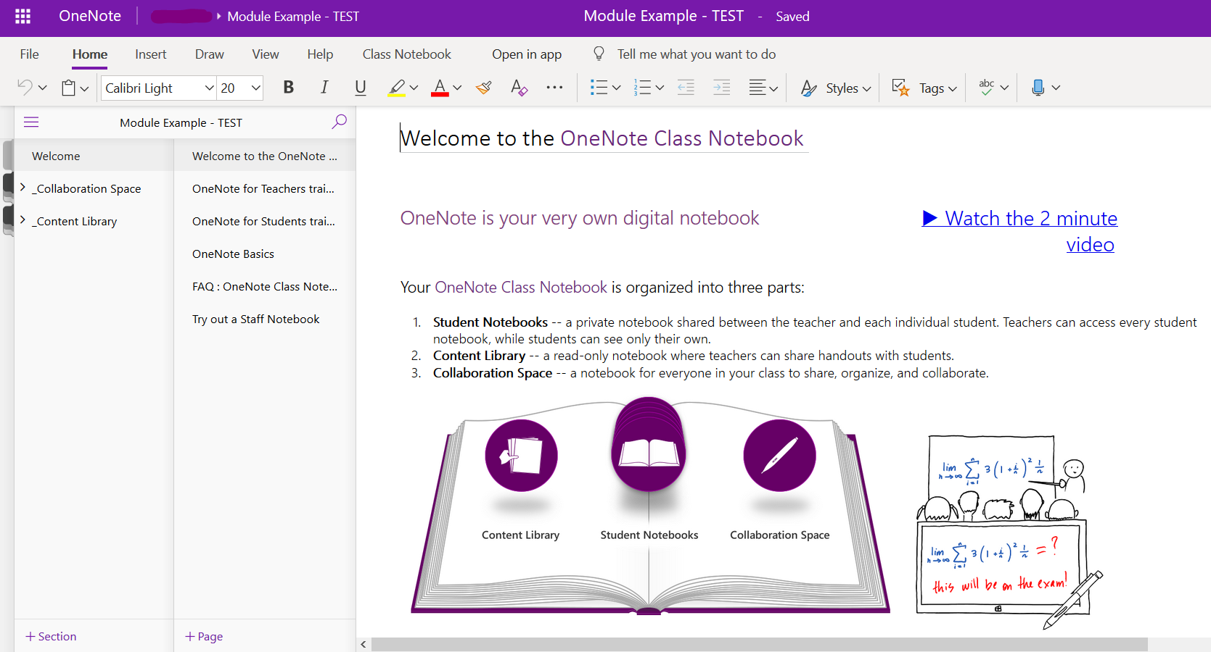
Student access to the Class Notebook space
Students click on the Class Notebook link in the module to access their individual Class Notebook space.
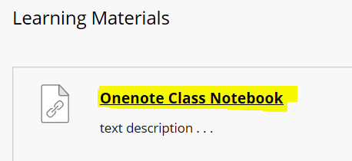
Viewing students Class Notebook spaces
Each student who clicks the Class Notebook link in the module will have their own Class Notebook space. In the instructor view all students will be listed in the main menu
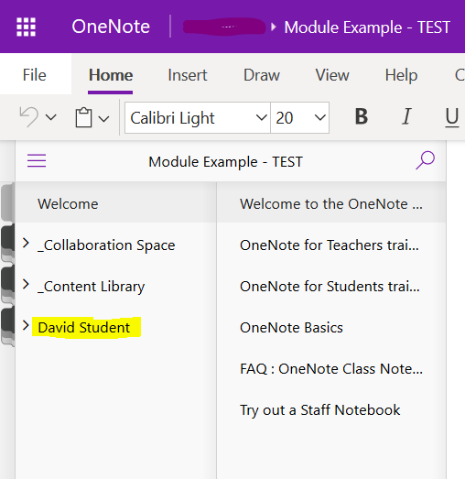
Instructors can access a student Class Notebook by clicking the name of the student. This will expand the student area showing sections, pages and any content that they have added to their Notebook.
