Staff Guide Information Sheet
Blackboard Collaborate Ultra

Blackboard (Bb) Collaborate Ultra is a video conferencing tool that lets you interact in real-time with colleagues, students and guests. You can add files, share applications or your desktop, and use a virtual whiteboard all from within your browser so you do not have to install additional software to run sessions. (Unlike the previous version of Bb Collaborate which required you to install the Bb Collaborate Launcher.)
This is an instructional guide to show you how to add the tool to your Blackboard module and deploy sessions. It does not provide pedagogical advice on how or why to use Bb Collaborate Ultra within your module. Please arrange a conversation with your CELT E-learning officer if you would like to discuss.
Further information about using the original Blackboard Collaborate is available on the CELT hub.
Developed and Produced by: Distance Learning Team, CELT, Library and Learning Services
© 2019 De Montfort University - All Rights Reserved

Contents
1 The Bb Collaborate Ultra Tool 3
1.1 Add Bb Collaborate Ultra tool to the module shell 3
1.2 Add Bb Collaborate Ultra tool to the content area 3
2 Setting up a Session 5
2.1 The Session Settings 6
3 Deploying a Session 7
4 How to Join a Session 7
4.1 First time joining a Session 8
4.1.1 Audio and Video Test 8
4.1.2 Tutorial 10
5 The Collaborate Panel 11
5.1 The Collaborate Panel – Chat 11
5.2 The Collaborate Panel – Attendees 14
5.2.1 Attendee Roles 17
5.3 The Collaborate Panel – Share Content 17
5.4 The Collaborate Panel – My Settings 22
6 Recording a Session 24
6.1 Deploying Recordings 25
6.1.1 Copy a Recording link 25
6.1.2 Adding a Recording to DMU Replay 27
7 Preparing a Session 30
8 Managing a Session 30
9 Other Useful Information 32
9.1 Attendance reports 32
9.2 Setting Camera and Microphone Permissions 32
9.3 Collaborate Ultra for Groups 34
10 Troubleshooting during a Collaborate Session 35
10.1 Accessing a Collaborate Session 35
10.2 Within the Collaborate Session 35

The Bb Collaborate Ultra Tool

Add Bb Collaborate Ultra tool to the module shell
- Log into your Blackboard Module
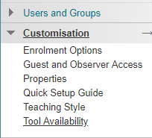
- Go to the Control Panel under the left-hand menu
- Select Customisation > Tool Availability
- Tick the Available option for the tool Blackboard Collaborate Ultra

- Click Submit.

Add Bb Collaborate Ultra tool to the content area
The Bb Collaborate Ultra tool link will need to be added to module content area. We usually recommend that you create a new separate content area for your Collaborate Ultra tool link.
- Open the content area where the tool is to be made available.
- Click on Tools button to open
- Click on More Tools to open
- Click on Blackboard Collaborate Ultra to select
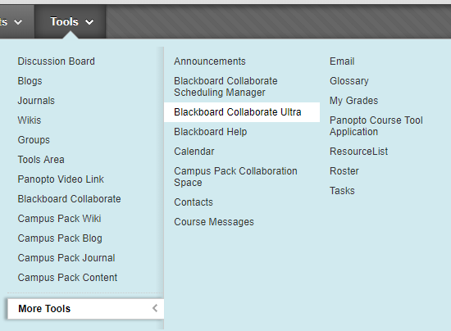

- Complete the Create Link form shown below.
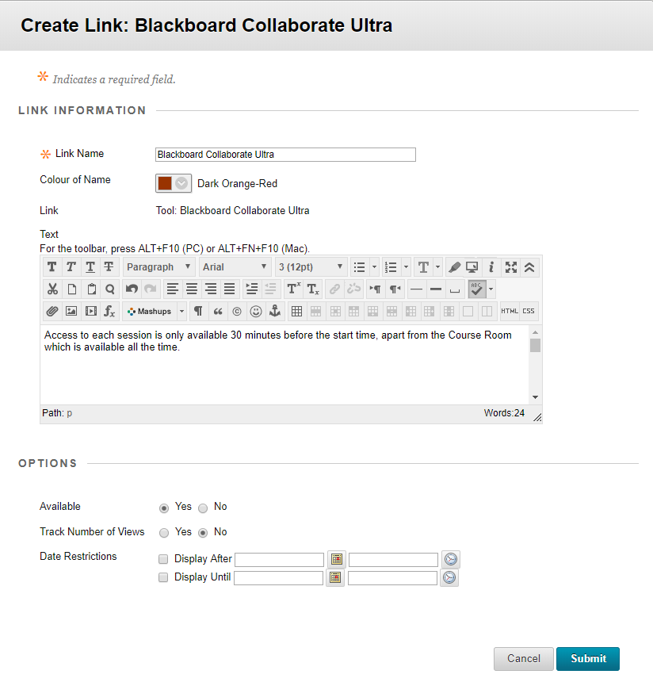
- Link Name: leave on default Blackboard Collaborate Ultra, unless you have a good reason to change it. However if you do change it make sure the students, etc, know it is Collaborate Ultra
- Colour of Name: for example, Community Justice use Dark Orange Red (#993300)
- Text: add details, i.e. “Access to each session is only available 30 minutes before the start time, apart from the Course Room which is available all the time.”
- Options: leave on default, unless you need to change anything.
- Submit – once all information has been set click the ‘Submit’ button.

- Tool will then appear in content area as shown below (icons and text both showing):
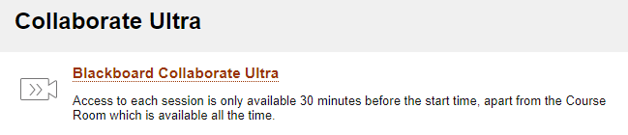

Setting up a Session
- Click on the tool name to open i.e. Blackboard Collaborate Ultra
- Click Create Session button
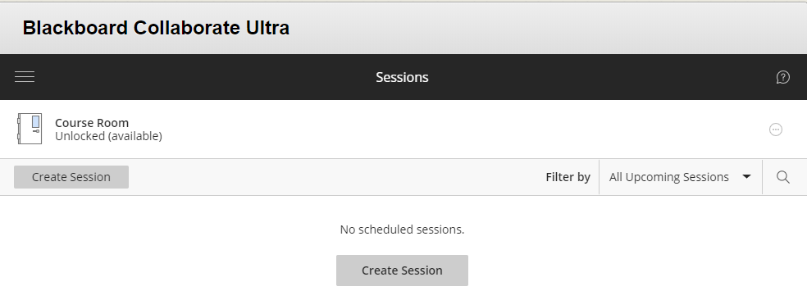

- You will now be able to enter the session details.
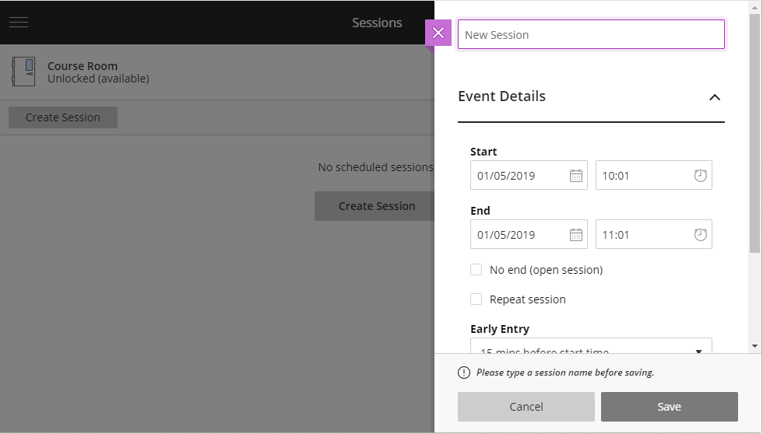
Event Details:
- Session Name: give it an appropriate name. (There is no need to include the session date and time as these now are listed with the name.) i.e:
  - Session 1: Introduction
- Start Time: Set the correct start date and time of the session. Clicking on the link prior to the start will only show the room (session) details. We strongly suggest that you limit the room’s availability as students can enter the wrong room if sessions are left open.
- End Time: Set the end date and time of the session. After this time you will no longer be able to join the room, but if you are already in the room you will not be forced to leave.
- No end (open session): tick if you want a session to remain open.
- Repeat: only use if you intent to hold regular sessions.
- Early Entry: this allows participants to enter the room before the start time. It is useful for the presenter to enter early to prepare and set up the session to enable a prompt start.
- Provide a description: click to open and then add a description that is visible before the students enter the session, i.e. “This session is repeated on Thursday afternoon. It will be available 30 minutes before the start time.”

The Session Settings

- Click Session Settings or the chevron to open.

- Default Attendee Role: set to ‘participant’ for staff-led sessions. Instructors on a module are automatically made ‘moderators’.
Recording:
- Allow recording downloads: leave off so students cannot save the recordings, as this is a privacy issue. However, if students from more than one module shell are sharing a session this will need to be selected, as sessions and recordings can only belong on one Blackboard shell. Therefore, a copy must be downloaded and then placed on the shell which does not host the Collaborate Ultra tool used for the session.
- Anonymise chat messages: for privacy, select so student names are not visible in the recordings.

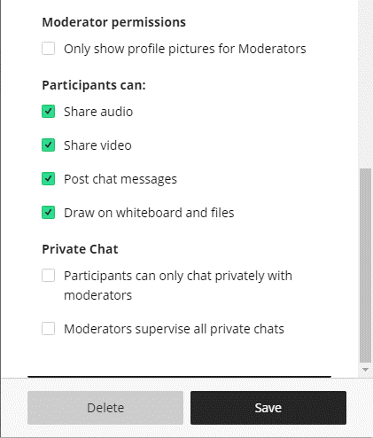
Moderator permissions
- Only show profile pictures for Moderators: no need to tick, as most people do not have a profile picture.
Participants can:
- Share audio: leave on by default, can restrict in session, if necessary
- Share video: leave on by default, can restrict in session, if necessary
- Post chat messages: leave on by default, can restrict in session, if necessary
- Draw on whiteboard and files: leave on by default, can restrict in session, if necessary

- Private Chat:
  - Participants can only chat privately with moderators: leave default off unless you have a need to change it.
  - Moderators supervise all private chats: leave default off unless you have a need to change it.
- Save – once all information has been set click the ‘Save’ button.

Deploying a Session
- Sessions are automatically listed under the Sessions menu.
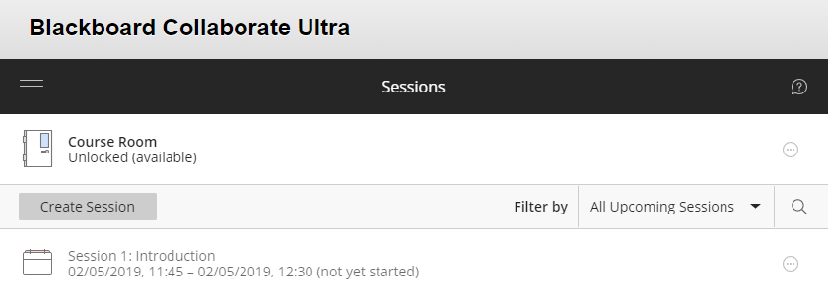

- Sort sessions with the ‘Filter by’ and ‘Search’ options.
- To see previous sessions:
  - ‘Filter by’ > ‘All Previous Sessions’.

How to Join a Session
If a student tries to join a session before it is available they will be shown the name, description, start time and end time.
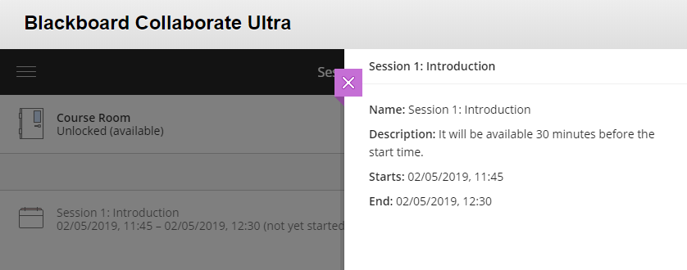
When a session becomes available, participants will be able to join it.
- Click on the session to open.
- Click Join Session.
- If you want to be able to email a link to students or guests to join the session ensure the ‘Guest access’ option remains ticked. You can copy the ‘Guest link’ and email it to anyone not enrolled on the module.
NOTE: This is necessary when students are enrolled on different module shells, but share the same Collaborate session.
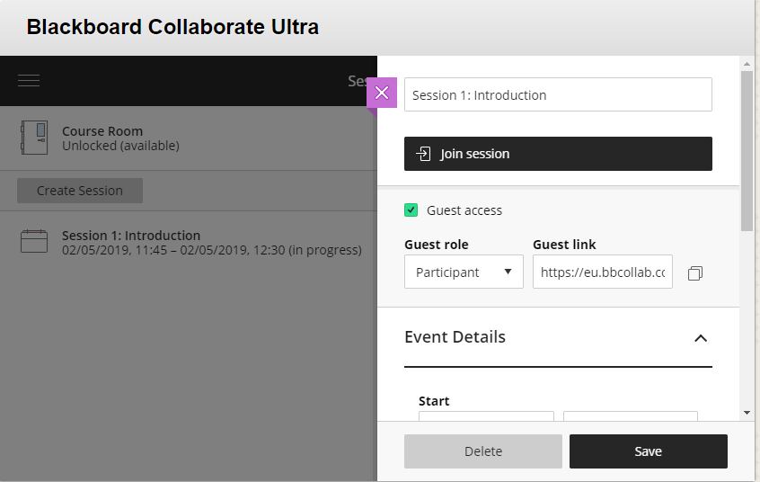

Copy ‘Guest link’

First time joining a Session

Audio and Video Test
- Usually the audio test automatically opens the first time you join a session. Use the drop-down menu to change your microphone if you have more than one. The audio bar should move as you speak to demonstrate it is working. Click the ‘Yes – it’s working’ button to continue. Clicking the ‘No – I need help’ button will open a new browser window/tab at the troubleshooting page of the Blackboard website.
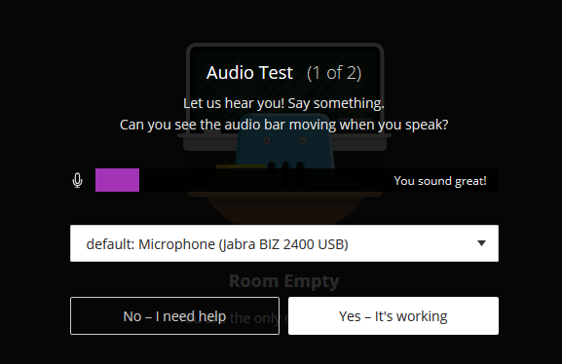

- The video test is next, use the drop-down menu to change your webcam if you have more than one. Click the ‘Yes – it’s working’ button to continue, even if you do not have a webcam or intend using one. Clicking the ‘No – I need help’ button will open a new browser window/tab at the troubleshooting page of the Blackboard website.

- On some browsers, you will have to give permission to Collaborate Ultra to share your camera and microphone, as shown here on the Firefox browser.
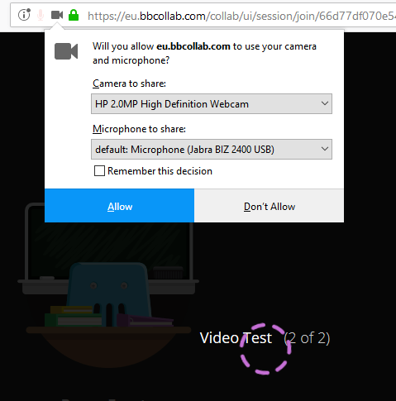

Tutorial
- A very short Tutorial will show some brief highlights which you can view by clicking on ‘Start Tutorial’. Click ‘Later’ to skip the tutorial.
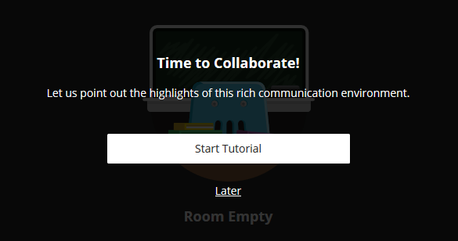

- The Session Menu opens on the left-hand side of the screen. Here you can record sessions, find help, report issues and leave the session. If you do not view the Tutorial you can select ‘Tell me about Collaborate’ to view it at another time. Click Next.
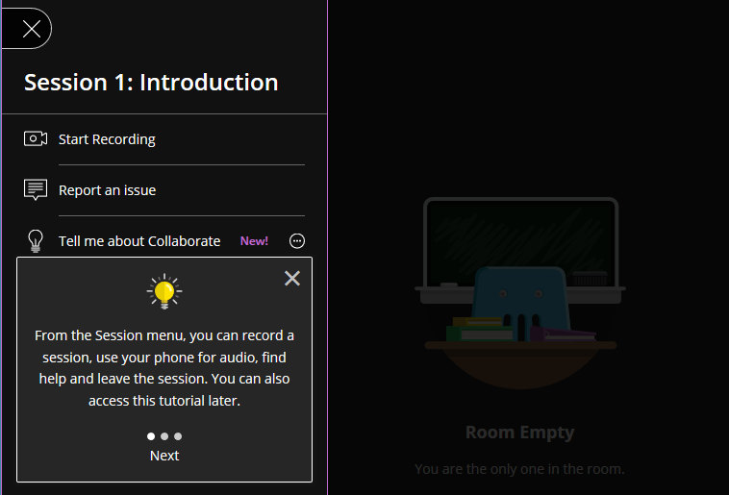

- The Collaborate Panel opens on the right hand side of the screen to show the chat, attendees, sharing options and settings pages. Click Next.

- The icons at the bottom of the screen enable you to turn on your audio and video, set your status or raise your hand. Click ‘Close’ to exit the Tutorial.
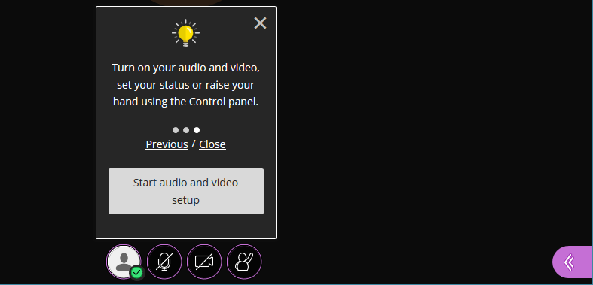

The Collaborate Panel
- Open the Collaborate Panel by clicking on the pink/purple tab in the bottom right-hand corner.
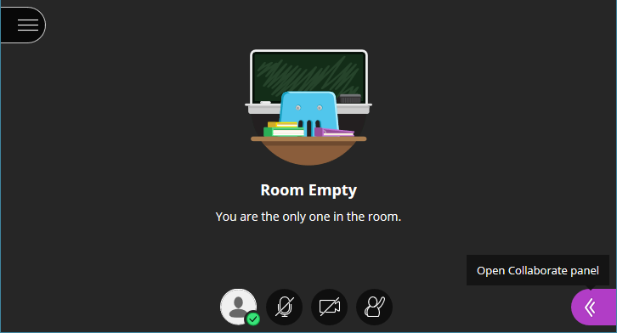

The Collaborate Panel – Chat
- Use chat to message other attendees,
- Select the Chat tab, which is the first tab along from the left.
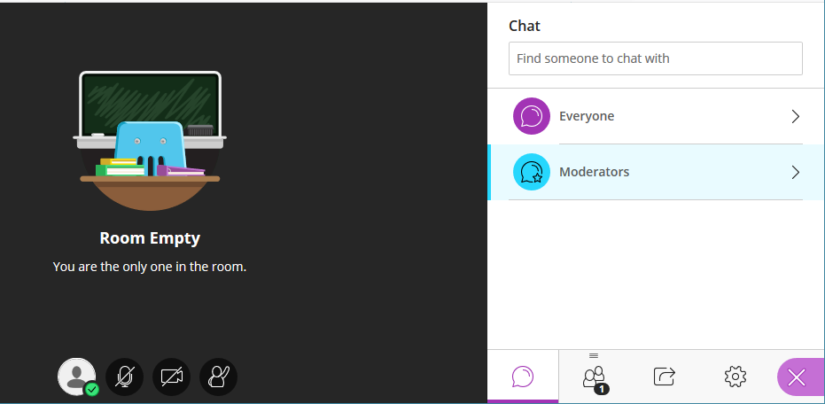

- Select Everyone to message all attendees, select Moderators if you want your message only to be visible to the moderators.

- Type a message and you can include an emoji to add emotion if you want.
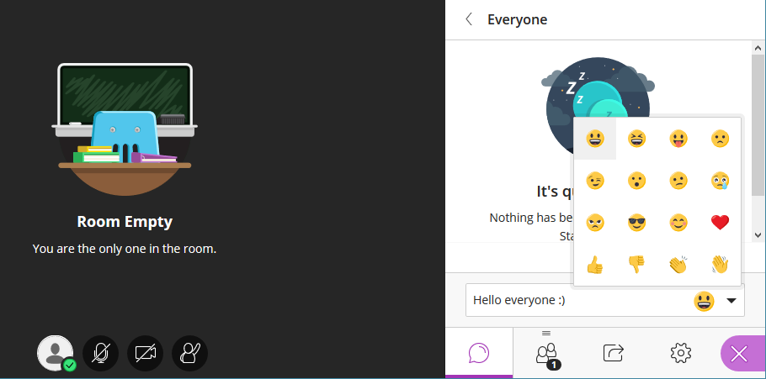

- Press Enter or Return on your keyboard to post it.
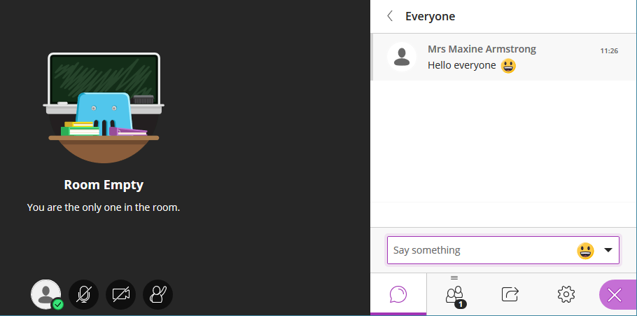
- To navigate the Chat history press Shift and Tab.
- Use the arrows to scroll between the messages.
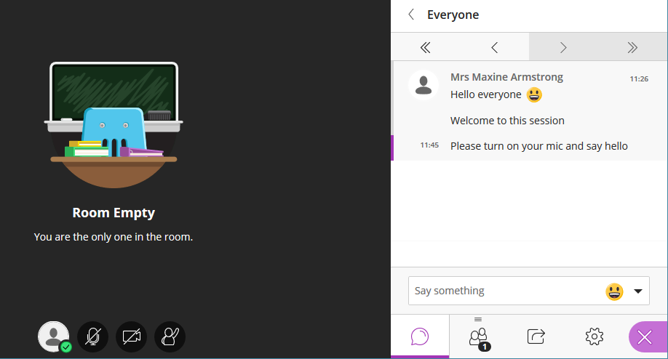

- Use the arrow to return to the previous Everyone panel.
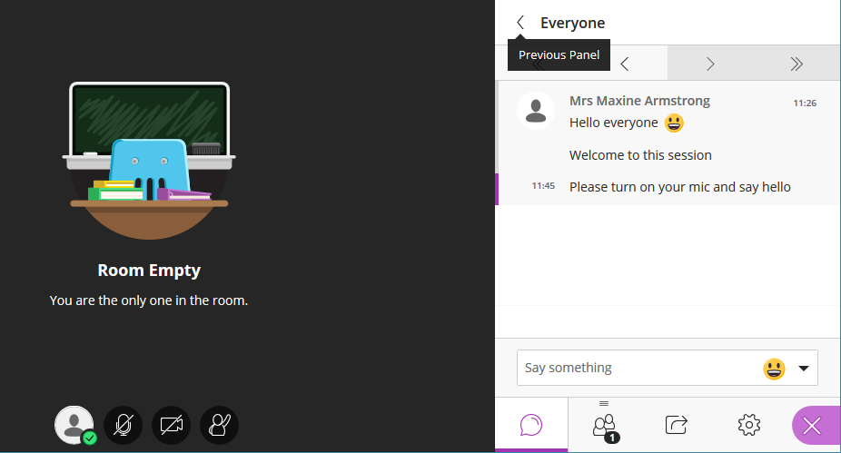

- You can use the search field to find someone to chat with.

- If you want to send a private chat message open the attendee controls menu, next to their name in the Attendees tab, see below.
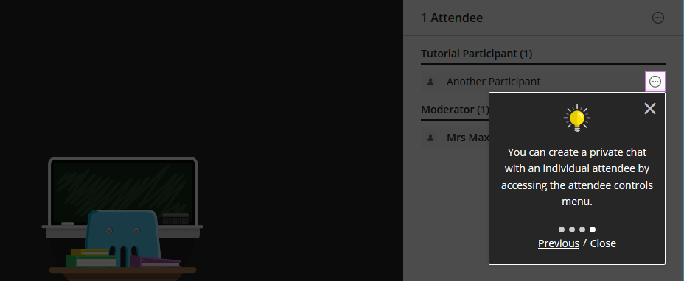

The Collaborate Panel – Attendees
- Select the Attendees tab, which is the second tab along from the left.
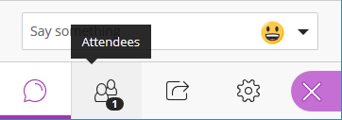

- The number shows the number of attendees in the session.
- Attendees are grouped by role.
- Attendees with their hand raised will appear at the top of the list.
- A moderator can promote a participant, mute them or remove them from the session.
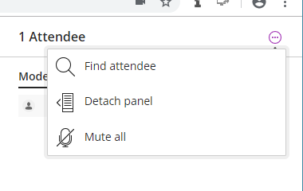
Detach the Attendees panel
- Drag and drop the attendees icon onto the main stage, or select More options at the top of the panel.

- Select Detach Panel.

- Any shared content on the main stage will move to the left to make room for the panel.
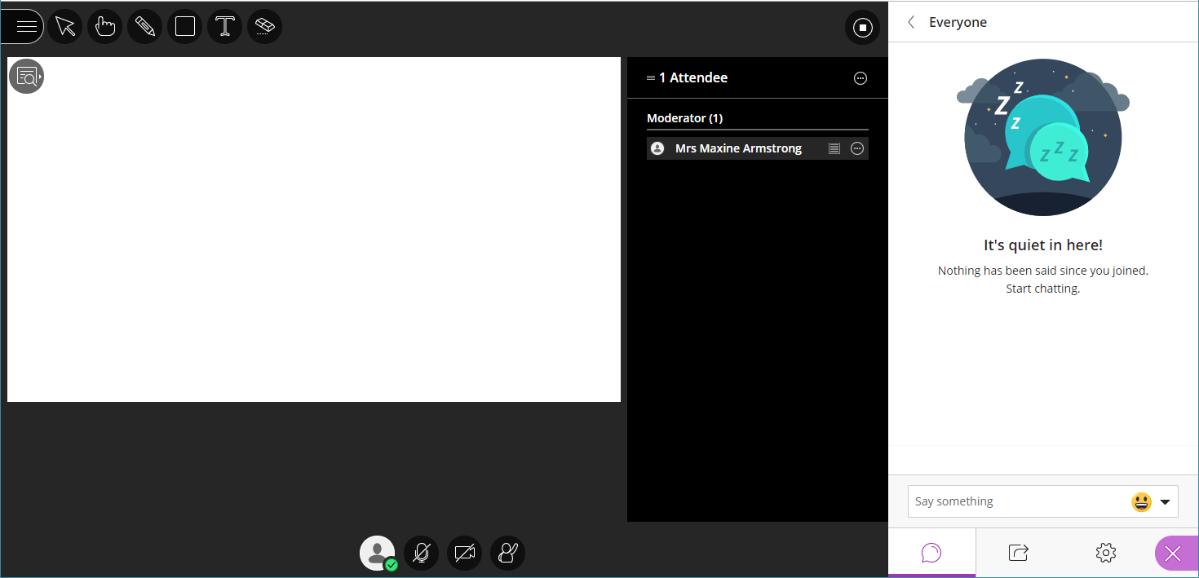

- Close the panel at any time. Select ‘More options’ at the top of the panel. Select Merge Panel.
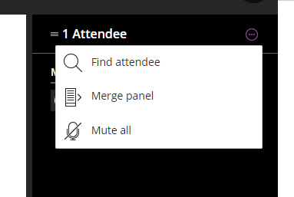

- By default, you will be notified when someone joins the session or leaves the session. These settings can be changed under My Settings.
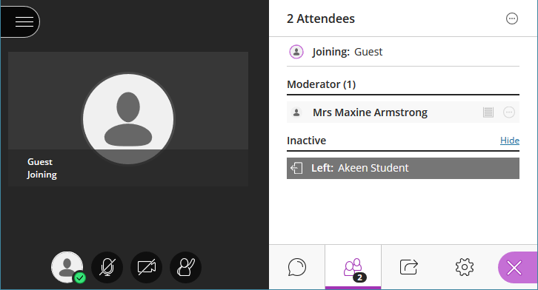

Monitoring attendees’ experience
- You can check the connection status for all participants by the connection status indicator.
- Click on the connection status indicator to see whether their experience is excellent, good, fair or poor. See Blackboard help – Network Connection for further details.
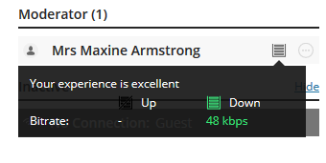

Attendees’ controls
- Attendee controls vary according to role.
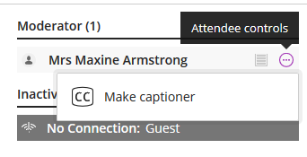
- A moderator can promote a participant to a moderator, presenter or captioner. They can also mute them, send a chat message or remove them from the session.
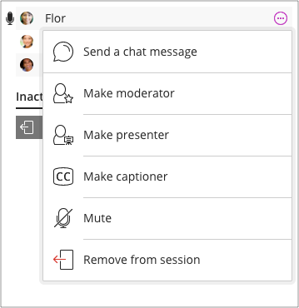
Mute all the attendees

- Open More Options
- Select Mute all. Attendees will be able to turn their microphones back on to speak.

Attendee Roles
- Moderator: has full control over content shared. Can change attendee role to a presenter or moderator. Can set session settings. See raised hands and lower them. Remove attendees, apart from other moderators, from session. Can decide what permissions participants have.
- Presenter: can present a session without having full moderator privileges. Can see who raises hand and lower them. Can upload, share, edit and stop sharing content.
- Participant: can enable notifications. If moderators have given permission, can also share audio and video, chat and draw on whiteboard or shared files.
- Captioner: provides captions for deaf, hard of hearing, or non-native language speaking attendees. An area is provided for the captioner to type, which others can view in real time. You can have multiple captioners for multiples languages.
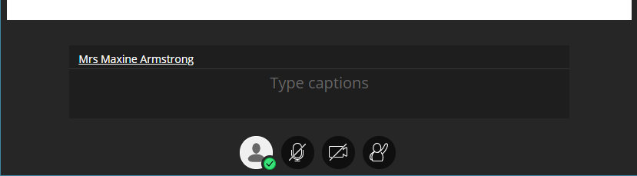

The Collaborate Panel – Share Content
- Select the Share Content tab, which is the third tab along from the left.
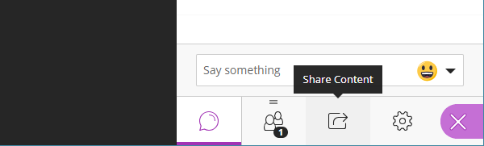

- To share a file, for example, a PowerPoint, select Share Files.
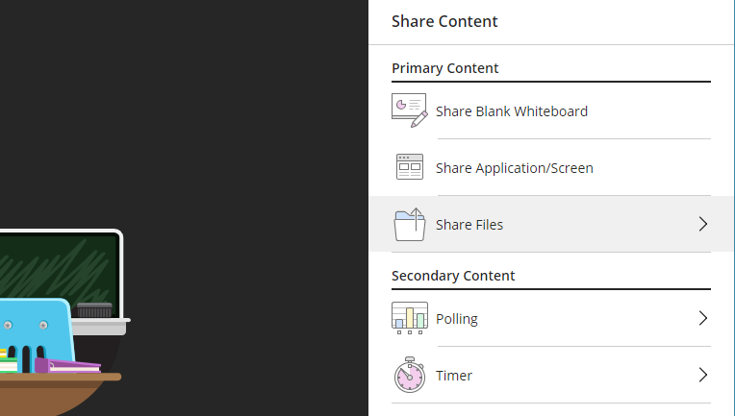

- Drag files onto the grey box if they are visible, for example, if they are on your desktop or Windows Explorer is open.
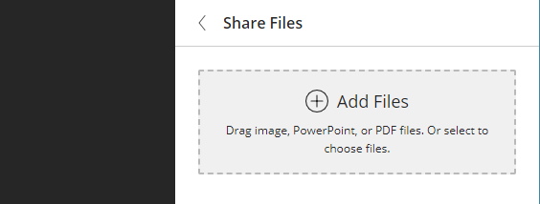
- Click Add Files if the file is not visible.
- Locate the file and click Open to upload it to the session.
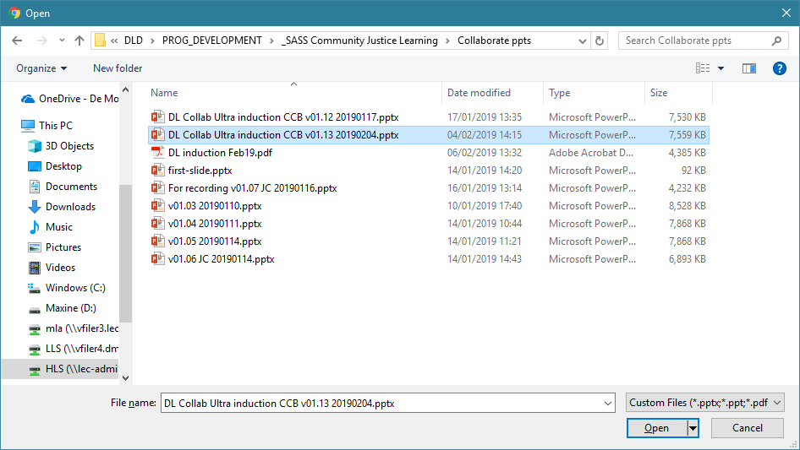
- The file will now upload and will be ready to share when you are ready.
- You can only share images, PowerPoint slides or PDF files in this way. (If you need to share a Word document or another type of file you can use the Share Application/ Screen option instead.)
- To share the file with the students click the Share Now button.
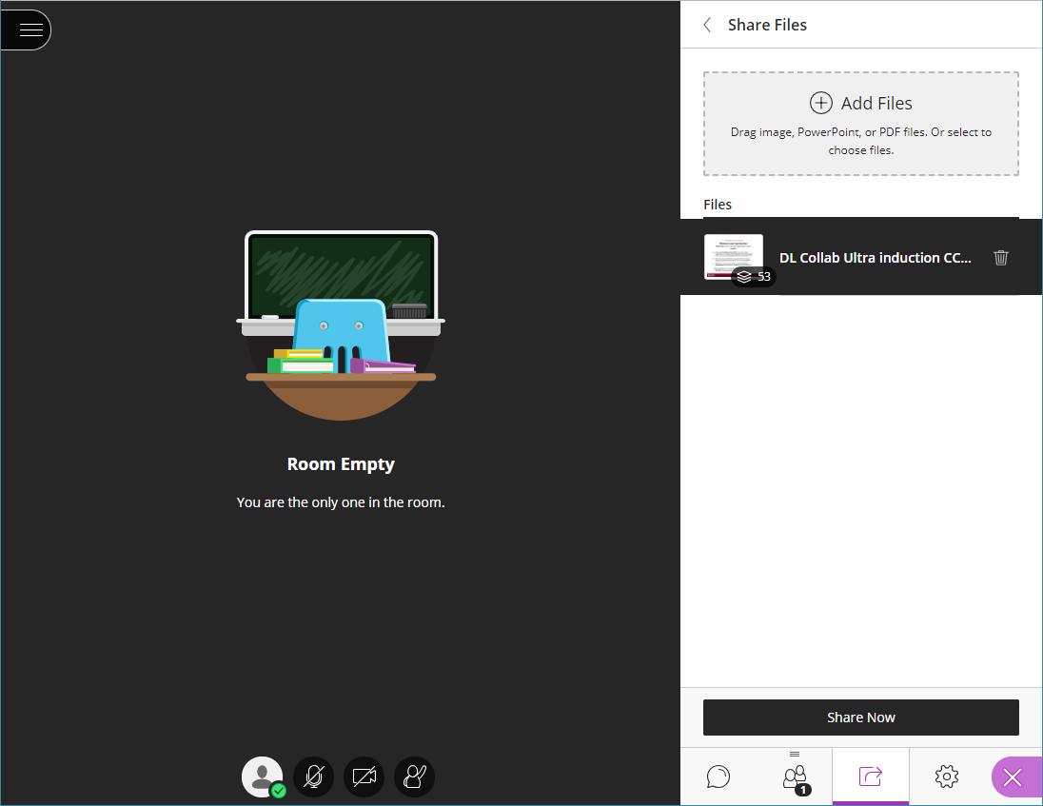

- From the thumbnails, click on the slide you want to show.
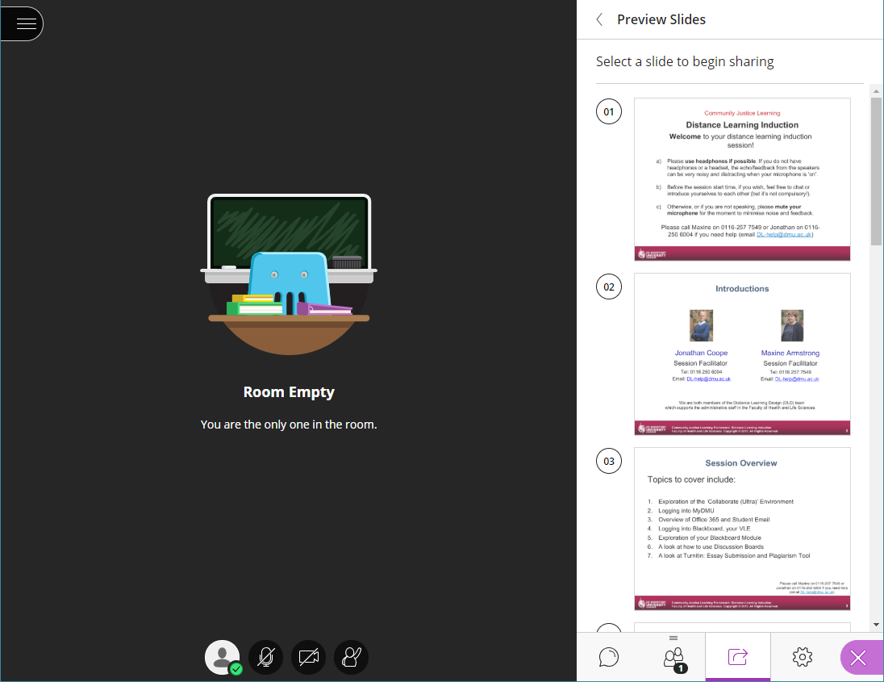

- The slide will now be visible to all participants.
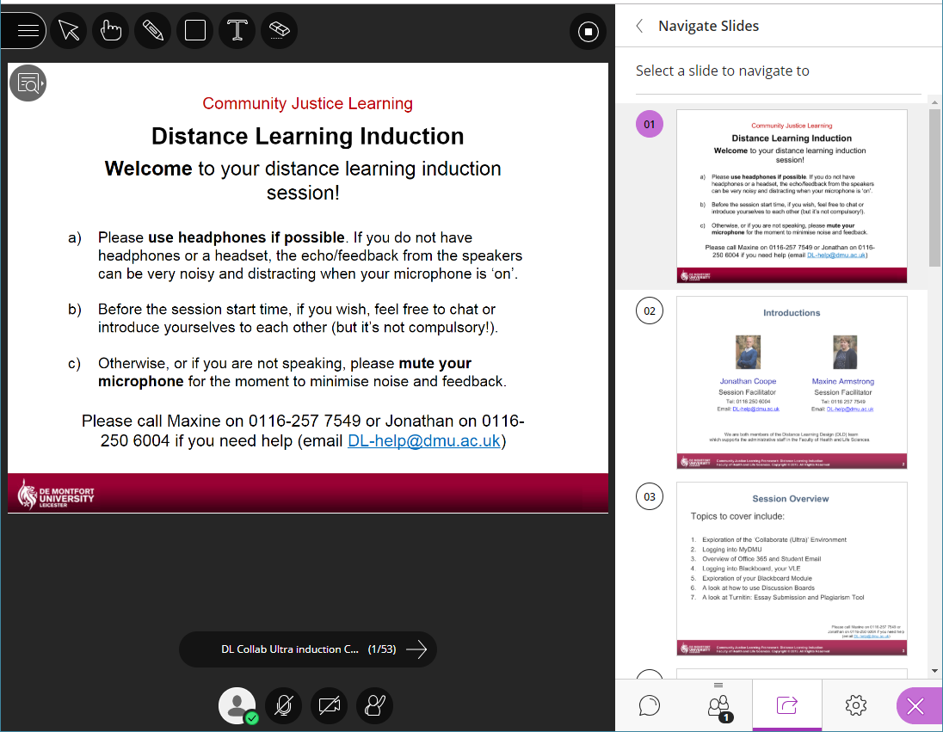
- You can use the arrows below the slide to move forward and back from one slide to another.
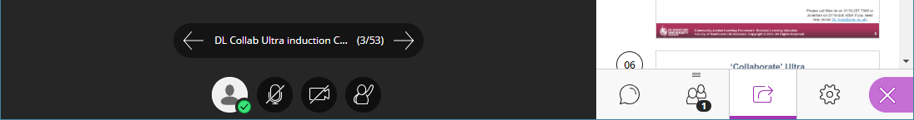

- If you want to jump over multiple slides, click on the thumbnail of the slide you want to show.
- To stop showing the slides use the Stop Sharing button.
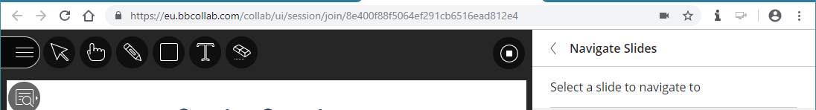

- Other content that can be shared is a Blank Whiteboard.

- Use the Whiteboard tools to write and draw on the Whiteboard.
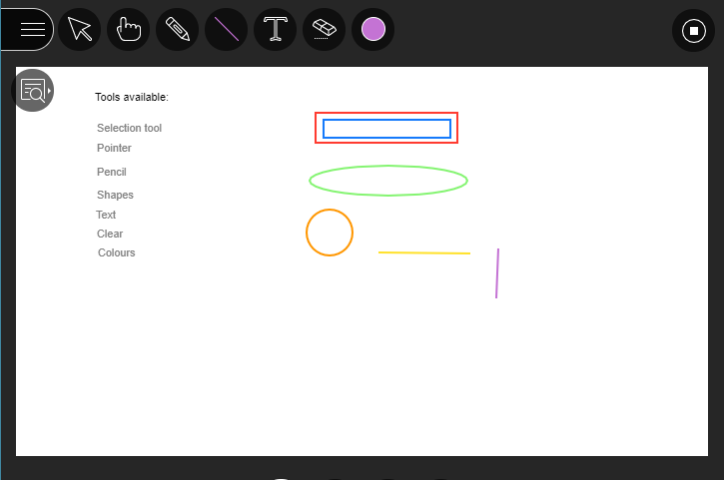

- Change the magnification of your viewing area by opening View Controls.
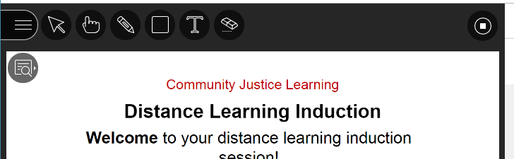

- The controls available are: Zoom In, Zoom Out, Best Fit and Actual Size.
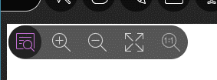

- Use Share Application/Screen to share a single application (computer programme) window, your whole screen (computer display) or a tab on your browser.
  - Click Share Application/Screen

  - Click Share to continue.
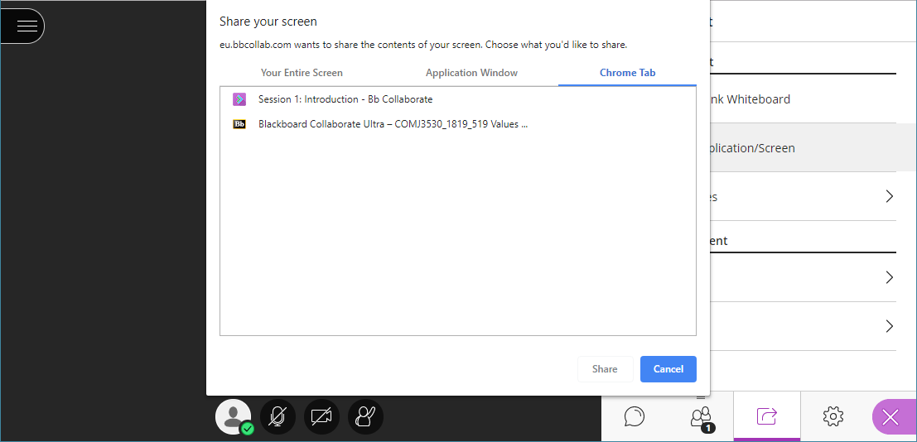

- This example is sharing the browser tab of Blackboard.
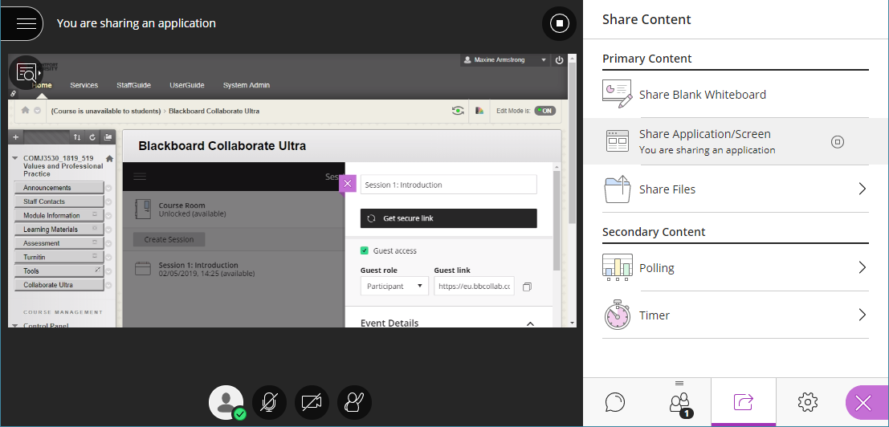

The Collaborate Panel – My Settings
- Select the My Settings tab, which is the forth tab along from the left.
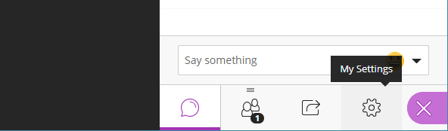

- The settings you can change during a session are audio and video settings, notification settings or session settings. Use the arrows to open each set.
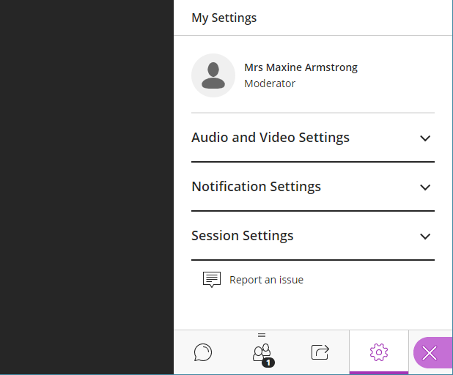

- Use the sliders to adjust the microphone or speaker volumes.
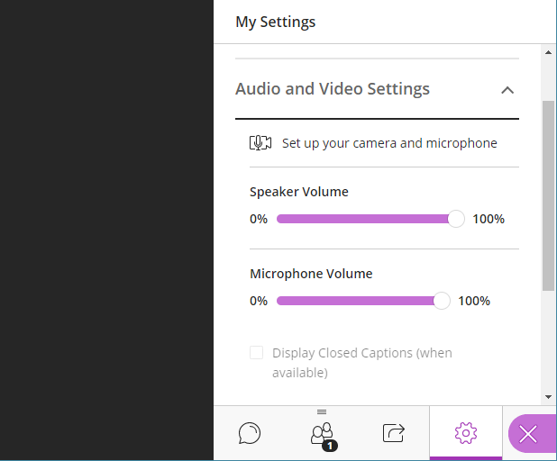

- Set up your camera and microphone if they need adjusting or selecting as you did when you first joined, see section 4.1.
- Audio or visual notifications can be turned on or off, by default they are turned on. Turning off the visual notifications only effects the banners, you can still monitor chat in the Collaborate panel.
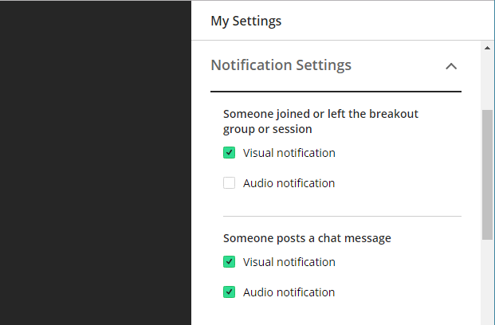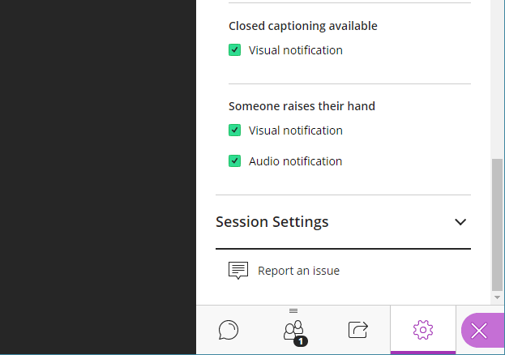

- By default, participants can share their audio and video, post chat messages and draw on the whiteboard or files. De-select to limit permission to only moderators and presenters.
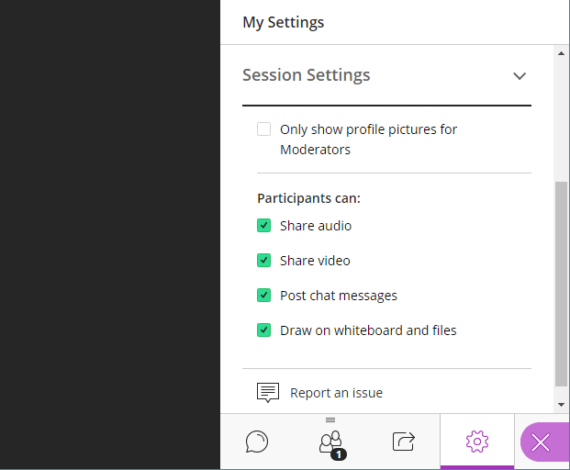

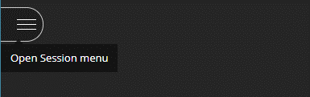
Recording a Session

- Open Session menu

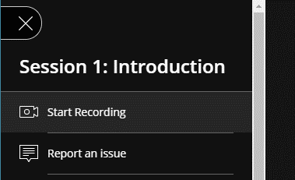
- Select Start Recording

- A recording icon is visible to show that the session is being recorded.

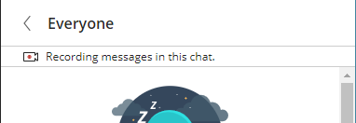
- There is also a notification to show that chat messages are being recorded.

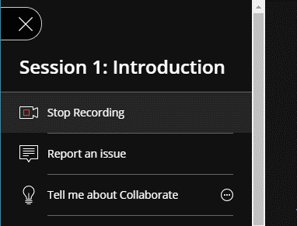
To stop recording:
- Open Session Menu
- Select Stop Recording

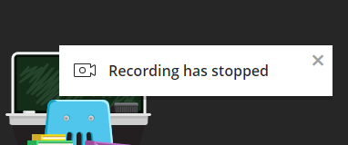
- There will then be a notification that the recording has stopped.

Deploying Recordings
Sessions are automatically made available within the Blackboard Collaborate Ultra tool.
- Open Menu (top left corner, icon looks like three horizontal lines).
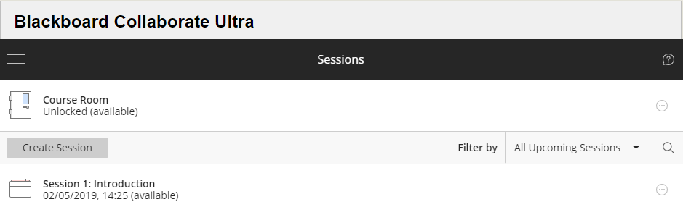

- Click on Recordings.
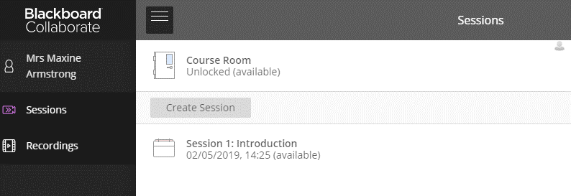

- Click on the recording to view
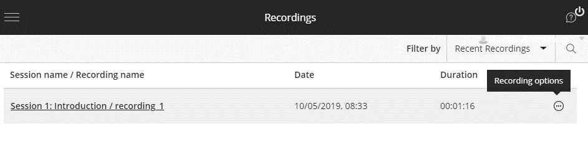

- Open recording options to edit, rename, copy link, delete or add captions file.

Copy a Recording link
If students attended a session that is not on their module shell or the recording needs to be deployed within a shell outside of the Bb Collaborate Ultra tool than the recording link can be copied.
- Open Menu (top left corner, icon looks like three horizontal lines).

- Click on Recordings.

- Open Recording Options (icon at end of row looks like three dots in a circle)

- Select Copy link
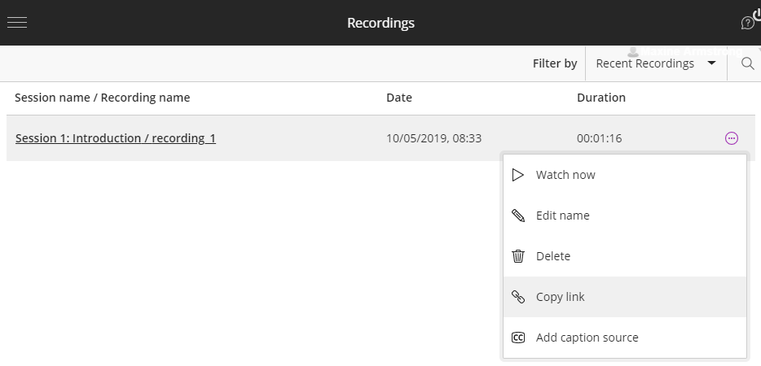

- The link is then copied to your clipboard.

Adding a Recording to DMU Replay
If students attended a session that is not on their module shell then the recording needs to be downloaded and added to DMU Replay.
- When the session is set up ensure the Allow recorded downloads box is ticked. If this is not done BEFORE the session is recorded then you will not be able to download it.
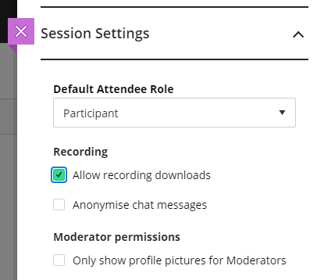

- Open the Blackboard Collaborate Ultra tool.
- Open Menu (top left corner, icon looks like three horizontal lines).

- Click on Recordings.

- Open Recording Options (icon at end of row looks like three dots in a circle)

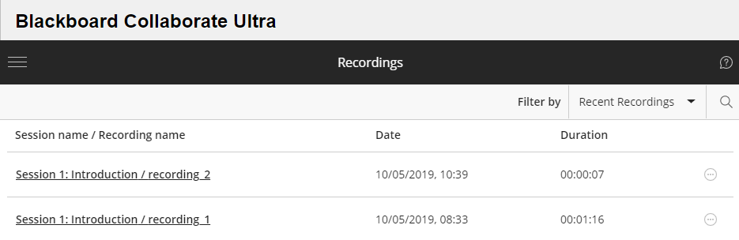

- Select Download
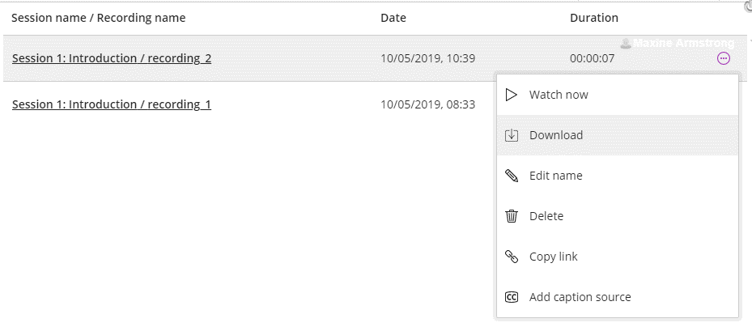

- Move or copy the file to suitable location where you can easily retrieve it. Usually the file has been saved to your Downloads folder and is called ‘collab-recording.mp4’.
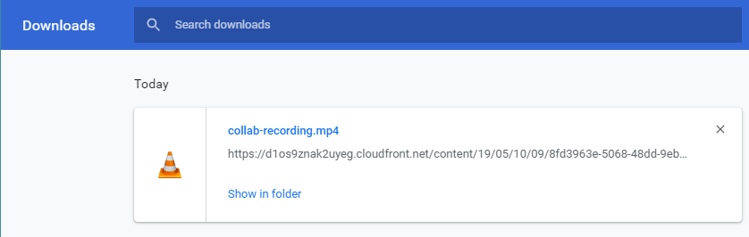
- Open DMU Replay
- Open folder for module
- Click on Create button to open drop down menu
- Select Upload media
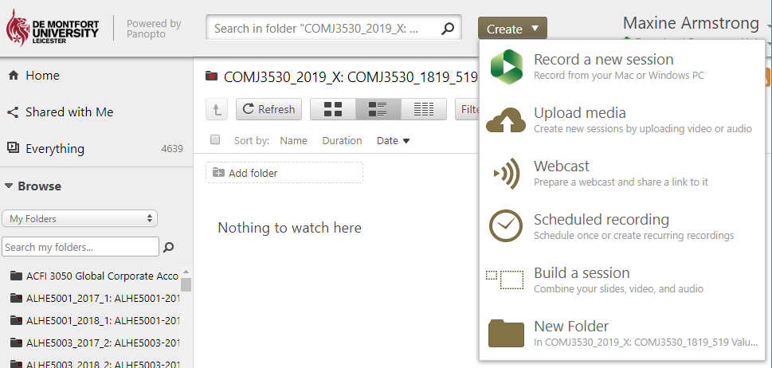

- Drag-and-drop the file over the box to upload.
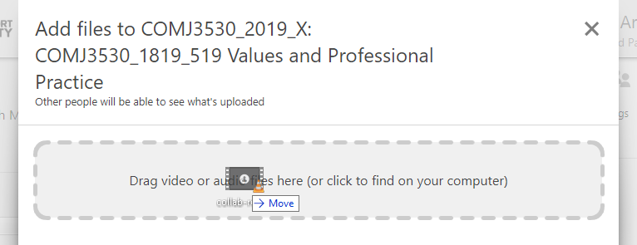

- Close the window after the file has uploaded.
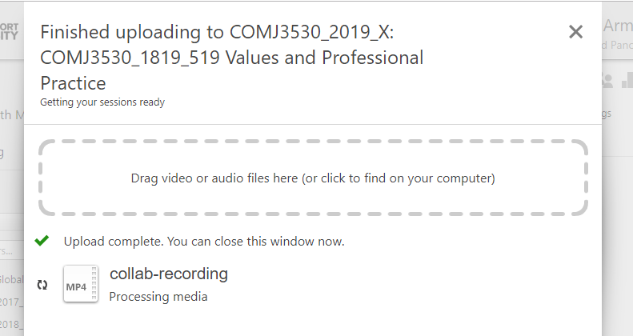

- When the file has been processed, you will receive an email. The recording can now be made available within the Blackboard shell. Choose an appropriate location, for example, add a folder called ‘Collaborate Session Recordings’ under ‘Collaborate Sessions’.

Preparing a Session
- Ensure you join a session before the students so you can prepare the session and sort out any technical issues you may have.
- Upload any files you intend to use during the session.
- Test any application or files you intend to share.
- Test your audio and video connections.
- If you intend to record the session, start recording when you are ready and the students have been pre-warned. You cannot edit recordings to trim them down or remove out sections, unless you download them as a video (mp4) and upload to DMU Replay.

Managing a Session
- Toggle the Mic button on and off to speak.
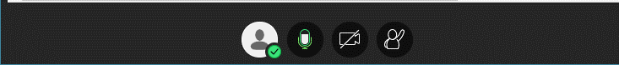

- Toggle the Video button on and off to show your webcam.
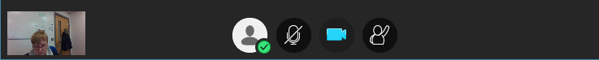

- Students can use the Raise Hand button to get your attention.
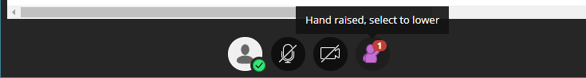

- Anyone who has raised their hands will be moved to the top of their role in the attendees list. They will also have an icon to show they have raised their hand.
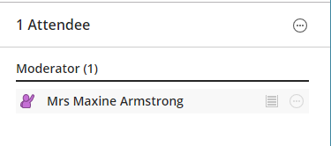

- My Status and Settings, shows your status and enables you to change settings during the session.
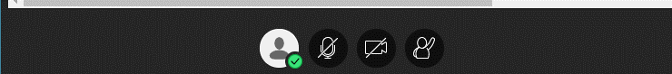

- Mark yourself away if you need to momentarily step away from the session.
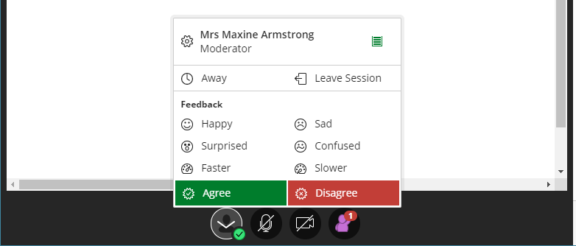

- Attendees can also leave the session and give feedback about the session as it is in progress.
- Feedback available: happy, sad, surprised, confused, faster, slower

- Feedback shows up in the attendees list.
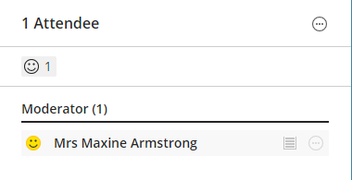

- You can use Agree/Disagree to quickly poll or get feedback from the students.
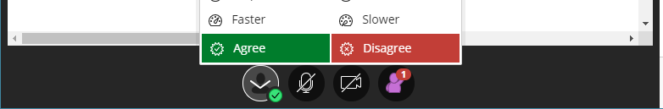

Other Useful Information

Attendance reports
- Session reports are available that provides an overview of attendance.
- Filter by All Previous Sessions
- Open Session Options
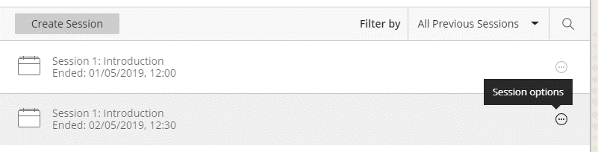

- Select View reports
- Report can be viewed online, printed or exported as a CSV file, which will open in Excel.

Setting Camera and Microphone Permissions
- You may need to check your browser permissions after the initial set-up. Different browsers show permissions from the address bar, click the information icon or padlock icon.
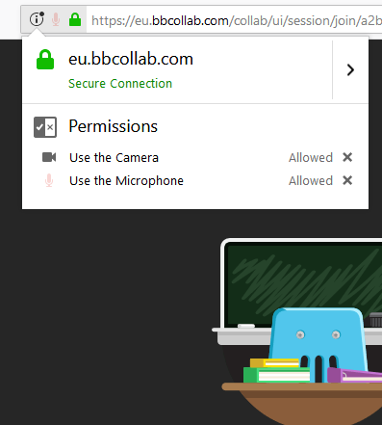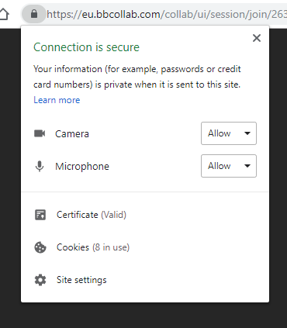

- If you have not granted permission to use the camera or microphone then Collaborate Ultra will seek permission when you join the session or when you try and use the microphone. Select your microphone if you have more than one and click ‘Allow’. If you tick the ‘Remember this decision’ box, it will be able to use it for future sessions.
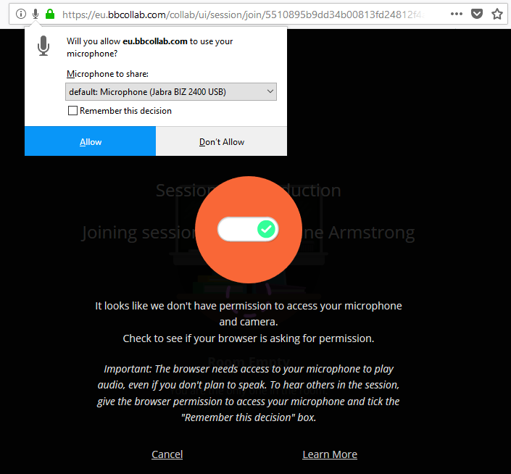

- If you want to check whether the browser has permission but you are not in a session, then open the ‘Menu’ and select ‘Options’.
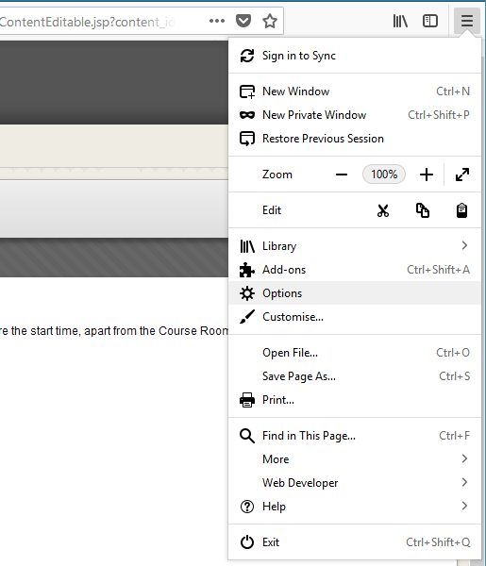

- Select ‘Privacy and Security’.
- Scroll down to ‘Permissions’ and click ‘Settings’ next to ‘Camera’ or ‘Microphone’.
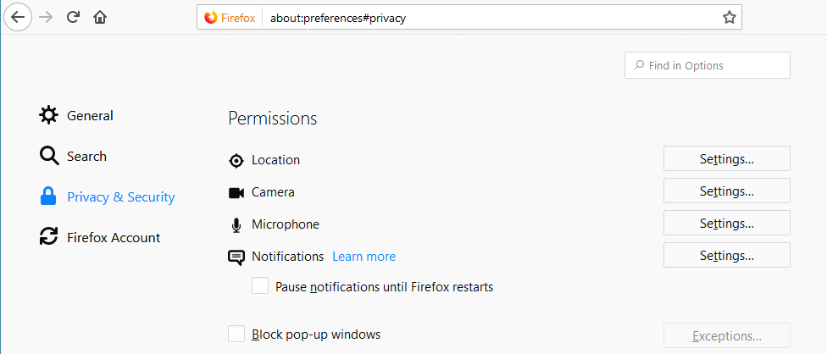

- You should be able to see https://eu.bbcollab.com listed under Web Sites.
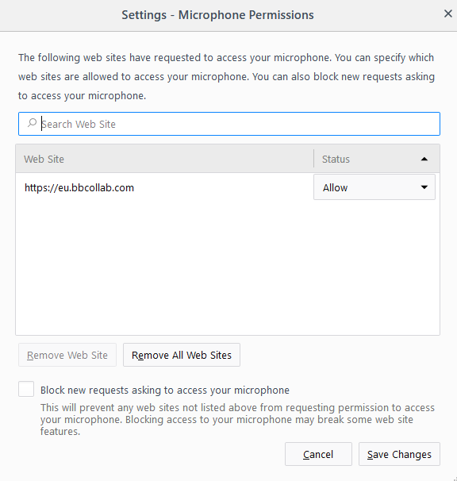 or 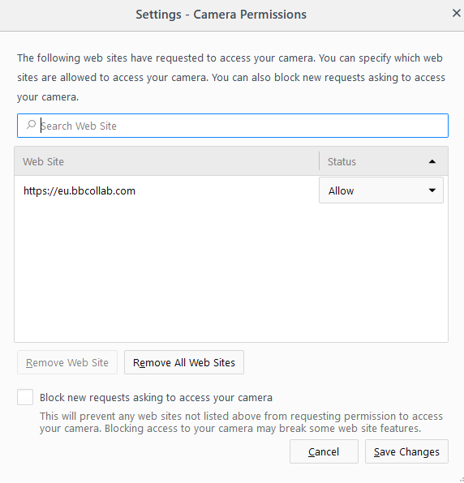

Collaborate Ultra for Groups
You are able to add the Collaborate Ultra tool to Blackboard groups. Tick the Blackboard Collaborate Ultra option when setting up the group and either allow or disallow students access to session recordings.

Troubleshooting during a Collaborate Session
Useful Links:
Blackboard: Collaborate Ultra Experience Help, https://help.blackboard.com/Collaborate/Ultra
Moderator FAQs, help.blackboard.com/Collaborate/Ultra/Moderator/Support/Moderator_FAQs

Accessing a Collaborate Session
Student can’t find Session link
- Open Blackboard
- Open Module
- Open Collaborate Ultra Session
- Ensure Sessions is visible not Recordings in Menu
- Select correct session date and time
Student is unable to find module on Blackboard
- If module is not under My Modules panel ask if they have fully enrolled? Ask them to contact the administrator
Student can’t Join Session
- Can student see Join Session button? (only available 30 mins before session start)
  - If yes, is student using Internet Explorer?
    - Collaborate Ultra is not supported on IE11, try using Google Chrome, Firefox or Edge.
  - If no, is it the correct session and is it in the timeframe session is available?
    - Have they previously tried to open it before the session was available? If so, the browser may be using an old cached version of web page. Ask them to clear their browser cache and try again. Ask them to Google their browser if they need advice on clearing their cache.
Error message opening Collaborate session
- Depends on error, suggest they try logging out, rebooting device and trying again. If still doesn’t work contact ITMS (0116-250 6050)

Within the Collaborate Session
Student can’t hear
- Are their headphones plugged in?
- Do the headphones have a mute button?
- Have they muted their device? Are their speakers muted?
- Is your speaker volume turned up?
Student can’t speak
- Have they switched on the talk button?
- Have they got a microphone/headset?
- Is the microphone switched on?
- Is the correct microphone selected within Collaborate Ultra?
- Did you mute the student or all students? The student can use the mic button to unmute themselves.

Sometimes logging off and rebooting device can solve an undiagnosed audio problem. Ensure the headset is plugged in before rebooting.
Student can’t use Whiteboard tools
- Are they using a tablet/smartphone? Tools may not be available to them.
- Have you set permission for students to use whiteboard tools?
Student has an audio delay
- Nothing you can really do about this as it is dependent on their network connection
- Could try closing cameras (videos) if using
Student keeps dropping out of session
- Nothing you can do about this as it is dependent on their network connection
- Could ask them to logout and reboot device, it might help
Developed and Produced by: Distance Learning Team, CELT, Library and Learning Services
© 2019 De Montfort University - All Rights Reserved

