IT Induction and support for learning technologies
This guide contains information about IT induction, learning technology, the Microsoft Imagine Academy (training courses for Microsoft technologies), Microsoft Office 365, ITMS contact details and assistive technology.

IT induction sessions
During your induction week you will be given an opportunity to see some of the various technologies that will be used by your lecturers and to learn how to access the Blackboard virtual learning environment (vle) and other student resources.
To log on to the university system and access the various student services, such as, your student email and the virtual learning environment (Blackboard), you will need to use the Single Sign-On.
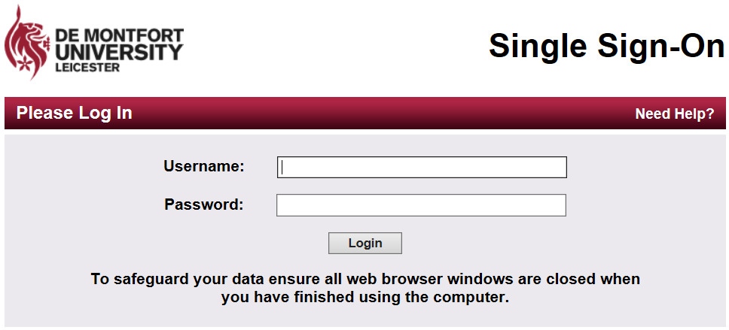
To Log In:
Your Username: will be the P number that you are given when you enrol and will be in the form P01234567 (P followed by eight numbers)
You will have been given your password as part of your induction.
You will be able to review the induction materials by using the links below:
- This link will take you to a copy of the Microsoft PowerPoint presentation used during your IT induction session.
- This link will take you to a Microsoft Word copy of the presentation used during your IT induction session.
- This link will take you to a recorded version of the IT induction session (closed captioning is included).
Please remember that it is always useful to attend the live event because there are often helpful questions and answers that will not be included in this recording.

Learning technology support
To help you understand and use the various learning technologies that are available at De Montfort University you should visit the students UserGuide tab in your Blackboard virtual learning environment (vle).
The IT induction session resources will show you how to access the Blackboard vle, this link will take you to the Blackboard vle (remember that you will need your username and password to sign in).

In the UserGuide tab you will have access to resources that will help you make the most from:
- Blackboard VLE - is the web based environment that is used to provide access to your programme and module materials, such as, assessments and learning resources.
- DMU Replay - a tool that allows you to replay staff led teaching sessions. This can help you recap learning and revise for exams.
- Turnitin - is a web based 'text matching' system that also allows your teacher to mark your work electronically.
- DMU Commons - this is a (WordPress) site that allows staff and students to blog and set up their own websites.
- Blackboard Collaborate - a virtual classroom that allows staff to facilitate learning and teaching events.
- Social Media - this provides advice and information about how to use the various social media tools that may be used in your course.
Please note that staff may only use some of these tools in their teaching but you are likely to experience most of them at some point during your time at DMU.
Blackboard supports the recent versions of four main internet browsers:
- Internet explorer v11, v10, v9
- Firefox
- Chrome
- Safari

Assistive technology
There are very many resources available to support learners with specific needs. Please see the library guide at this link for more information.

Microsoft Imagine Academy
De Montfort University subscribes to the Microsoft Imagine Academy, which offers access to on-line training courses free of charge for Microsoft Office and Microsoft Project. In addition, there are courses for those interested in technical applications such as Windows operating systems and server software.

Which course should I take?
There are in excess of 1500 courses available in a range of languages.
The full list of Microsoft Imagine Academy courses (in all available languages) is available from this link.
This documents is rather long I am afraid but you can search for a particular package (for instance Microsoft Word) by using the ‘Select and Find’ button to the far right hand side of the ‘Home’ tab. In the drop down menu select ‘Find’ and then type the software training that you are interested in, such as Word. If you click ‘find next’ at the bottom of the pop-up window it will move you down the list to the various Word training options.
When you have selected a course or courses (there is a maximum of three courses at a time) that you want to take do make sure that you note the ID number and course title.
Once you are enrolled and have started a course, you are allowed to use it for 150 days, giving you ample time to complete.

How do I enrol?
If you wish to enrol on a course please email microsoftit@dmu.ac.uk with;
- the Microsoft Imagine Academy course title
- the Microsoft Imagine Academy course ID number
- your student DMU email address
- your faculty or school
We will setup access to your chosen course or course’s and will explain how you can access the Microsoft Imagine Academy.

Microsoft Office 365
Office 365 is free to DMU students and offers a wide selection of useful apps. In addition to access to online access you can download the latest version of Microsoft Office to a maximum of 5 personal devices and you will have 1 Tb of online storage.
There are a number of resources to help you download and set up Office 365. The resources to help you set up Office 365 can be accessed at this link
You will need to sign in using your usual account details to access these resources.
If you have any problems accessing Office 365 you can email office365feedback@dmu.ac.uk or contact the ITMS service desk via the routes described on the ITMS support page, which is available via this link.

There are many resources available that can help you to get going with Office 365 and that can give you some ideas about how to use the various Apps available.
This link will take you to a selection of Office 365 resources
You will need to sign in using your usual account details to access these resources
There are very many more Microsoft training resources available via the Microsoft Imagine Academy. This link will take you to the Microsoft Imagine Academy resource page.

Inspiring Digital Enterprise Award (iDEA)
This award is free and can help you to develop a range of skills that will assist you in your studies, your employability and your life beyond university. Have a look at the information provided by the iDEA team at this link.
To help get you started you can register for the DMU Digital badge
All that you need to do is:
1. Sign up to iDEA at idea.org.uk and click HAVE A BADGE CODE.
2. Enter the badge code DMUDIGIT4L and press REDEEM to get your DMU Digital badge and your first points.

ITMS support
ITMS can provide support for a range of general computing issues, such as:
- Eduroam (secure wifi for all students)
- email
- printing
ITMS can be contacted at the ITMS service desk in the Kimberlin Library on floor 1
email: itmsservicedesk@dmu.ac.uk
phone number: +44 (0)116 250 6050
internal phone number: ext 6050

