Sharing QuickMarks in Turnitin
If you want to be able to use the same set of bespoke QuickMarks across a programme/module team. Follow this guide.
1. Navigate to any module which has Turnitin submissions, and from the Course Tools menu select Turnitin Assignments
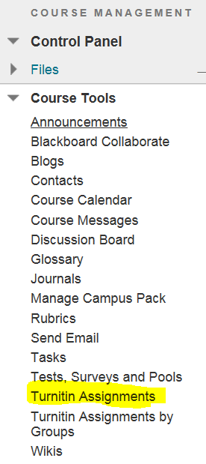
2. Click on an assignment in the list
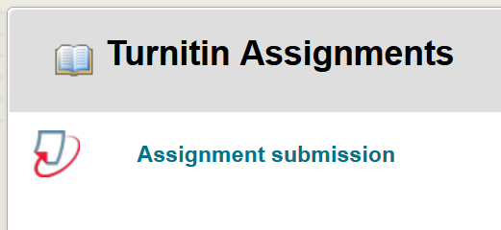
3. Click the Libraries tab
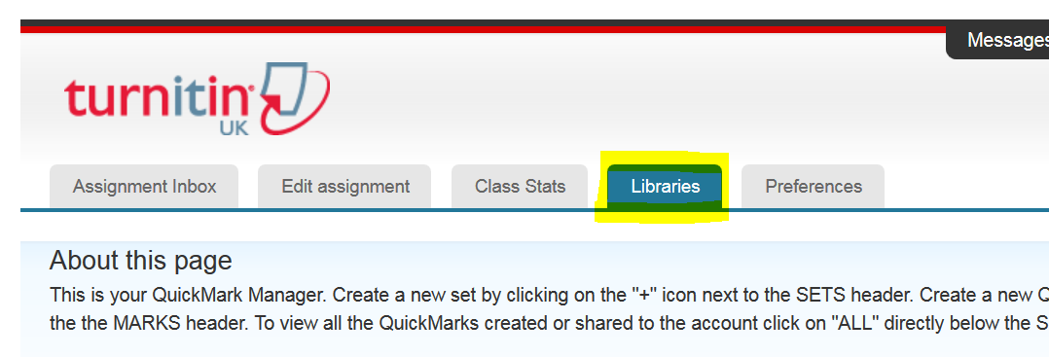
4. In the Quick Marks Manager panel, click and highlight the QuickMark set that you want to share.
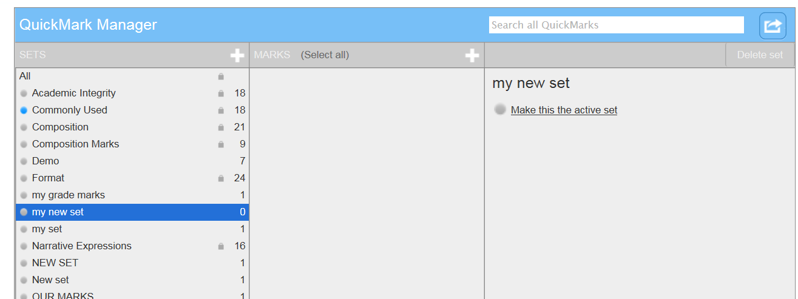
5. Click the Import/Export icon at the right of the panel and select Export Set…
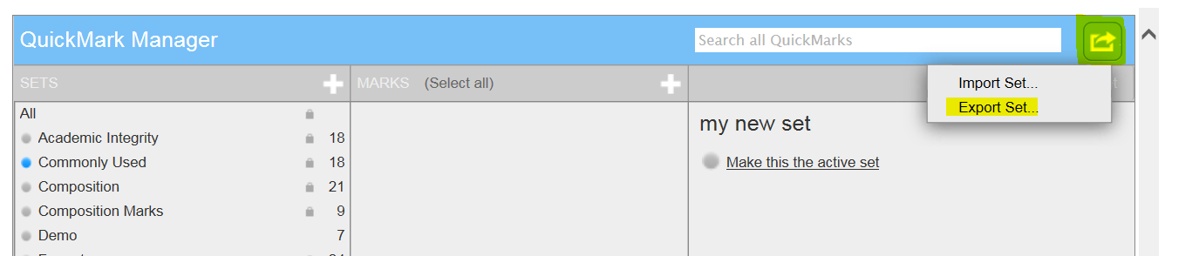
6. Click the Save button in the panel that appears at the bottom of your screen
7. Close the panel
8. Locate the exported file in the Downloads folder on your computer
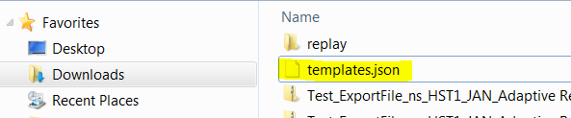
9. Email this file to anyone who you want to be able to use the QuickMarks
Importing QuickMarks
When you have received an email containing a QuickMarks file
1. Right-click the file attachment in the email and select Save As – save the file to your computer (remembering where you saved it to!)
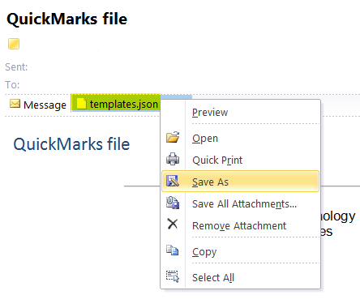
2. Navigate to any module which has Turnitin submissions, and from the Course Tools menu select Turnitin Assignments
3. Click the assignment link
4. Click the Libraries tab
5. Click the Import/Export icon at the right of the panel and select Import Set…
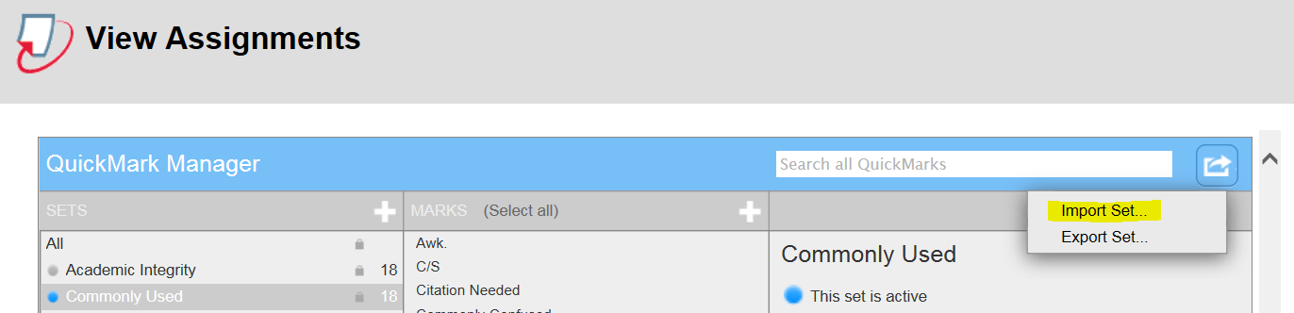
6. Click Browse and locate the QuickMark file in your computer
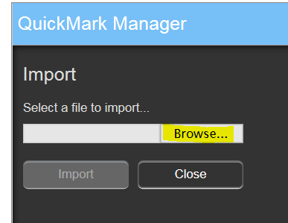
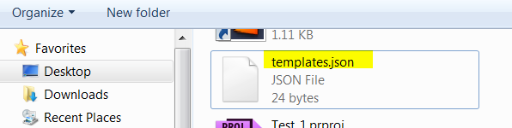
7. Click the Open button
8. Click Import
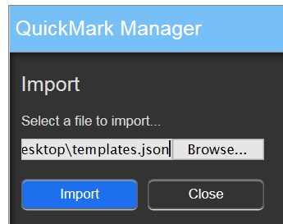

8. Click Close
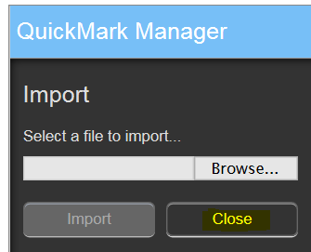
9. The QuickMarks will be added to your list of available QuickMarks and you will be able to use them when marking any Turnitin submissions in any module.

