Use the Blockbuster Quiz template to create a new quiz
1. In preparation – create a MS Word document with all of the questions that you want to add.

2. Download the Blockbuster Quiz template from the CELT Hub
3. Open the Blockbuster template in PowerPoint
4. New questions must be added one at a time in the numbered order 1 to 25.
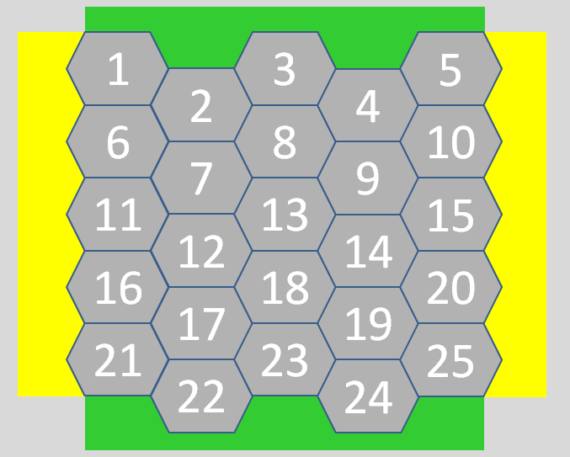
5. Change the number in the grey hexagon to the letter that matches your answer. Do this by highlighting the number and typing in the new letter.
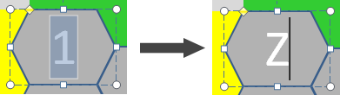
6. Change the matching number in the 'Choose a question' selection grid to match the letter on the hexagon.To do this, highlight the number and then type in the new letter.
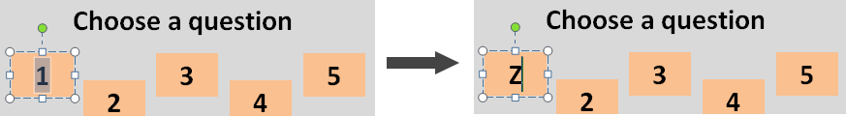
7. To add a new question, copy the question text from the Microsoft word document
and paste this question text into the question area on the powerpoint template (the blue rectangle at the bottom of the page)
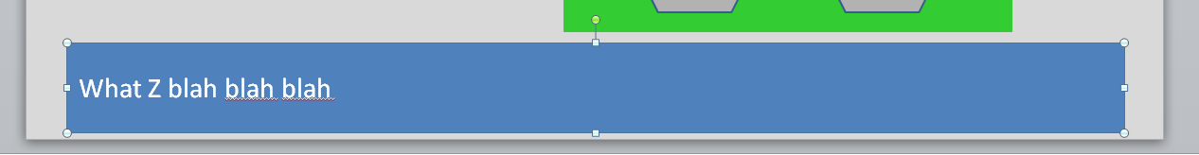
8. Click the Arrange tool and select Send to Back
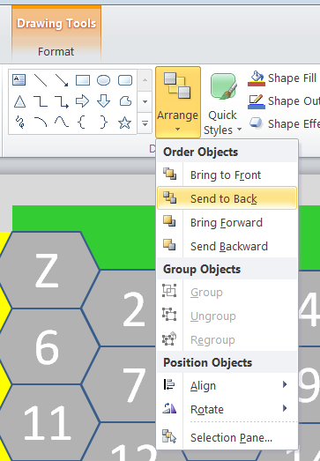
The current question area will disappear, to reveal the next question area.
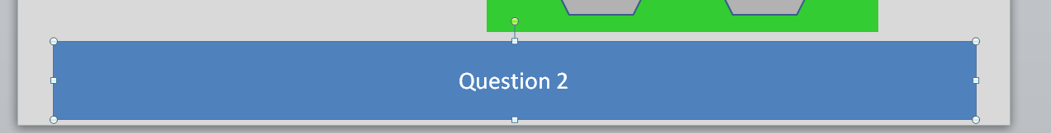
9. Repeat this process (steps 5-8) for all of the 25 questions (one by one in numerical order) - when you have done this the Extra question 1 rectangle will be visible
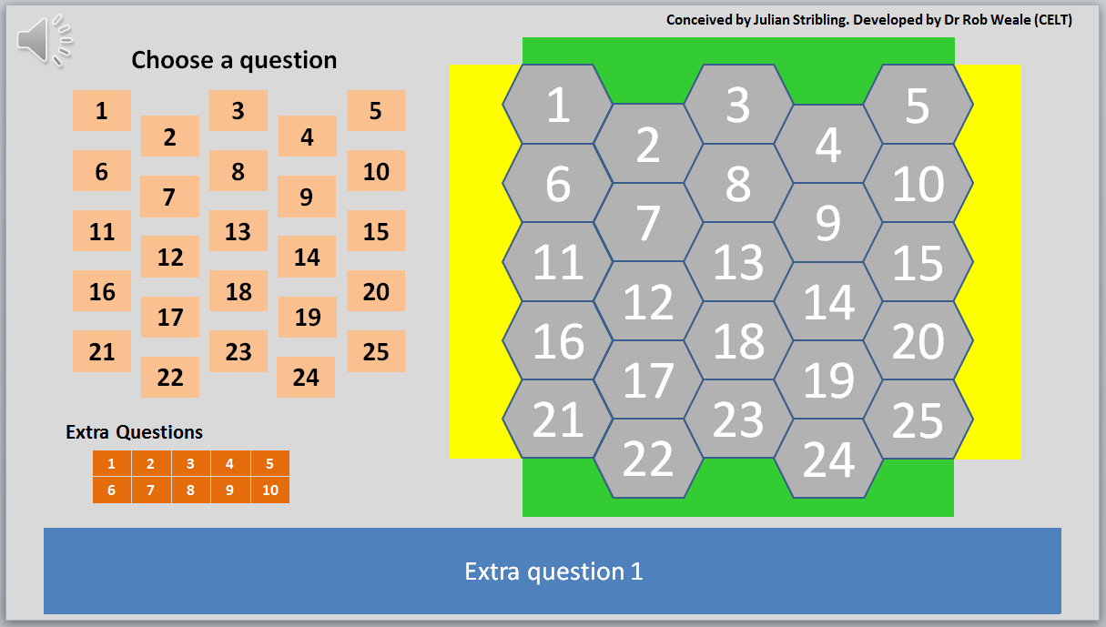
10. Add the extra questions (you will just need to add the question text to each of the blue question rectangles), remember to send each rectangle to the back when you have added the question text.
11. When all of the extra questions have been added - click anywhere on the grey background rectangle to highlight it.
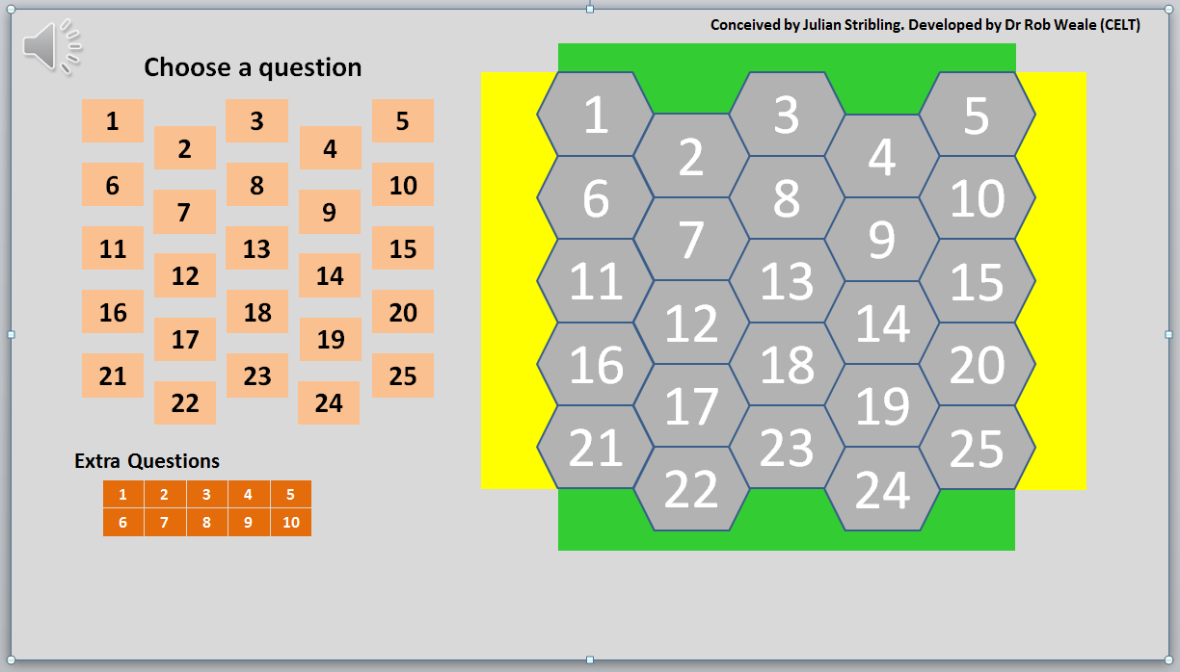
12. Click the Arrange tool and select Send to Back
The template should now look like this.
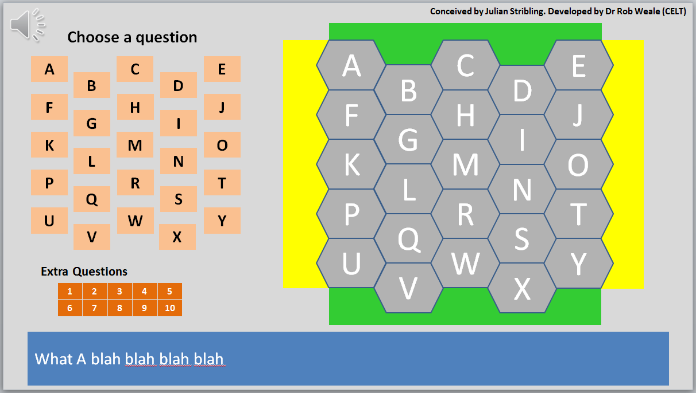
13. Save your new Blockbuster Quiz

