Bulk downloading student grading and feedback documents from Turnitin
1. In the module, click the Turnitin Assignment link in the Course Tools menu
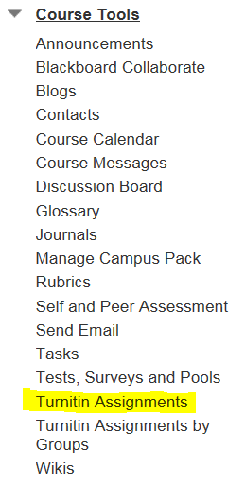
2. In the Turnitin Assignments list click the assignment for which you want to download the grading documents
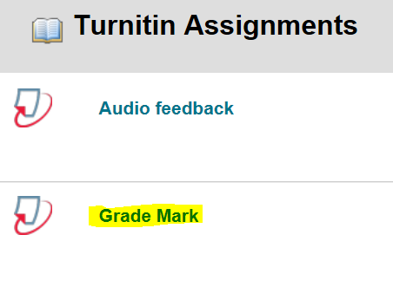
3. Click the checkbox at the top left of the submission list – this will select ALL of the student submissions; even if they are spread across several pages.
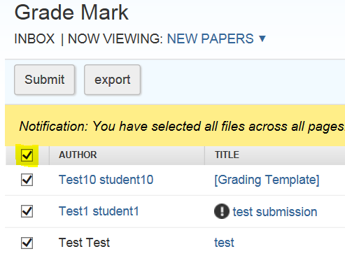
4. Click the Download button on the right, and then click the Online Grading Paper option
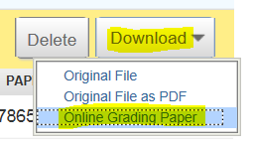
5. Click OK
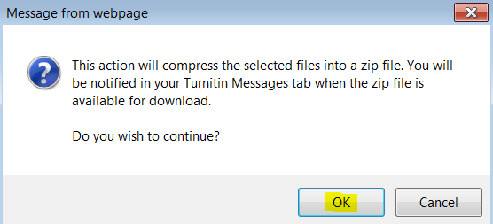
6. The following message will appear
7. Click on the Messages tab at the top right of Assignment list
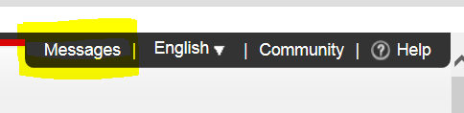
8. There should be a new message. Click on the Message link. (If there is no new message try refreshing your web browser).
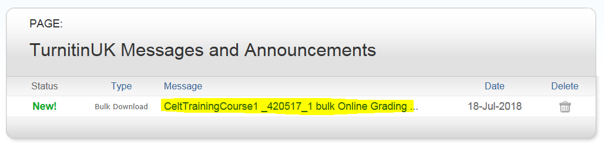
9. Then click the zip download link
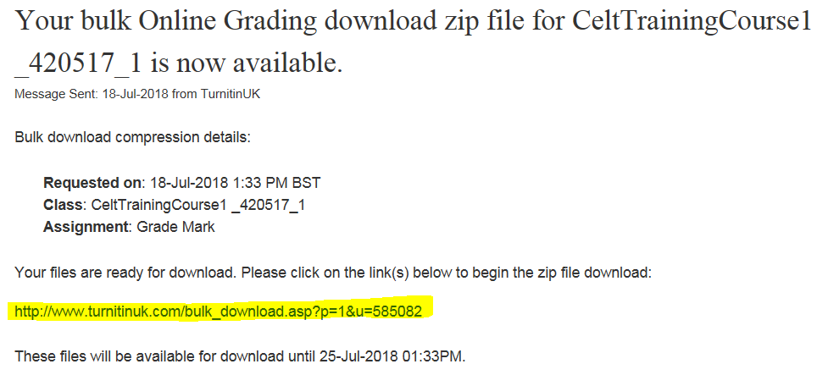
10. A message will appear at the bottom of the screen. Click Save. This will save the files to the Downloads folder on your desktop computer.
11. Click Open Folder
12. Locate the Turnitin bulk Download zip file in the Downloads folder – double left click to open it.
13. The folder will contain a list of all of the online grading and feedback documents in PDF format.
