Delete a student submission in Turnitin
You may encounter a situation where a student has submitted an assignment to the wrong Turnitin submission link. To rectify this you can delete the submission and ask the student to re-submit to the correct submission link.
To delete a submission:
1. Navigate to the Turnitin assignment inbox where the rogue assignment has been submitted
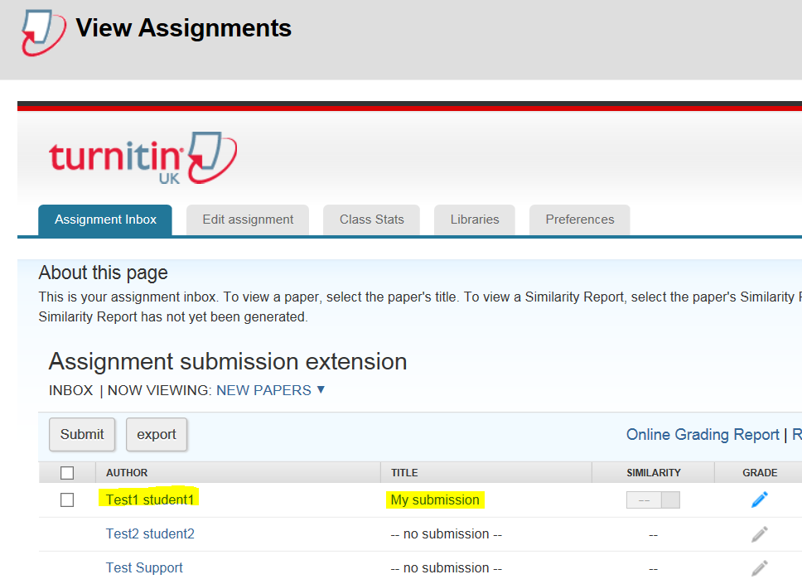
2. Click the checkbox next to the name of the student whose submission you want to delete, then click the Delete button
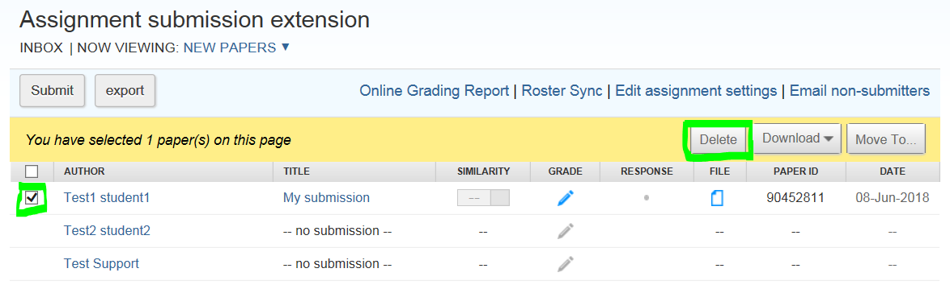
3. Click OK
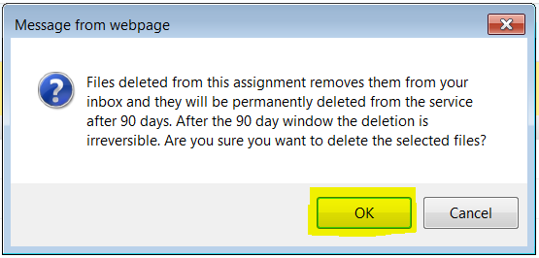
The submission will be deleted

