Making a DMU Replay recording available to persons outside DMU
1. Navigate to the DMU Replay server (http://panopto.dmu.ac.uk) and locate the recording you wish to share.
2. Hover your cursor over the recording and click the Share button.
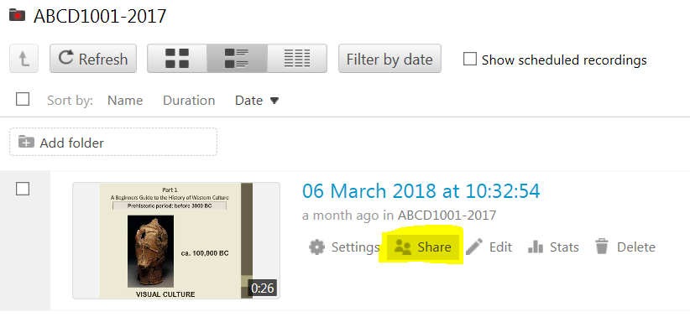
3. Click on the little arrow in Who has access panel.
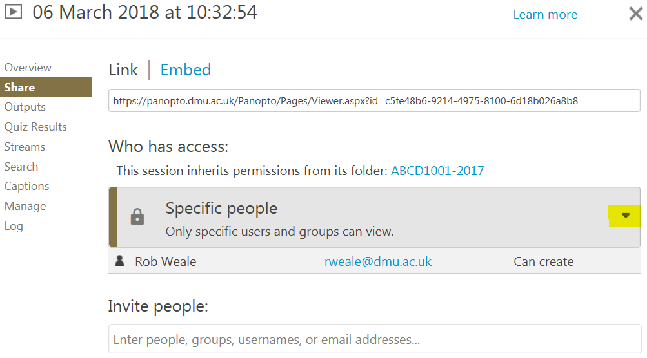
4. Click the Anyone with the link option
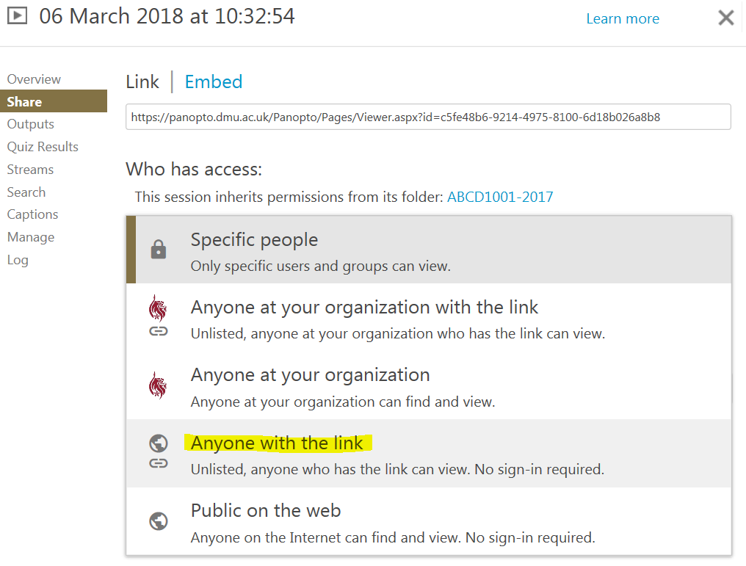
5. Copy the recording link, and send this link to whomever you want to view the recording.
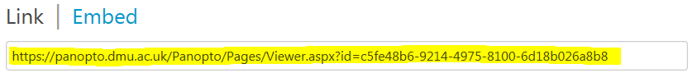
IMPORTANT NOTE: Anyone who has the link to the recording can access it. So if any of the people you have given the link to share it with other people, they will also be able to view the recording.

