Downloading and saving an originality report in Turnitin
It may be necessary in cases of suspected bad academic practice (e.g. plagiarism) to download and save evidence from the Turnitin originality report.
To do this:
1. Navigate to the student submission list in Turnitin as usual, and click the similarity percentage for the submission you wish to download
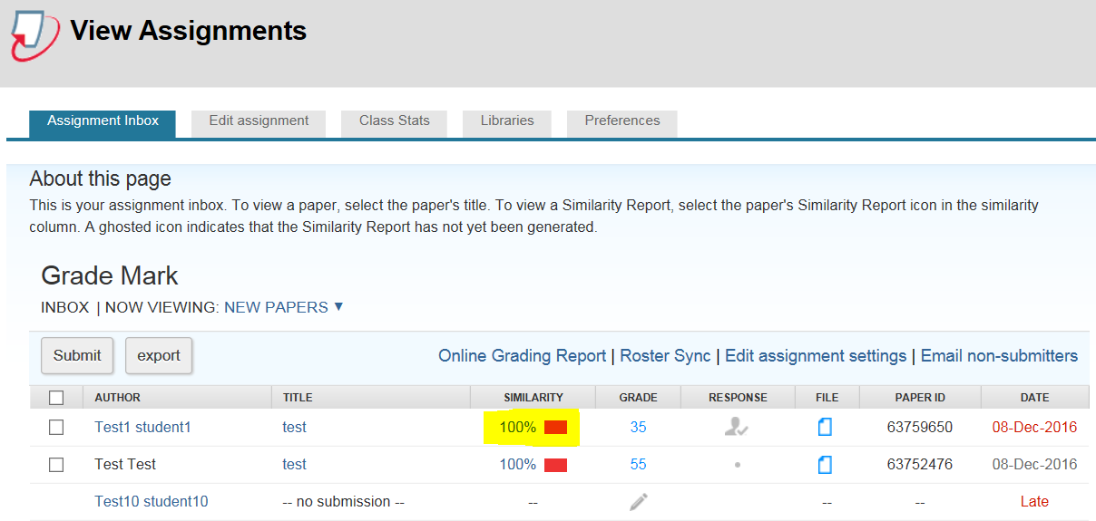
2. In the similarity report view, click the Download button (highlighted)
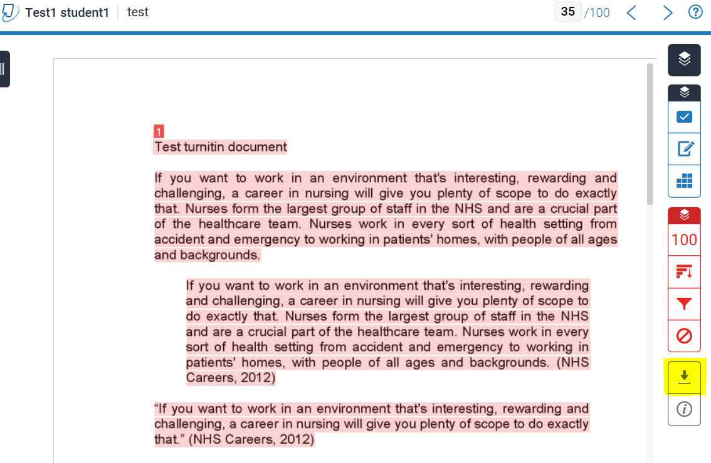
3. In the download panel, click the Current View option
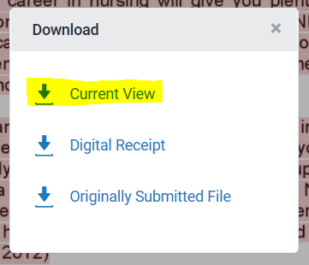
4. In the panel that appears at the bottom of your screen, click the small triangle to the right of the save button and select the Save as option; then save the file to the folder of your choice on your computer.
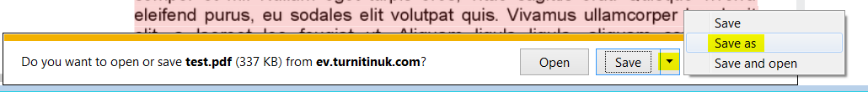
5. The turnitin originality report will be saved as a pdf file. The pdf will contain a basic overview of the similarity scores.
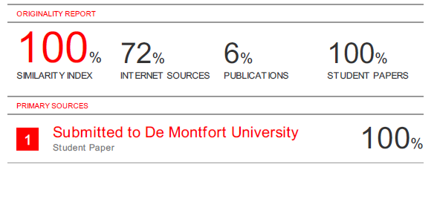
If you need to download and save examples of specific sources of text matches within a Turnitin submission, rather than a general overview of the similarity report.
1. In the similarity view, click the All Sources button
2. In the All Sources list, click the source that you wish to highlight in the similarity view
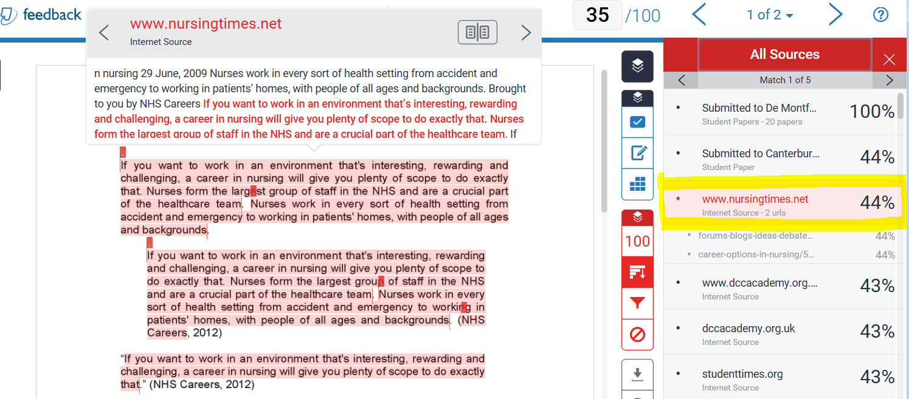
3. In the similarity report view, click the Download button (highlighted)
4. In the download panel, click the Current View option
5. In the panel that appears at the bottom of your screen, click the small triangle to the right of the save button and select the Save as option; then save the file to the folder of your choice on your computer.
6. The pdf file generated will include the matching text and the specific source to which the text is matched.
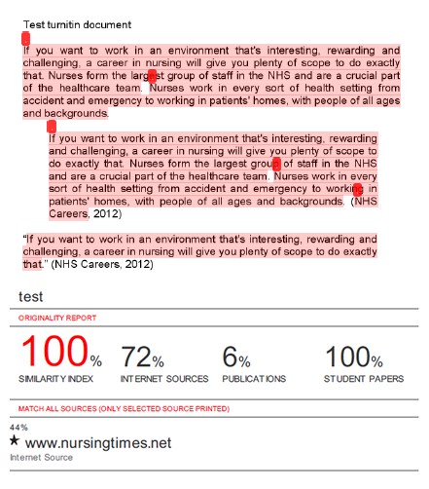
If you want to show multiple specific matched sources, you will need to download and save a report for each of the specific matched sources.

