Download an original document file submitted to Turnitin
1. In Blackboard, navigate to the Turnitin assessment inbox as usual
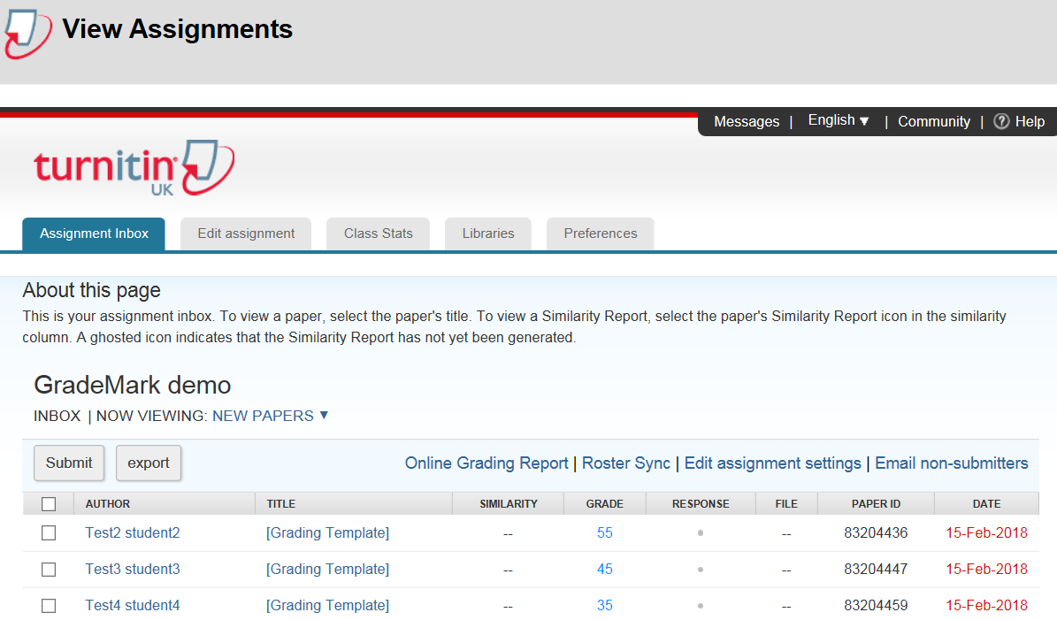
2. Click the checkbox of the submission that you want to download
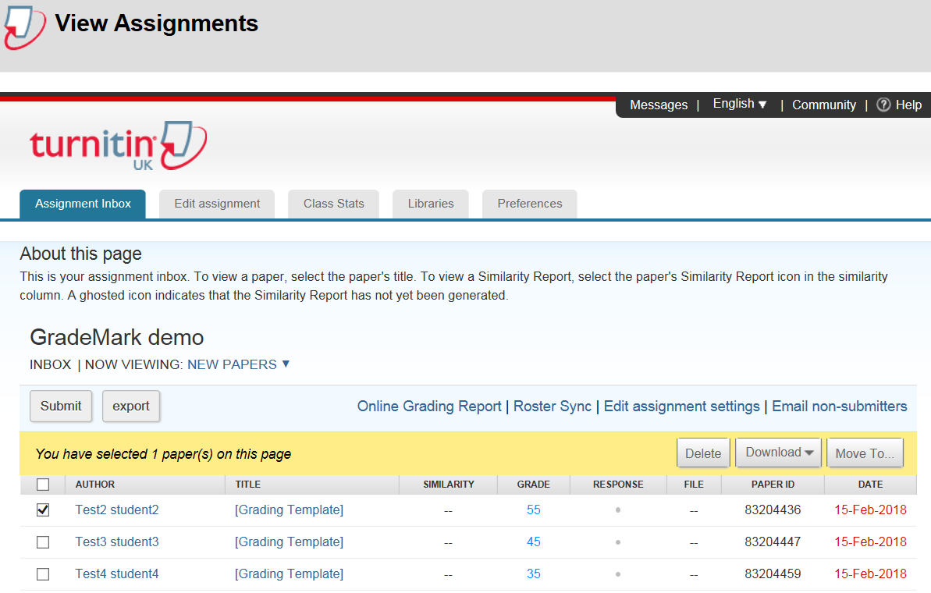
3. Click the Download menu and then click Original File
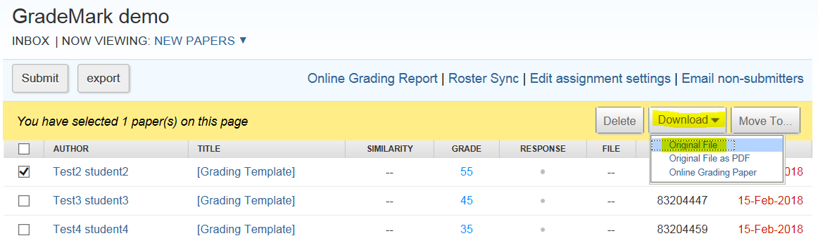
4. The following message will appear; click OK
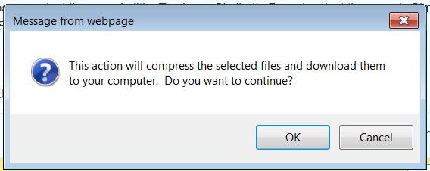
5. The following message will appear
6. When the above panel disappears, click the Messages tab
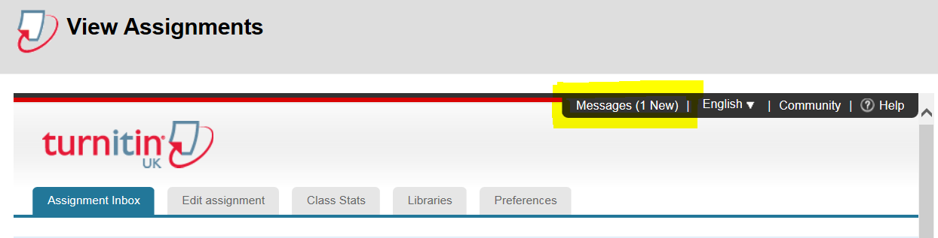
7. Click the file link in the Message column
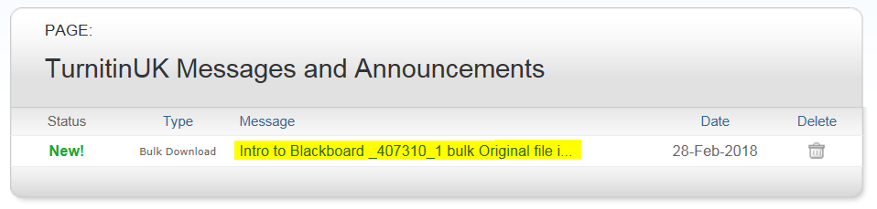
8. Click the file download link
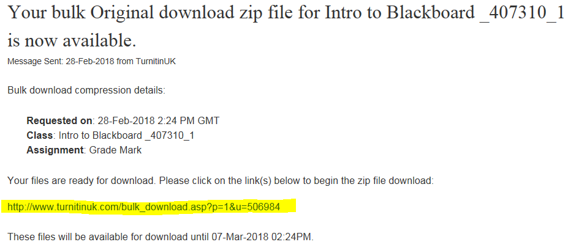
9. You will be asked if you want to Open or Save the file; select Open
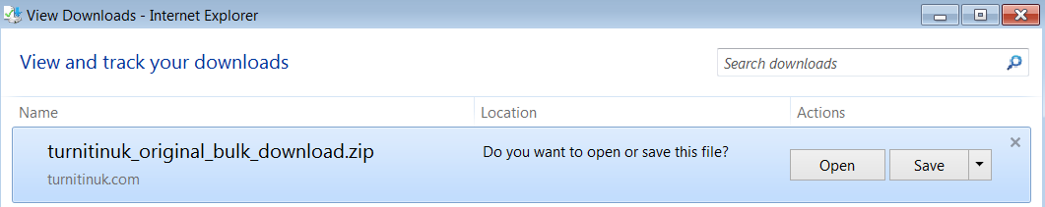
10. The document file will be made available to you – double click to open it.
