Using the Snipping tool to take a snapshot of an area on your computer screen
1. Click the Snipping tool icon in your taskbar
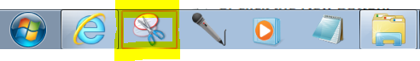
a) if you cannot see the Snipping tool in your taskbar; click the Start icon 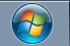 and select All Programs
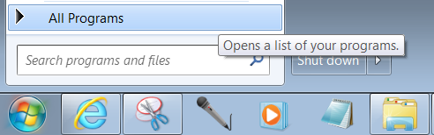
b) From the list of folders click Accessories
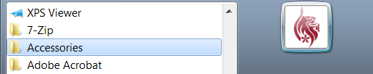
c) Click Snipping Tool
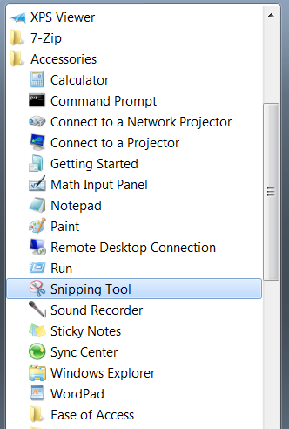
2. The Snipping tool panel will appear
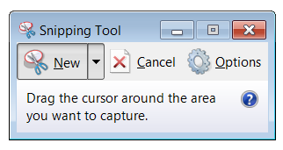
3. To use the Snipping tool – left click on the computer screen, hold down the mouse button, and drag the cursor to draw a red square/rectangle around the area that you want to take a picture of
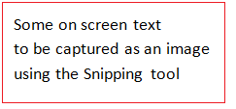
4. When you release the mouse button a picture will be taken of the area that you selected, and will displayed in the Snipping tool panel
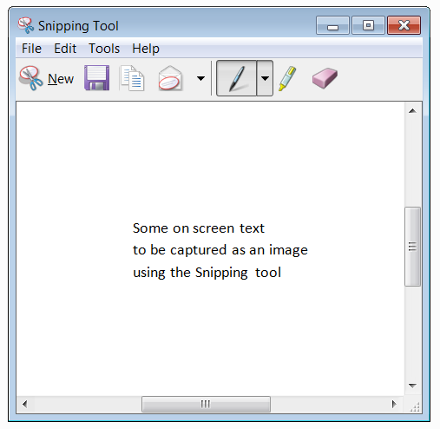
5. You can save a copy of your picture to your computer via the File/Save menu in the Snipping tool
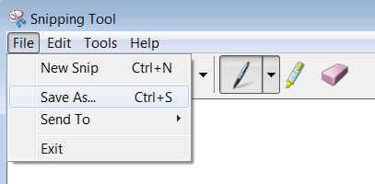
6. To create a new snip, click the New tab in the Snipping Tool panel
