Checking that the microphone is setup correctly for DMU Replay recording in the classroom
When recording in DMU Replay it is important to check that the selected microphone is picking up the sound of your voice. If the microphone is not correctly picking up the sound this can result in a recording that cannot be used.
1. Log in to the DMU Replay software as usual
2. Ensure that the correct microphone (e.g. DMU Replay Lectern Microphone) is selected in the Audio section
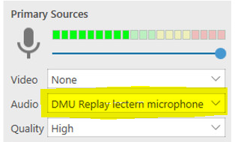
3. If the correct microphone is not selected, click the grey arrow to the right of the Audio area and select the microphone from the dropdown menu
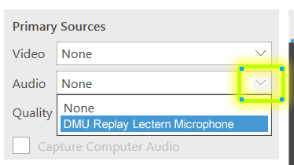
3. Begin to speak – if you see the audio meter moving as you speak – the audio is set correctly and you can commence your recording.
The audio meter is the multi coloured strip just underneath Primary Sources
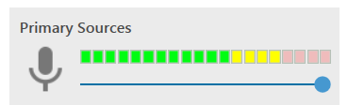
4. If you have selected the microphone, but the meter DOES NOT move when you speak:
a) Ensure that the microphone volume control is set to maximum by clicking and sliding the volume control button all the way to the right.
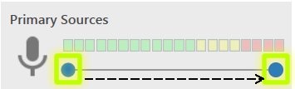
Begin to speak – if you see the audio meter moving as you speak – the audio is set correctly and you can commence your recording.
If the meter is still not moving:
b) Check that the lectern microphone is switched on.
This only applies to lecterns with a ‘Goose Neck’ style microphone. If the red button on the front of the microphone base is not lit. The microphone is OFF.
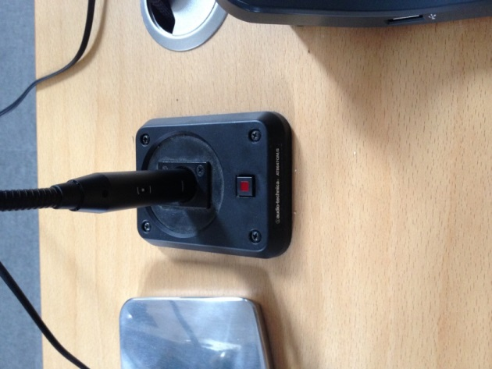
Press the button, and it will light – indicating that the microphone is switched ON.
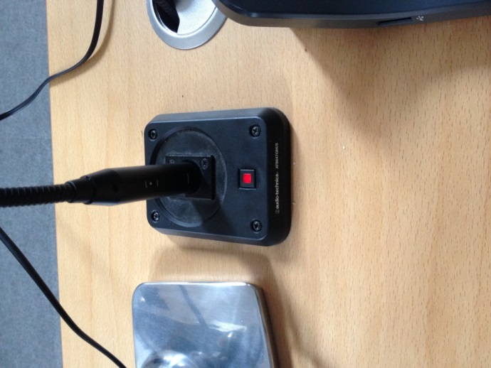
Begin to speak – if you see the audio meter moving as you speak – the audio is set correctly and you can commence your recording.
If the audio meter is still not moving – there may be a problem with the system and you should call ITMS immediately.

