Self-enrol on a Blackboard community shell
Some Blackboard community shells are set up so that academic staff can self-enrol on them. To self-enrol on a Blackboard community shell.
1. Log in to Blackboard and look through your home page for the Self enrol Communities panel
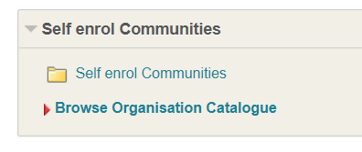
if you cannot see the panel
a) Click the Add Resource button in the top left of your Blackboard home page
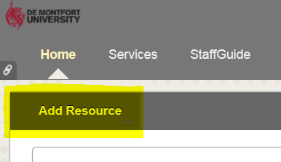
b) locate the Self enrol Communities widget and click the Add button
You will now be able to see the Self enrol Communities panel on your Blackboard Home page
2. Click Browse Organisational Catalogue
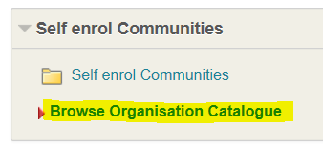
3. Enter the name of the Community shell on which you want to enrol in the search area and click Go
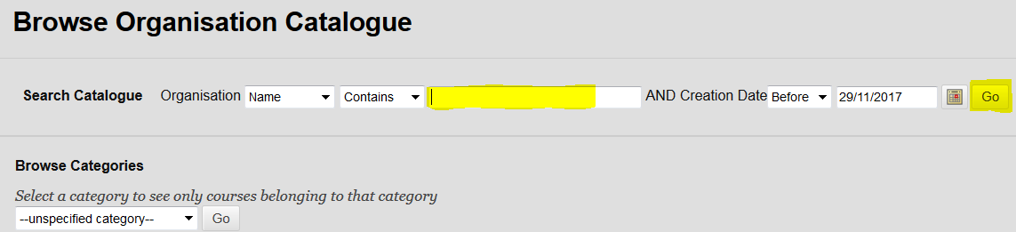
4. Click the grey button next to the Community shell name
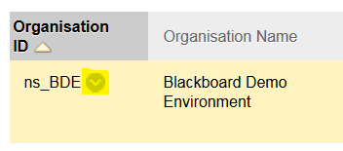
and select the Enrol option
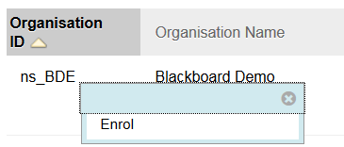
5. Click the Submit button
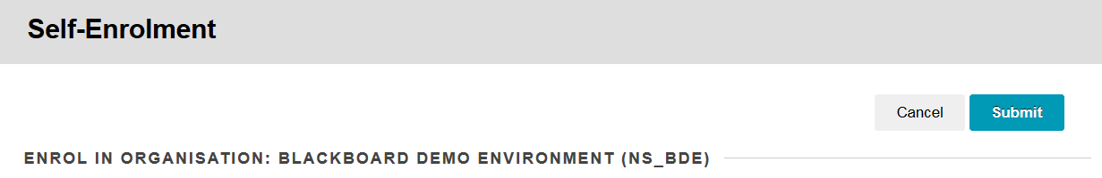
6. You will receive a success message - click OK
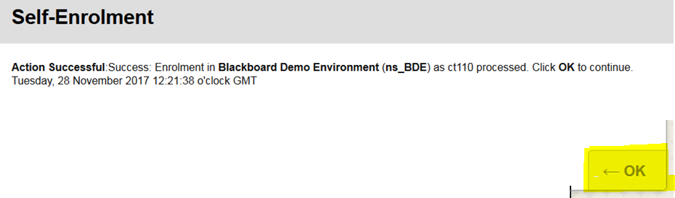
7. You should now see the Community shell listed in the My Communities panel on your Blackboard home page
