**Copying Blackboard tests and surveys into different modules**

To copy tests or surveys from one module into another:

1. In the module where the tests/surveys that you want to copy are located, select **Course Copy** from the Packages and Utilities menu

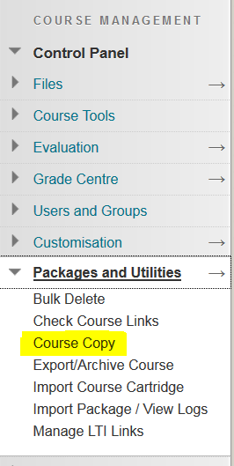

2. To set the destination module, click the **Browse** button

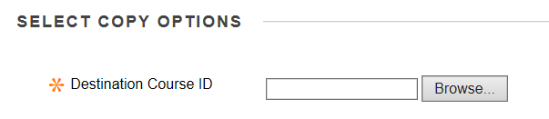

3. From the list of modules, select the course into which you want to copy the tests/surveys

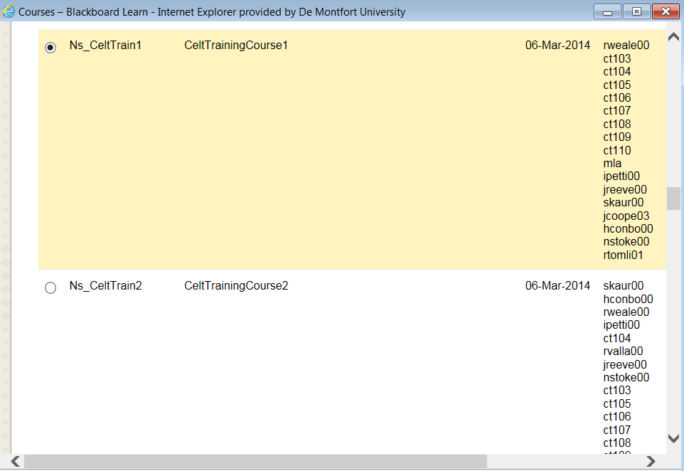

4. Scroll to the bottom of the list and click **Submit**

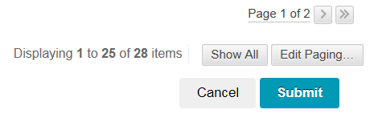

From the list of things to copy check **Tests, Surveys and Pools** (ONLY), and click **Submit**

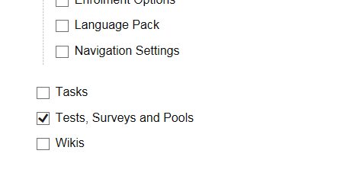

The tests and surveys will be copied into the destination module where you can edit and deploy them as usual. You will receive an email confirming that they have been copied.