DMU Replay – provisioning a module: method 2
If you can see a Tools option in the main navigation menu, then skip to step 5
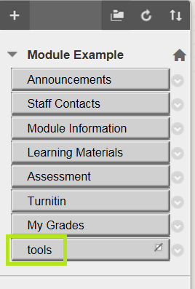
If not . . .
1. In the main navigation menu click the plus sign (+) and select Tool Link
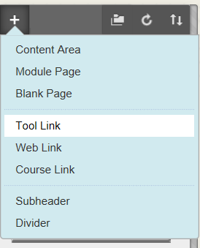
2. Type a Name (you can put anything), and click the grey arrow to the right of Announcements
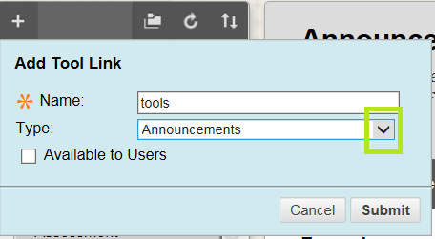
3. From the list select Tools Area
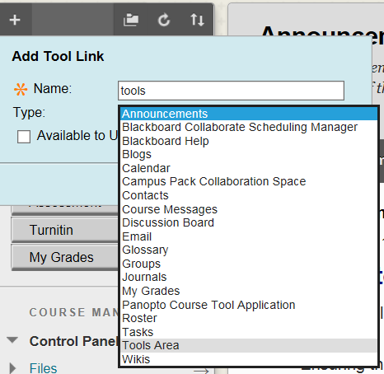
4. DO NOT make the link available to users – click the Submit button
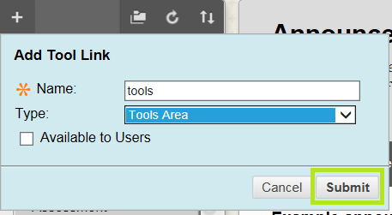
5. Click on the tools link that you just added to your menu
6. Click the Panopto Content option (not the Hide Link button)
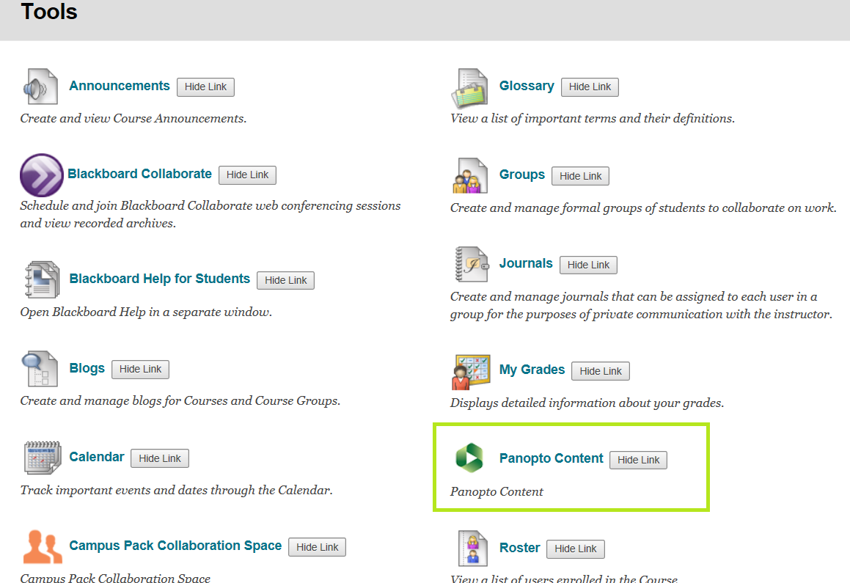
7. Click the Configure button
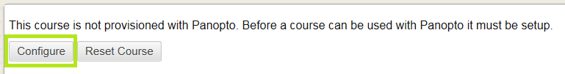
8. Click the Add Course to Panopto button
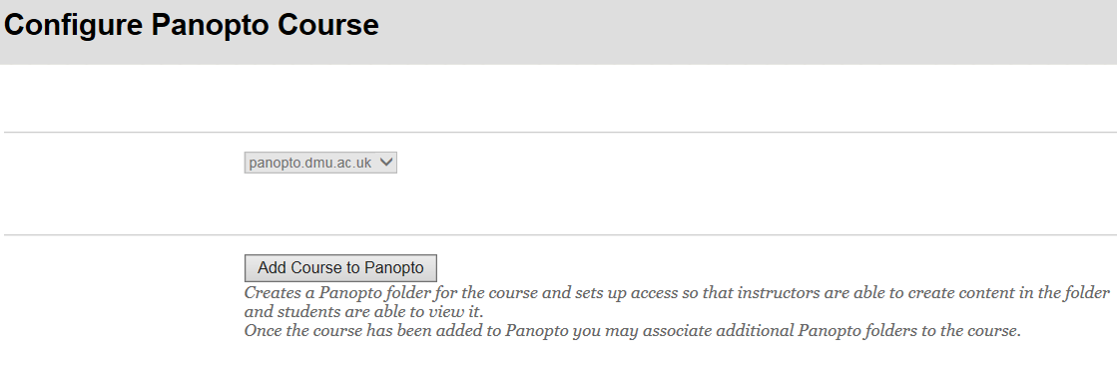
9. Click the OK button
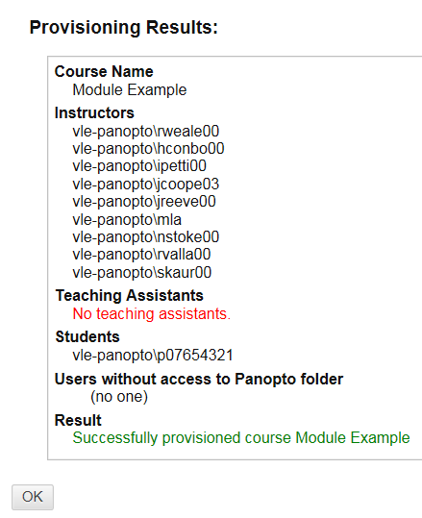
10. Click the Submit button
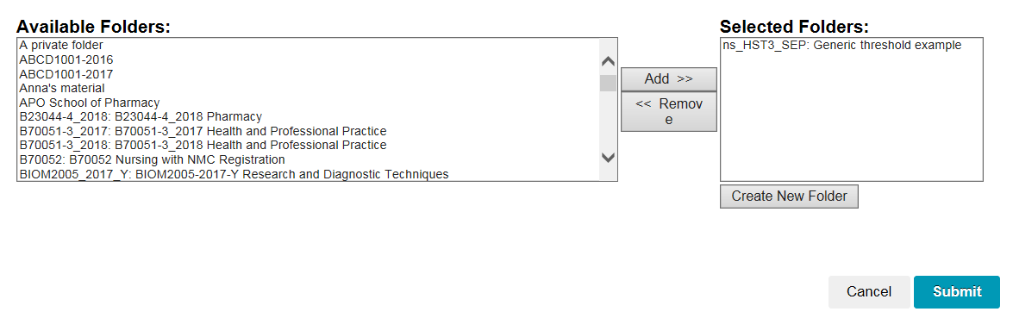
Your module will now be provisioned to accept DMU Replay recordings.

