Roster Sync in Turnitin
If when trying to mark student submissions in Turnitin you are not able to see all of the students who should be enrolled on the module, you may need to run a Roster Sync process – as follows:
1. In your module, navigate to your list of Turnitin Assignments as usual via the Course Tools in the Control Panel
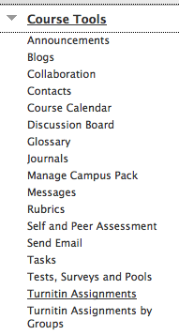
2. From the list, click on the title of the appropriate assignment
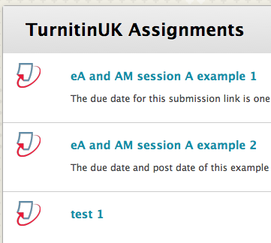
3. Click the Roster Sync button and the class roster will be synchronised
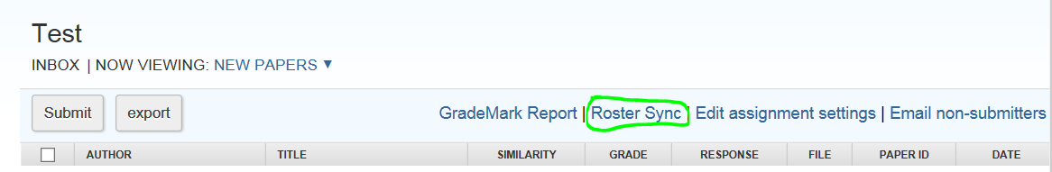
4. Refresh your web browser using the F5 key at the top of your computer keyboard. All enrolled students should now be visible in the list

