Downloading a DMU Replay Recording as a video file
Note: when saving a DMU Replay in a video file format, it will no longer include the navigation index on the left.
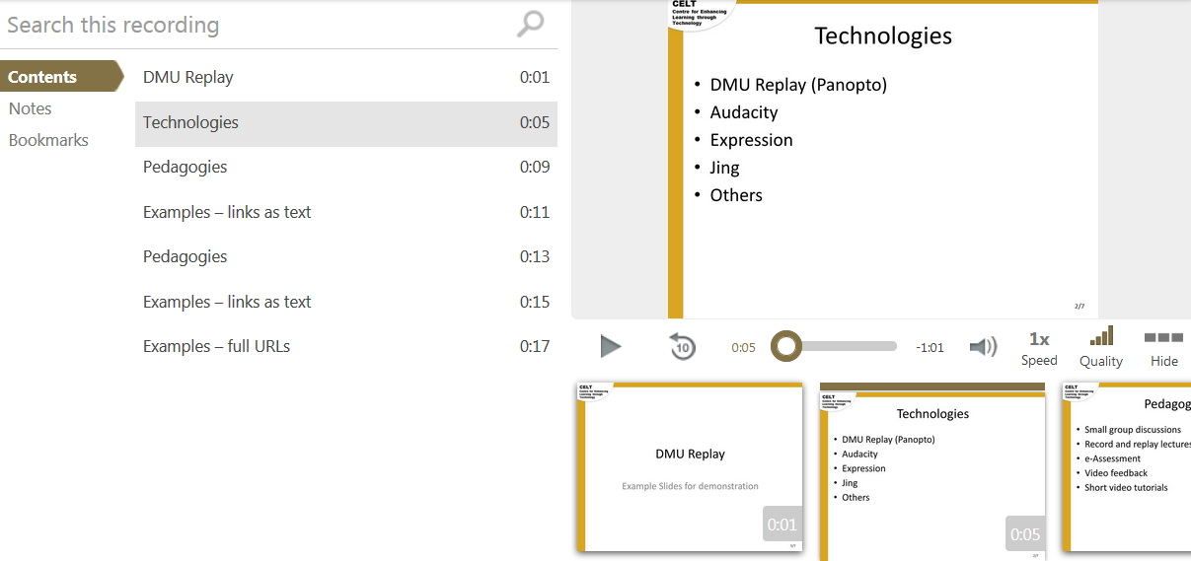
it will present as a linear video recording.
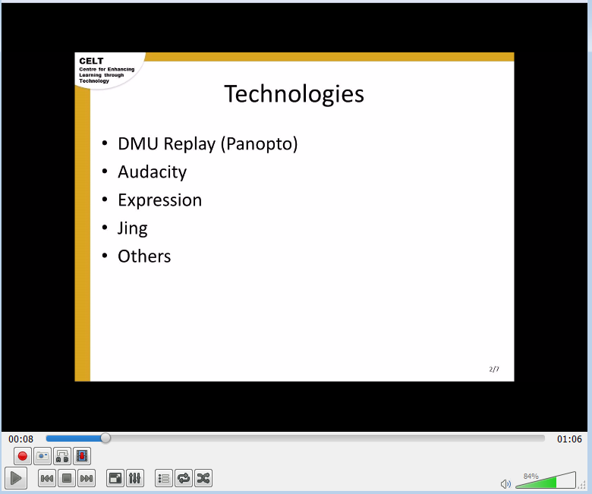
1. Navigate to https://panopto.dmu.ac.uk and log in
2. Locate the recording that you want to save as a video file and click Settings
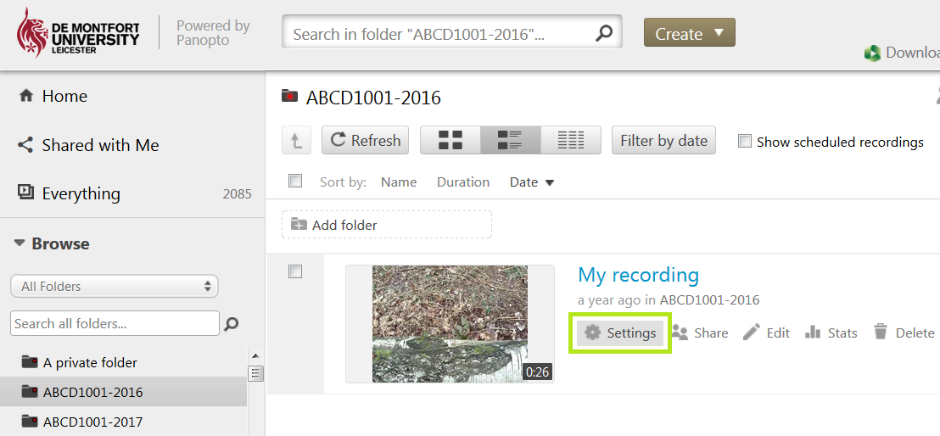
3. In the panel that appears click Outputs
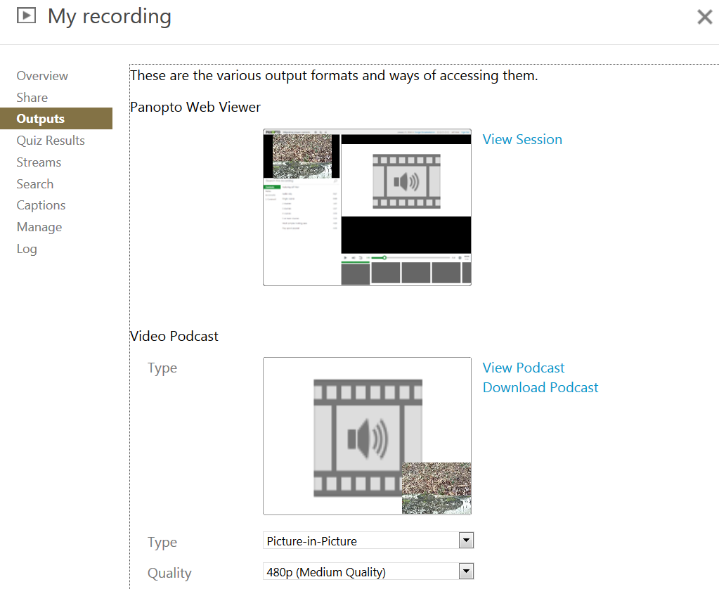
4. In the Video Podcasts section click on the Type menu and select Secondary Video Only
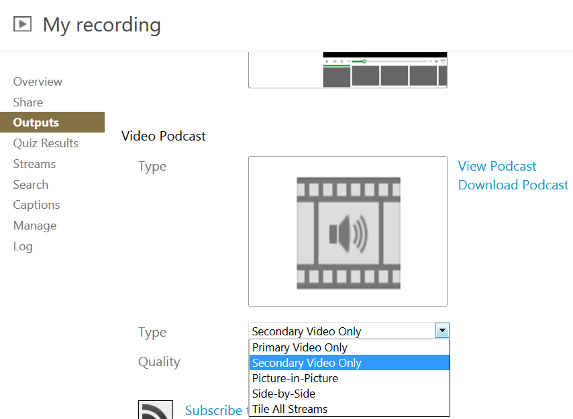
5. Click on the Quality menu and select 1080p (30 fps)
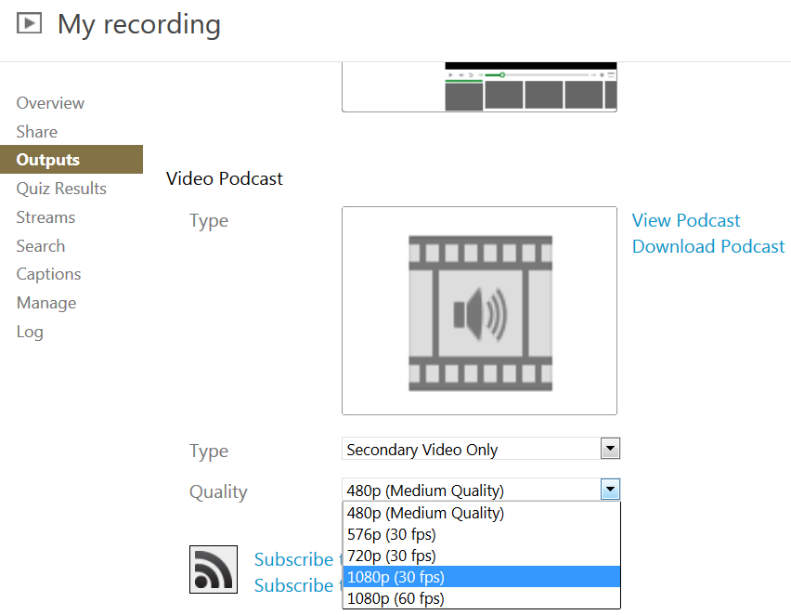
6. Click Apply
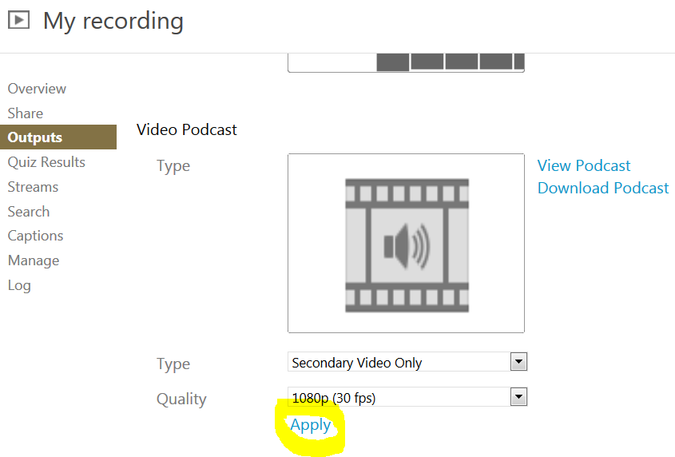
7. Click OK
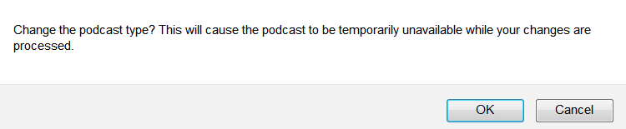
8. The video will begin processing. At this point close the Podcast panel by clicking the X
9. When the video has finished processing, click the Outputs tab and then click Download Podcast
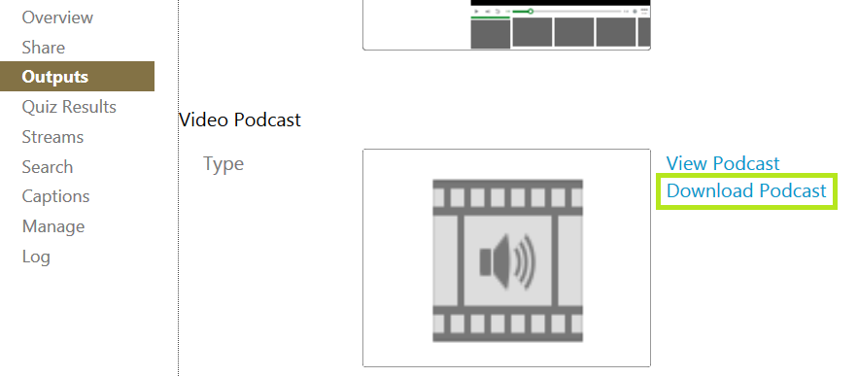
10. Click the Save option in the panel that appears at the bottom of your screen
11. Click the Open folder option
12. The recording file will be highlighted. You can move this file, as with any other file to the storage folder of your choice – this can include a data stick.
