Use the Focus tool with my DMU Replay recording
This procedure does not work when slides are recorded. To learn how to achieve the same effect in the Advanced Editor using slide content click here.
1. Navigate to https://panopto.dmu.ac.uk
2. Click the Sign In button
3. Sign in with your usual DMU credentials
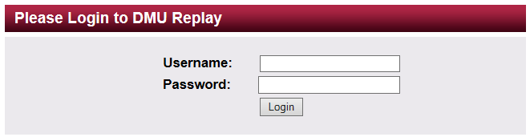
4. Click Browse and locate the Folder in which the recording is located
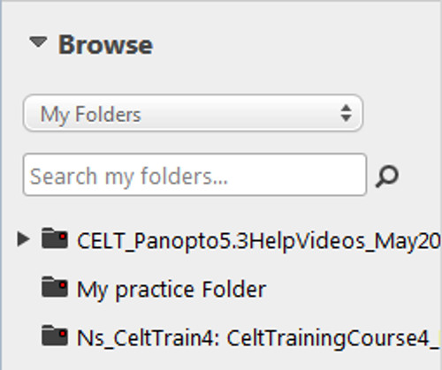
5. Click the Edit icon for the recording
6. Once the Editor has loaded into the browser, click the Focus button
7. On the timeline, click and drag the stream that you need to be visible to mask the opposing stream(s)
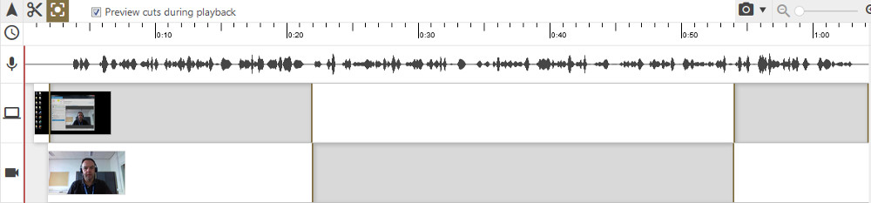
8. Click the Publish button to save the changes

