Use the BASIC DMU Replay Editor
1. Navigate to https://panopto.dmu.ac.uk
2. Click the Sign In button
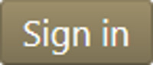
3. Sign in with your usual DMU credentials
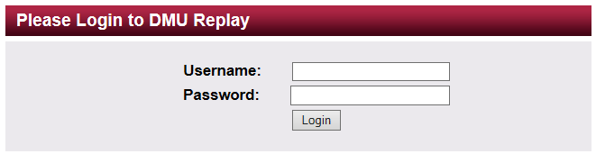
4. Click Browse and locate the Folder in which the recording is located
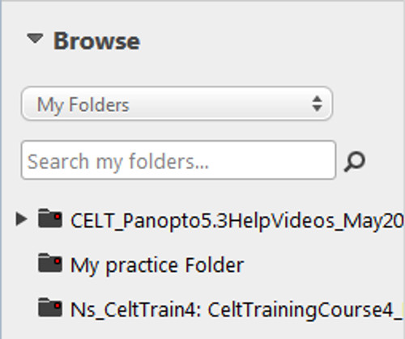
5. Click the Edit icon for the recording
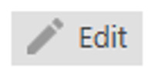
6. The Basic Editor will open as below
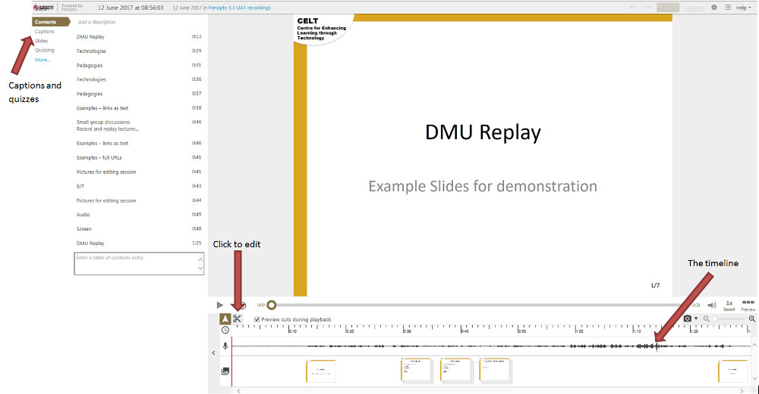
7. Click the Scissors icon to enable cuts to be made on the timeline
8. Click Captions and then Import automatic captions to add captions to the recording
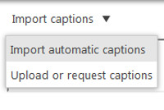
9. Click Quizzing followed by Add a quiz to add a quiz to the recording
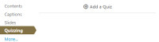
10. Once complete, click Publish to save your changes

