Managing your DMU Replay recordings
This guide provides information that will help you to manage content and recordings that have been made using the DMU Replay system; including copying, viewing the statistics that are available, the sharing permissions etc. It also covers ‘Building a Session’ which enables us to create a space within the system, with specific permissions, for recording to at a later time.
This guide is split into the following sections:
- Logging in;
- Accessing settings and other information;
- The Settings Overview screen;
- The Share screen;
- The Outputs screen;
- The Quiz Results screen;
- The Streams screen;
- The Search screen;
- The Captions screen;
- The Manage screen;
- The Log screen;
- Stats;
- Delete; and
- The Create functions.
What you will need
- An Internet connected PC – to perform these actions you do not need any specialised software, only an Internet connection and a web browser.

Logging in
1. Once logged on to the computer, open your preferred web browser, navigate to panopto.dmu.ac.uk and click the Sign in button
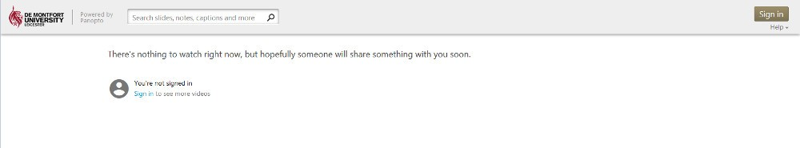
2. Click on the second Sign in button, enter your DMU credentials and click on Login
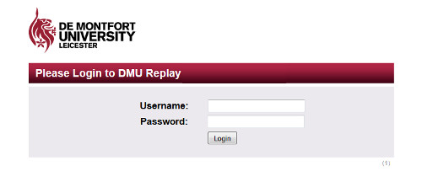
3. The DMU Replay dashboard will be displayed in the Home view
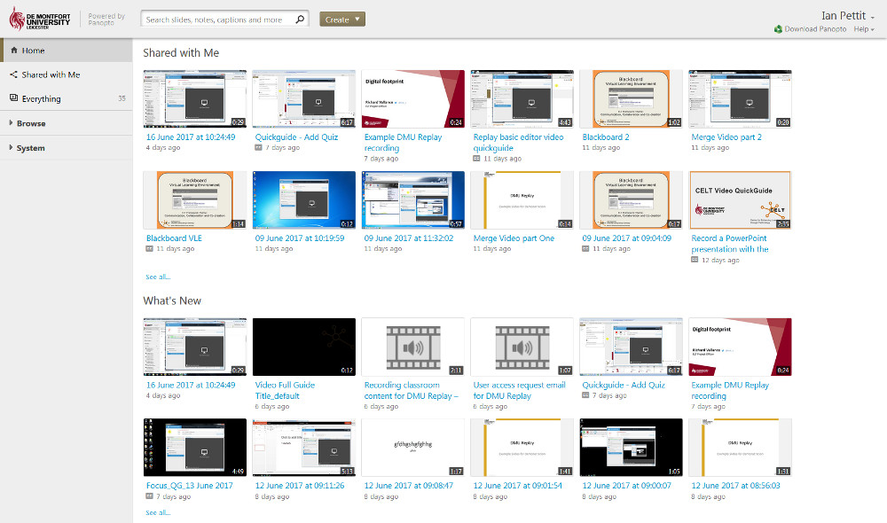
As the dashboard is displayed you will see the following items:
- The main screen will show a list of the most recently recorded content that is associated with the Blackboard shells on which you are an Instructor;
- The left hand side of the screen will display some links that can be used to filter the display and Browse your recordings; and
- Toward the top of the screen, you will see the Create button.
For the rest of this guide, a Folder will be selected in the left hand side and we will work with a piece of content as we explore the other headings and functions.
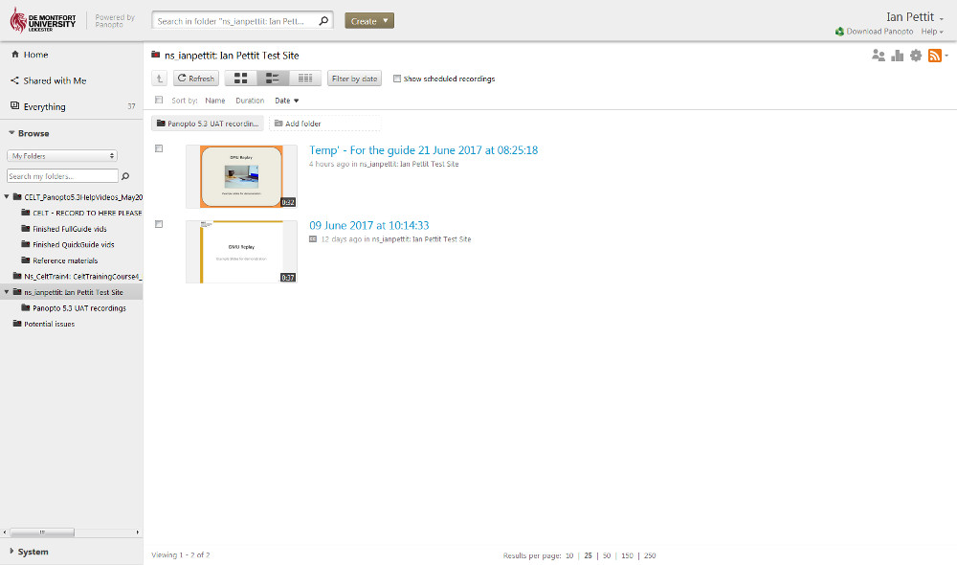
Back to top

Accessing settings and other information
In this example, a folder has been selected in the left hand side and the main view is now displaying the list of recordings that are contained in that folder.
When the mouse is moved over a recording, the following icons become available to click:
- Settings;
- Share;
- Edit;
- Stats; and
- Delete.
Clicking on the Settings icon will open a new window and from here we can access the majority of the functions that are available – however, to access the editor and the stats we must click the corresponding icons.
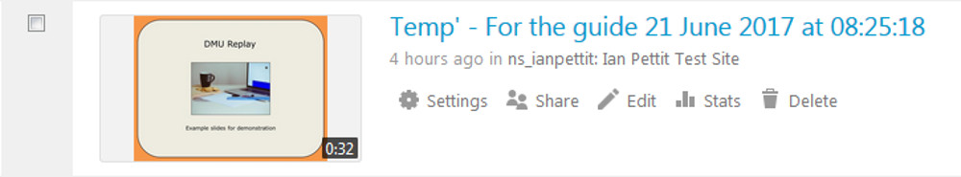
Back to top

The Settings Overview screen
1. Click the Settings icon and the following window will be displayed
This is the Settings overview window that displays information about the recording and here we can change items such as the folder in which the recording is stored and the name of the recording.
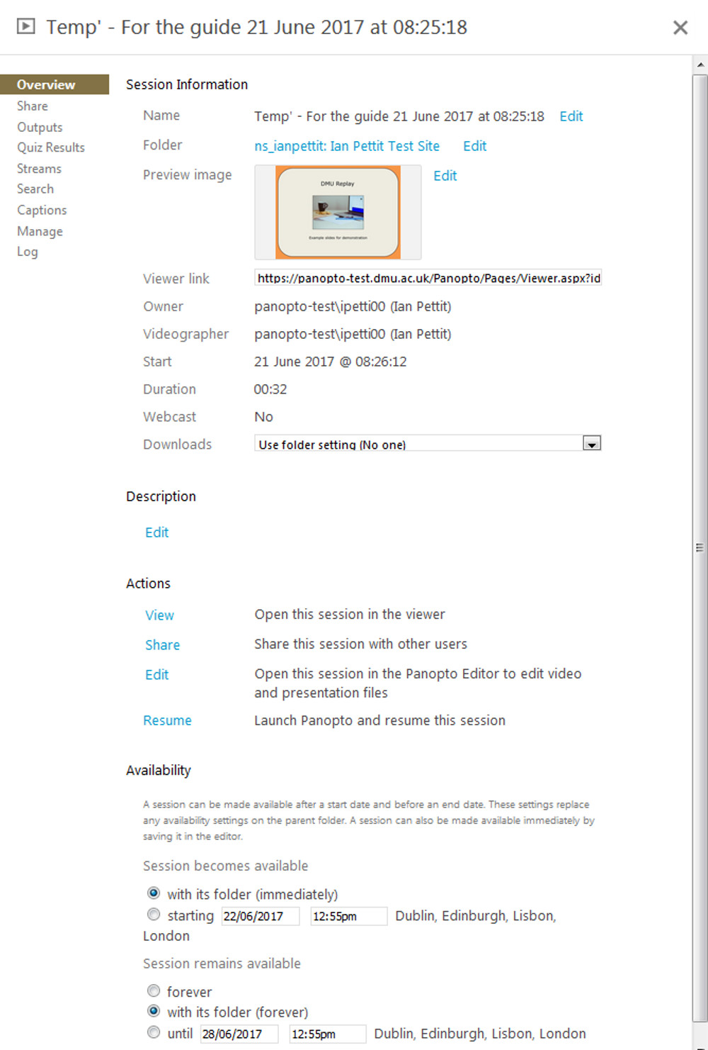
By clicking on the blue text we can change the settings or take action with regard to the recording. For example to change the Folder in which the recording is stored, click the blue Edit link next to the Folder name. To play the recording, click the blue View link under the actions section.
By default the Availability settings are associated with the Folder and since the Folder is linked to the Blackboard shell this will be available until the Blackboard shell is no longer available.
Back to top

The Share screen
1. Click on the Share link on the left hand side
This takes us to the Share settings and has the same effect as clicking the Share icon from the main Folder view.
The default settings are shown below and these are populated from the Folder which links to the Blackboard course enrolments. This is shown under the heading Who has access:. The notice This session inherits permissions from its folder is displayed and this indicates that the default (aligned with Blackboard) share settings are in place.
Students (who are enrolled as Student in Blackboard) are referred to as Viewers and staff members (who are Instructors in Blackboard) are referred to as Creators.
We can also access the link and the embed code for embedding the recording in websites.
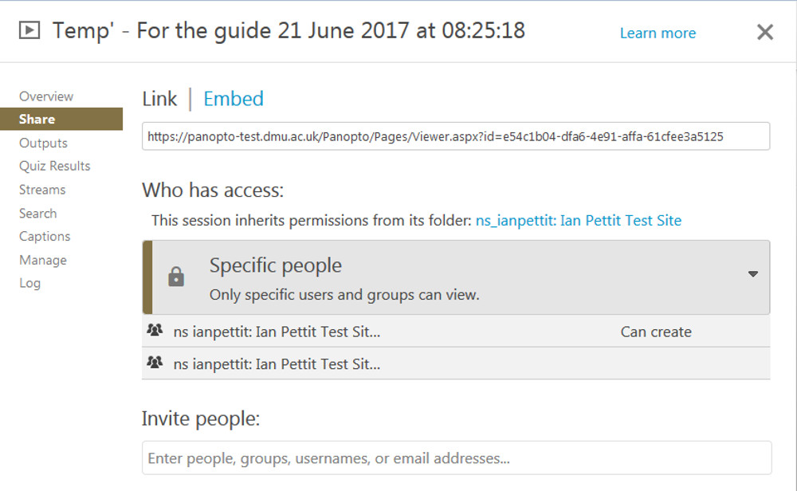
2. To access general permissions settings click on the grey box containing the words Specific people
A number of options will be displayed as is described below.
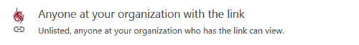 | This setting enables anyone at DMU (staff or student) to view the recording but they need to have been sent the link and they will need to log in to view the recording. Recordings shared in this way do not appear in the Home view and they will not appear in searches.
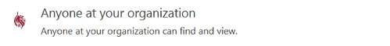 | Similarly, this setting requires viewers to log in to view the recording but they do not need the link as the recording will be open to searches (once logged in) and recordings shared in this way will appear in the Home view following log in.
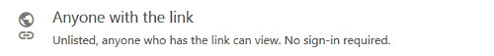 | Anyone with the link removes the requirement for viewers to log in. However, this setting precludes recordings from included in web search results both within DMU Replay and on the wider web (e.g. Bing and Google searches) and recordings will not appear in the Home view.
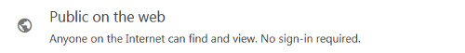 | This setting fully opens up the permissions and enables search engines such as Google and Bing to find the recording. Also when staff, students and visitors navigate to panopto.dmu.ac.uk this recording will be available in the Home view whether logged in or not.
3. Using the Invite people field we can add specific people to a recording either as a Viewer or Creator
Begin to type a name in this field and DMU Replay will search for the person as you type. Once found, select Creator or Viewer to control whether the individual is able to edit and manage the recording or only view it.
Although possible, it is not recommended that recordings are shared with entire module cohorts in this way as this becomes problematic as Blackboard shells are rolled over. Please take a copy of the recording and place the copy in the relevant module folder to enable access to multiple cohorts.
4. Once the Share settings have been amended, click on the Save changes button.
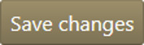
Back to top

The Outputs screen
The Outputs screen enables us to view the recording and work with the ‘Podcasts’ that DMU Replay creates as part of the processing. Elements of the recording (or Podcasts) can be downloaded for watching offline in a traditional media player.
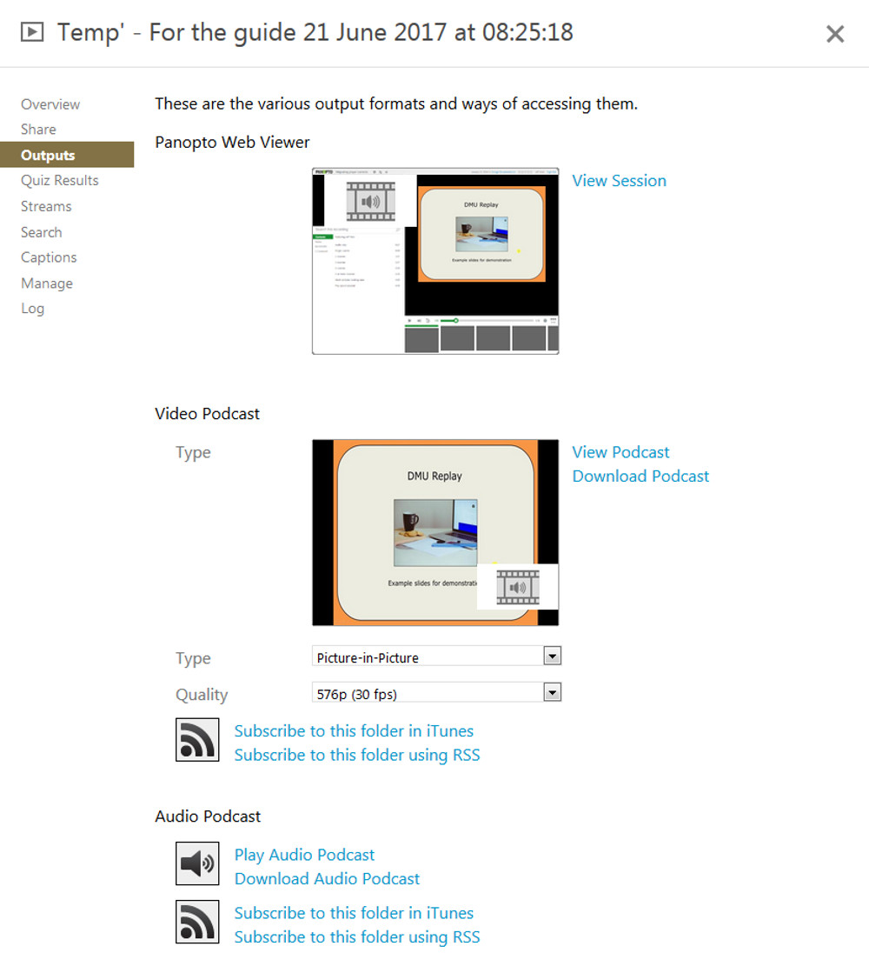
If enabled, students can also subscribe to the Folder using either iTunes or an RSS feed handler. However, for this to be effective the recording would need to be available without signing in (in the Share settings) as without this change to the Share settings iTunes and RSS feed handlers will be unable to pick up any changes without the student firstly logging in.
When embedding recordings into websites, it is essential that the Quality is set to 1080p (30fps) as without this the embedded recordings will appear fuzzy when watched.
Setting the Quality to a higher level will cause the Podcast to re-process and temporarily become unavailable. It will also affect the quality of the download and therefore the Podcast file will size will be affected.
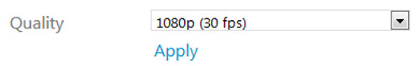
Back to top

The Quiz Results screen
If a quiz has been added to a recording in the Basic Editor, we can view and download the results via the Quiz Results screen.
The Quiz Results Summary section of this screen provides the link to download the results for viewing in Excel or an equivalent whereas the Detailed Results By Section area can display results by question or quiz where multiple quizzes and questions may have been deployed.
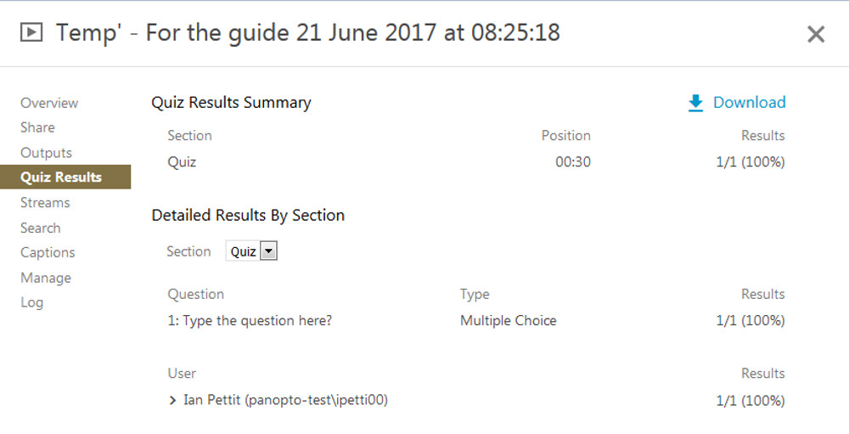
Back to top

The Streams screen
In the Streams view we can see information about the various streams that were recorded. This can be useful when trouble-shooting but we would not generally be concerned with this information.
However, we can upload a PDF file with supplementary information via the Streams screen.
To do this click the Browse… button and locate the PDF to be added. This will open in the default PDF reader as the student opens the recording in the DMU Replay Viewer.
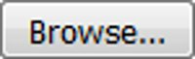
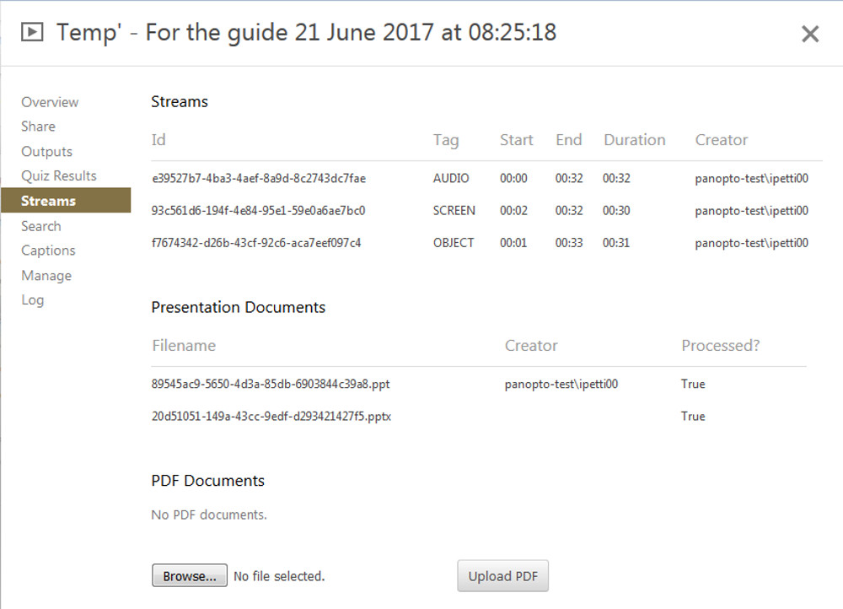
Back to top

The Search screen
The Search screen only provides information with regard to whether the audio and text has been included for students and other viewers to search.
There are no actions that can be taken in this section.
Back to top

The Captions screen
The Captions screen provides the opportunity to upload a specific file type which contains subtitles for the recording. By clicking on the Browse… button a caption file can be added.
Alternatively, if the automatic captions have been pulled through in the Basic Editor, clicking the Download file link will download the captions for saving. This could be an easy way of providing a transcript of the DMU Replay content’s audio.
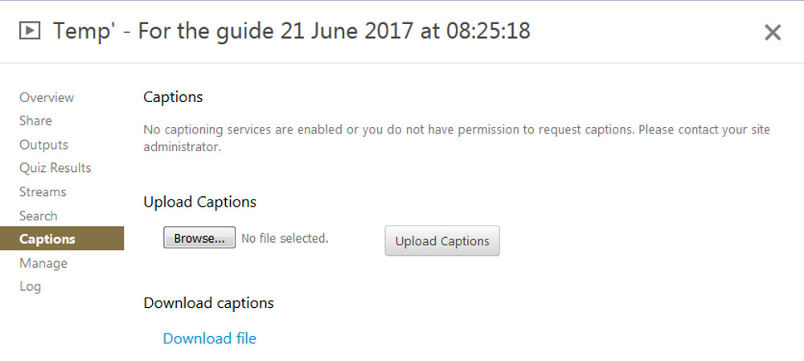
Back to top

The Manage screen
In the Manage screen we firstly see information about the recording and whether it is ready view.
Further on we have options to Merge Copy or Delete the session/recording.
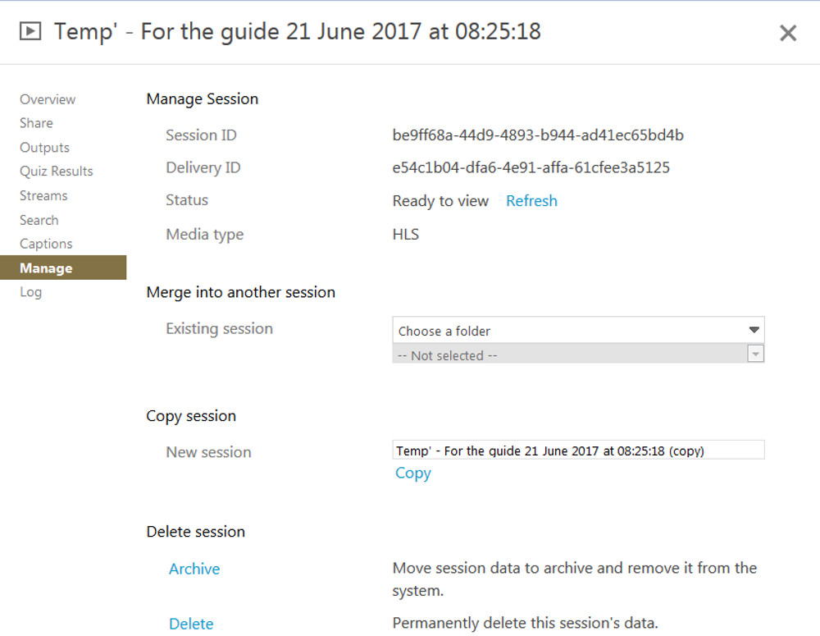
To Merge the recording with an existing session, select the recording to be merged using the two drop down fields and click the blue Merge link. The two recordings will now become one and will accessible based on the other session’s Share settings.
The Copy function will take a copy of the session and place it in the same Folder.
The Delete function will permanently delete the session.
Back to top

The Log screen
The Log screen only provides information with regard to troubleshooting.
There are no actions to be performed on the Log screen.
Back to top

Stats
To access the Stats, in the list of recordings, move the mouse over the recording and click the Stats icon.
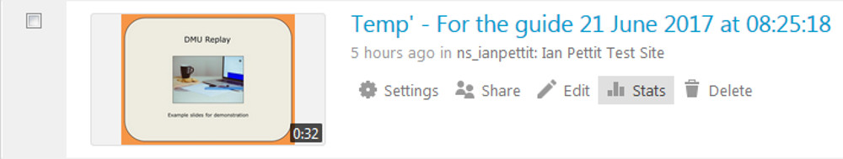
As people engage with the recording this view will build a picture with regard to who is viewing the recordings, for how long and which sections are being viewed the most.
The stats can also be downloaded for viewing and analysis in Excel or an equivalent.
Toward the top of the screen there will also be a blue link with the module folder name. Clicking this will display the viewing statistics across all recordings within the module folder.
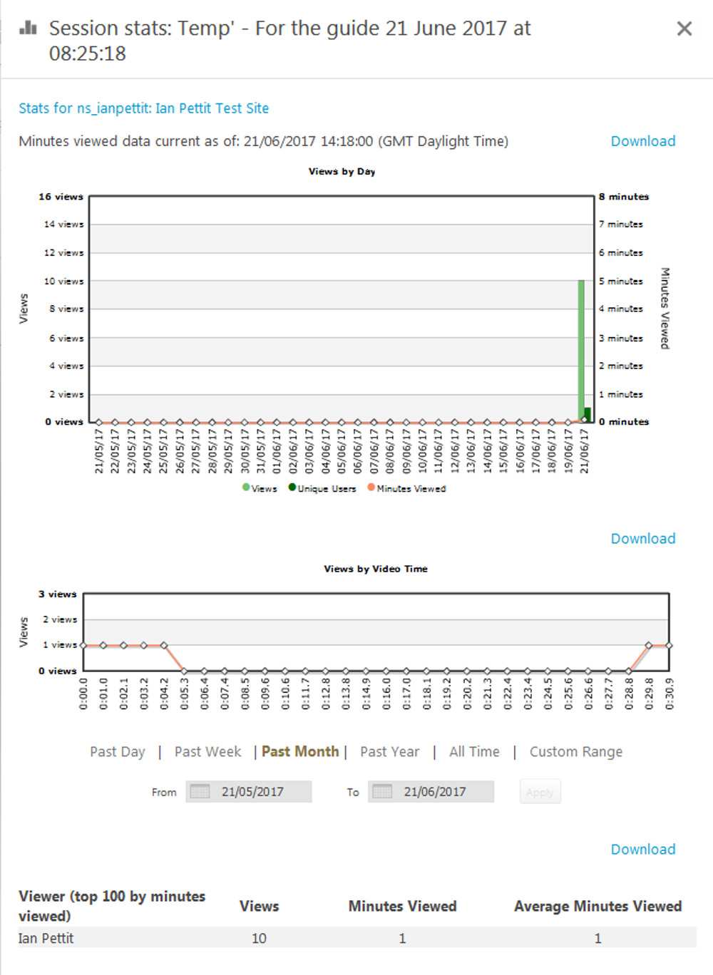
Back to top

Delete
To permanently delete a recording from the main Folder list, click the Delete icon.
There is no recycle bin in DMU Replay and therefore recordings that are deleted in this way cannot be retrieved.
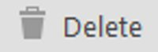
Back to top

The Create functions
Toward the top the screen is the Create button. This provides access to the following tools:
- Record a new session;
- Upload media;
- Webcast;
- Build a session; and
- New Folder.
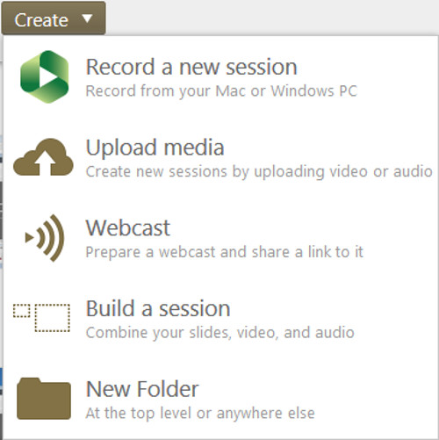
Record a new session
Clicking this will open the DMU Replay recording software or download it for use.
It is not usual practice to start a new recording in this way.
Back to top
Upload media
Upload media enables previously created traditional video files to be uploaded into the DMU Replay system.
Uploading videos in this way enables traditional video content to benefit from some of the editing features such as Automatic Captions, Quizzes, Events and URLs that can be added using the DMU Replay Editors.
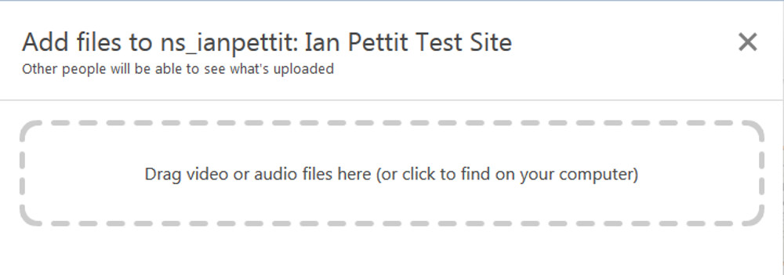
Back to top
Webcast
This is the term given to the scenario where the session is broadcast live on the Internet whilst the recording is being made.
Using this tool we can set up a session and share the link in advance of the class or event taking place so that people can click the link and watch the session as it is being recorded. Using the Share settings we can open the Webcast up to a wider audience or by default it will only be available to students who are enrolled on the corresponding Blackboard shell.
Once the Webcast is created, we will be able to select it using the DMU Replay recording software when recording.
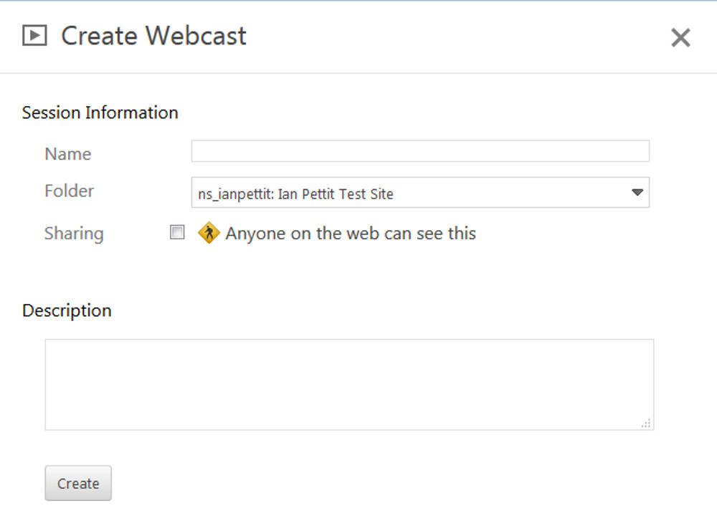
Back to top
Build a session
Build a session enables us to create a session in advance of recording. As with the Webcast tool we can create a session that will be available to select in the DMU Replay Recording software before the recording takes place.
However, Build a session enables us to set all of the parameters relating to Sharing and access before recording. This is achieved by clicking the Create button after clicking Build a session and following the advice above regarding Settings and Sharing.
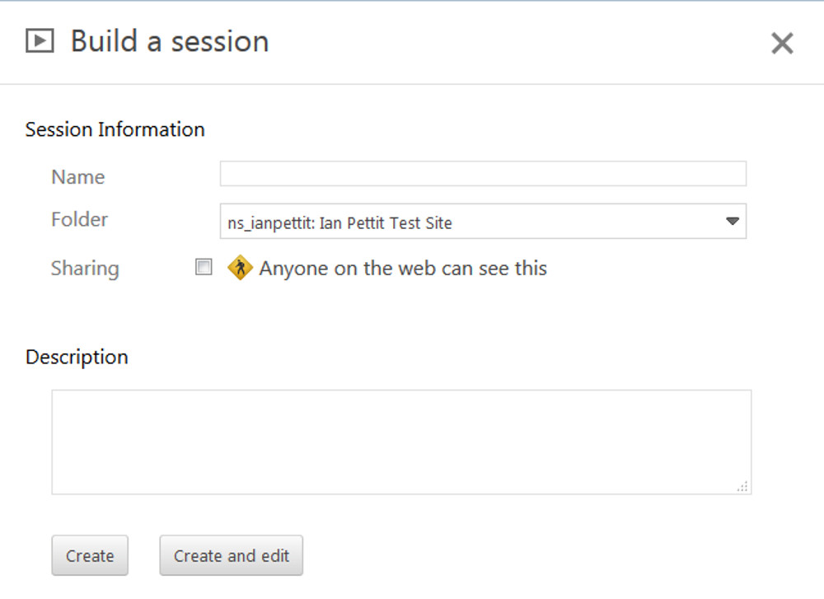
Back to top
New folder
The New Folder function enables us to create a Folder within the module Folder – this is required when creating student feedback videos as the new Folder will be set up with permissions for a single student and their feedback video will be recorded to their Folder.
Folders can also be created at the top level of the system (not associated with a Blackboard shell) and this can be an effective way to share a batch of recordings with a wider audience. For example; a set of conference recordings could be shared by making the Folder available to Anyone with the link in the Folder’s Share settings.
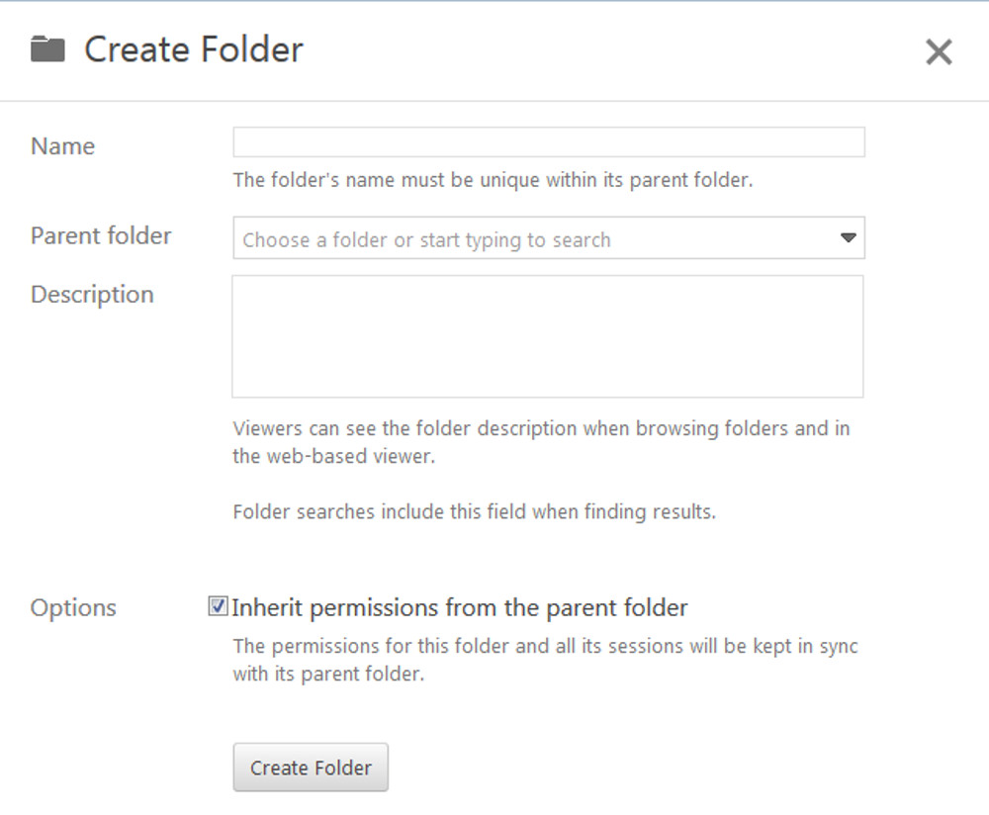

Back to top
If you wish to explore different ways in which DMU Replay may be able to help with innovation please contact your local ELT Project Officer.

