Editing DMU Replay recordings
There are two Editors in DMU Replay – the Basic Editor and the Advanced Editor. The Advanced Editor enables us to work with recordings in a more advanced manner but there are a number of functions that are only available in the Basic Editor as listed:
- Adding the automatically generated captions to a recording;
- Adding a quiz; and
- Working with the Focus tool.
Tasks such as making cuts can be completed in either Editor but only the Advanced Editor enables the following:
- Remove a stream;
- Add new content (slides or multimedia);
- Merge recordings;
- Remove, add and amend Events.
This guide covers both the Basic and Advanced Editors that are accessed via the DMU Replay dashboard but it is important that we plan our editing activity as once the Advanced Editor is used we cannot revert to the Basic Editor.
For example; should I need to replace a slide in a recording, add a quiz question, add the automatic captions and merge an existing piece of DMU Replay content I would need to perform these tasks in the following order:
- Add the captions (Basic Editor);
- Add the quiz (Basic Editor);
- Click through to the Advanced Editor;
- Replace the slide (Advanced Editor); and
- Merge the existing content (Advanced Editor).
Completing the Basic Editor tasks first ensures that the captions and quiz are added prior to replacing the slide and completing the merge as making these advanced edits first would prevent future access to the Basic Editor and the quiz and captions could not be added.
The DMU Replay editors are of a ‘non-destructive’ nature. This means that when edits are made the sections that are removed are merely hidden and they are never fully deleted. Therefore, edits can always be reversed and nothing is ever lost when using this system.
What you will need
- An Internet connected PC;
- The Microsoft Silverlight browser plug-in (Advanced Editor only); and
- Speakers or a headset.
The Microsoft Silverlight browser plug-in is not available for the Google Chrome browser and tehrefore teh Advanced Editor is only available in teh following browsers:
- Internet Explorer;
- Edge; and
- Firefox.

Opening the Basic Editor
1. Once logged on to the computer, open your preferred web browser, navigate to panopto.dmu.ac.uk and log in
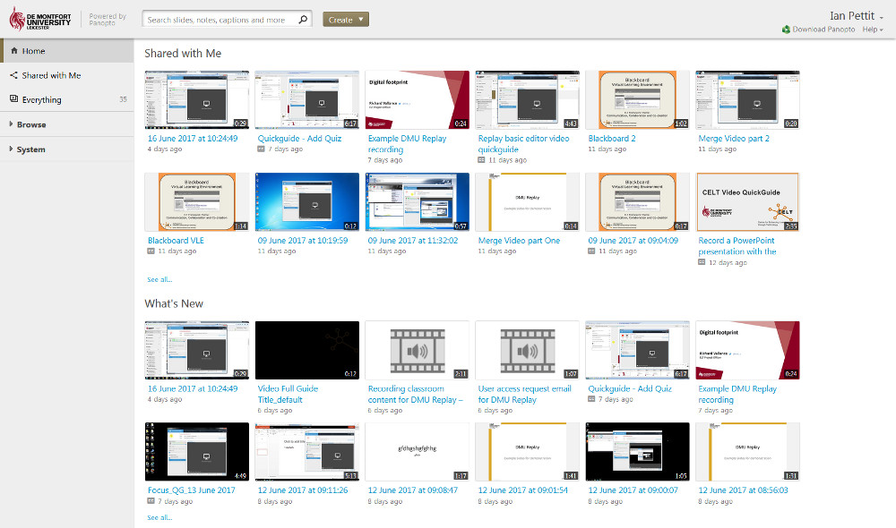
2. Using the instructions detailed in the Managing your recordings guide, locate the recording that you wish to edit and click the Edit icon
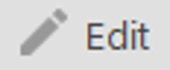
3. The Basic Editor view will now open in the web browser
After clicking the Edit icon, the Basic Editor is the default view for new recordings that are yet to be edited. If you see a message advising that the recording must be opened in the Advanced Editor you will not be able to use the Basic Editor with this recording unless you undo all advanced edits that have been made to to the recording to date.
Therefore, if you are planning to work with the automatic captions, quizzes or the Focus tool you must do this now before making any advanced edits.
Back to top

Adding captions in the Basic Editor
1. Having clicked the Edit icon the Basic Editor will be displayed
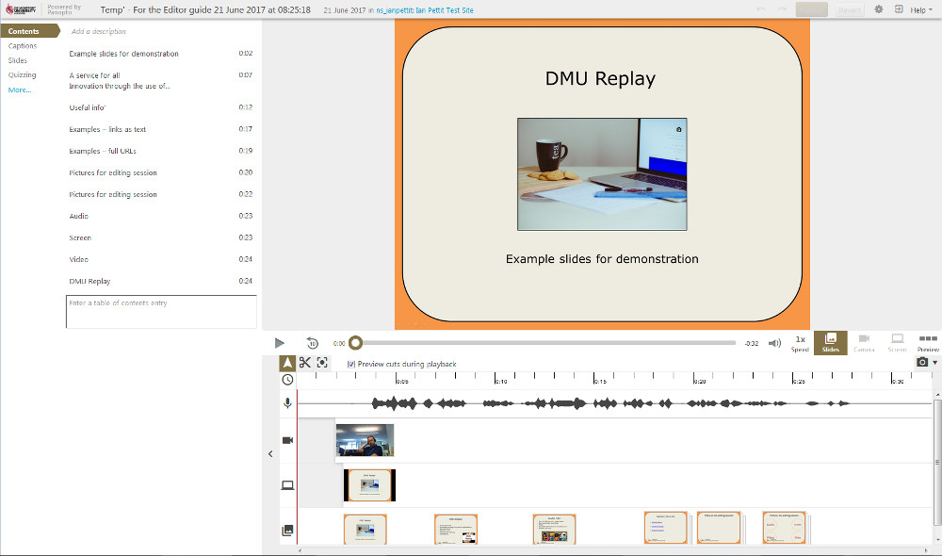
2. To add the automatic captions to the recording click the Captions link followed by Import automatic captions
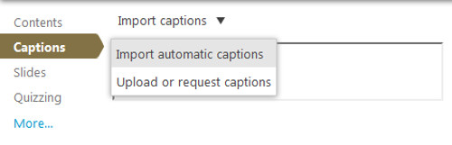
3. The captions will now be displayed in the left hand side
4. To correct any mistakes, select with the mouse and overtype with the correct text
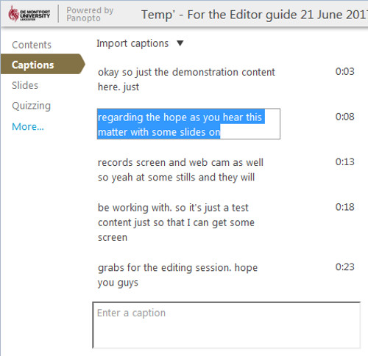
Back to top

Add a quiz in the Basic Editor
1. To add a quiz question, click the Quizzing link followed by Add quiz
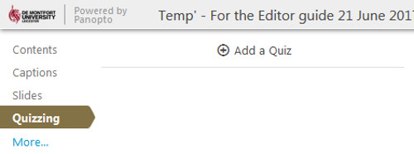
2. The quiz builder screen will be displayed, using the fields presented type a question and the potential answers
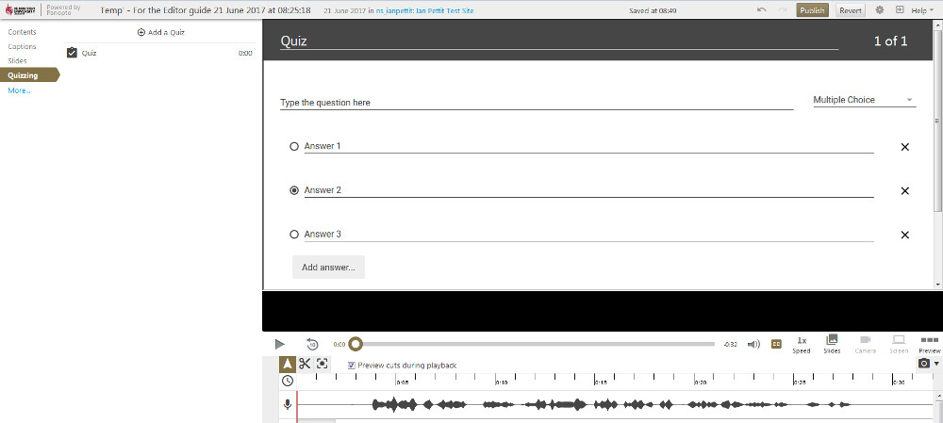
In this example I have opted for a Multiple Choice question and using the radio button I have indicated that Answer 2 is the correct option
3. Once the question(s) are entered, scroll down and click the Done button
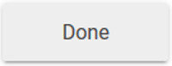
4. The quiz options screen will now be displayed
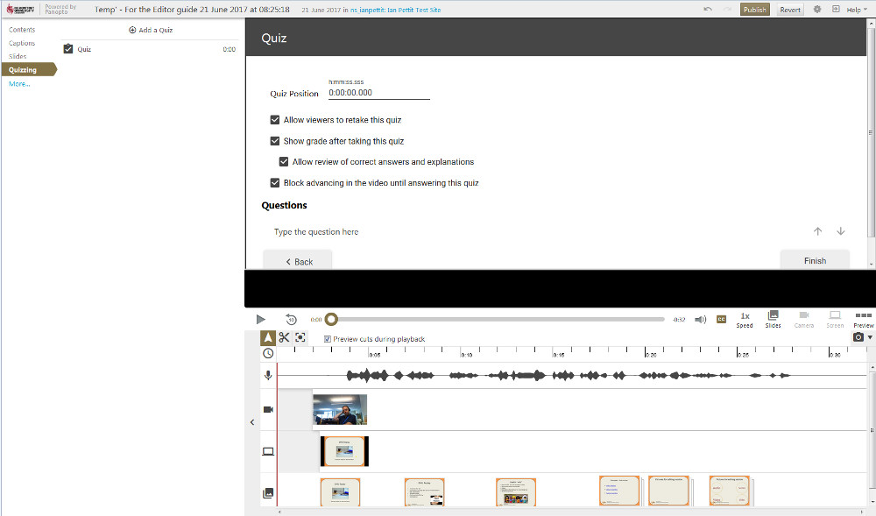
5. Using the fields, firstly type in the Quiz Position the time at which you want the quiz to appear in the recording. For example; if the quiz is to be taken 30 seconds into the video type 0:00:30:000
6. Using the tick boxes tell DMU Replay whether you require students to be able re-take the quiz, see their score, see the correct answers in the event they get the question wrong and whether you need students to have answered the quiz before advancing further in the video
For this example I have set DMU Replay to display the quiz 30 seconds in, students will only be able to take the quiz once and they will see their score with the option to review the correct answer should they get the question wrong. DMU Replay will allow students to watch the entire video even if they opt not take the quiz
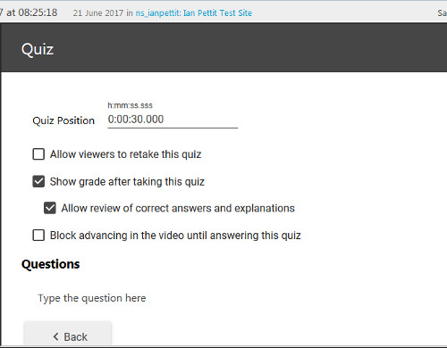
7. Click the Finish button to add the quiz
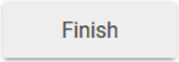
8. The quiz will be inserted at the desired point and the recording will begin to play in the Editor view
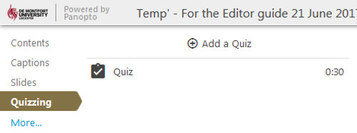
Multiple quizzes can be added, to add another quiz click the Add a Quiz button and repeat
Back to top

Using the Focus tool
In the example, multiple Secondary Streams were recorded. This prompts the DMU Replay Basic Editor to make the Focus tool available for use.
The Focus enables us to tell DMU Replay which of the visual streams should be displayed in order to ensure that students watch the correct visual element at the correct time. For example; I may talk to the webcam for 10 seconds and introduce the video but after this introduction I need the students to watch the screen content. Using the Focus tool we can force this scenario.
1. Click on the Focus icon
2. Using the mouse, click and drag the stream that you need to be visible
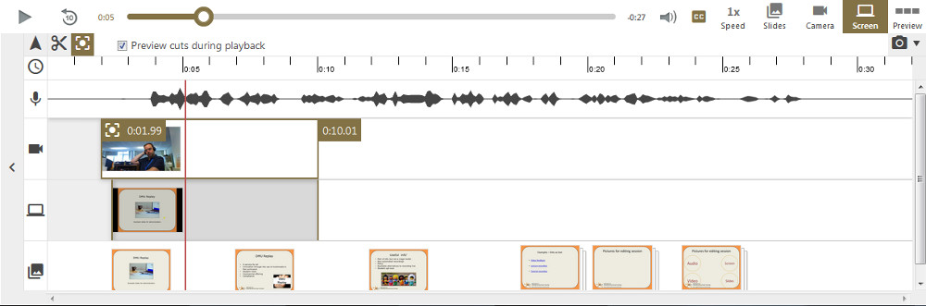
Here I have dragged for 10 seconds on the top stream (the webcam). Notice that the opposing portion of the middle stream (the screen) is now greyed out. This indicates that when the students watch this video, only the webcam stream will be available to view for the first 10 seconds and the view will then switch to teh screen stream.
Notice that the bottom stream (the slides) is unaffected. this is because the Focus tool cannot be applied to the slides but having applied it to the other stream(s) DMU Replay will display these as a priority over the slides.
3. Continue to use the Focus tool as desired – in the example below I have now hidden the webcam to ensure only the screen displays after 10 seconds until 20 seconds. Unfortunately I cannot manipulate the slides in this view – to force a slides only scenario we would need to use the Advanced Editor
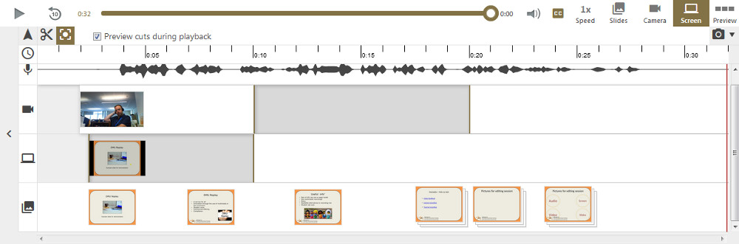
Back to top

Making cuts/edits
1. To make a rudimentary edit to a recording click on the Scissors icon
2. Having clicked this, a pair of handles will appear at the beginning and end of the recording
Clicking the scissors also adds handles around any Focus edits we may have made – using this technique we can fine tune our Focus edits.
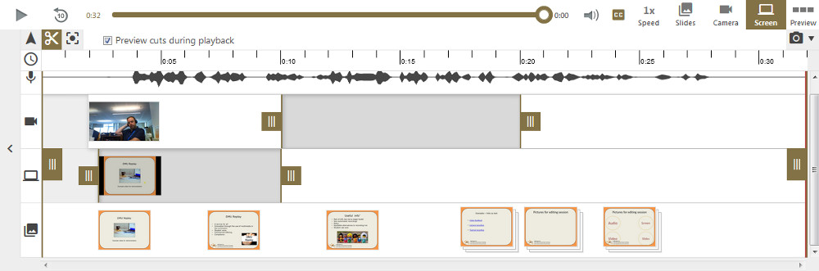
3. Using the full height handles, top and tail the recording to hide any unwanted material that may have been captured at the beginning and end of the recording
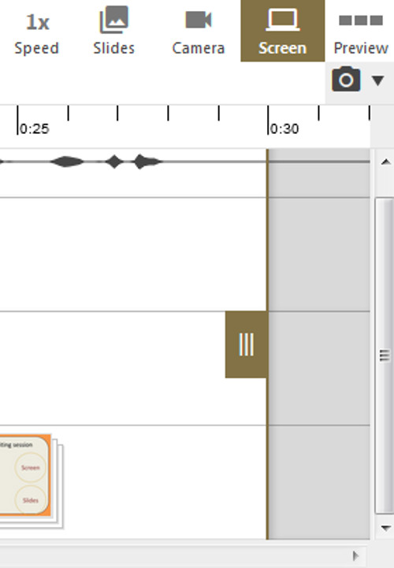
4. To remove a section from the middle of the recording, click and drag the mouse over the audio (top) stream and a new pair of handles will appear. Fine tune the edit as desired
Repeat this step to add multiple edits if required.
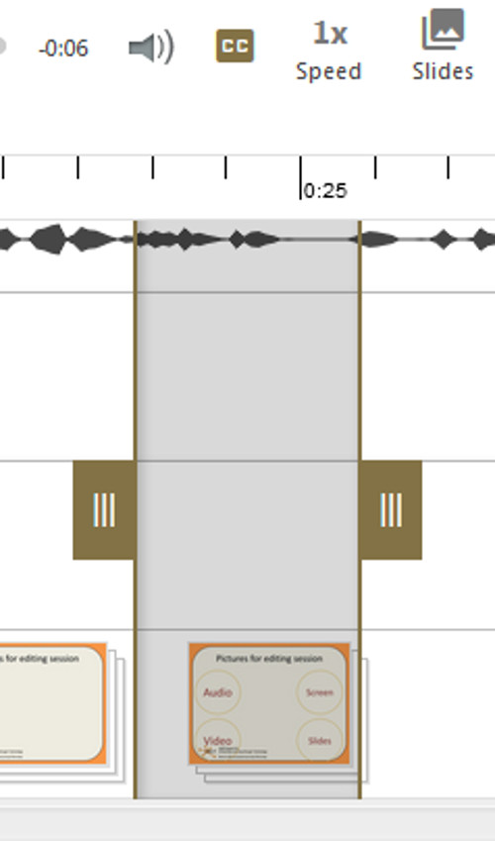
5. Once all edits have been performed click the Publish button
You will see a message asking if you wish to quit the Editor. Answering Yes will play the recording with the edits in place once it has re-processed. Answering No will save your edits but you will remain in the Editor view.
Back to top

Opening the Advanced Editor
The Advanced Editor requires the Silverlight browser plug-in and will therefore not work in the Google Chrome browser.
1. To access the Advanced Editor, click the More… link in the Basic Editor
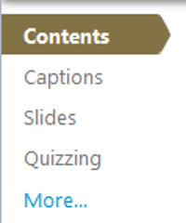
2. Click on Open in advanced editor
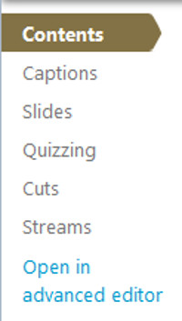
3. The Advanced Editor will be displayed
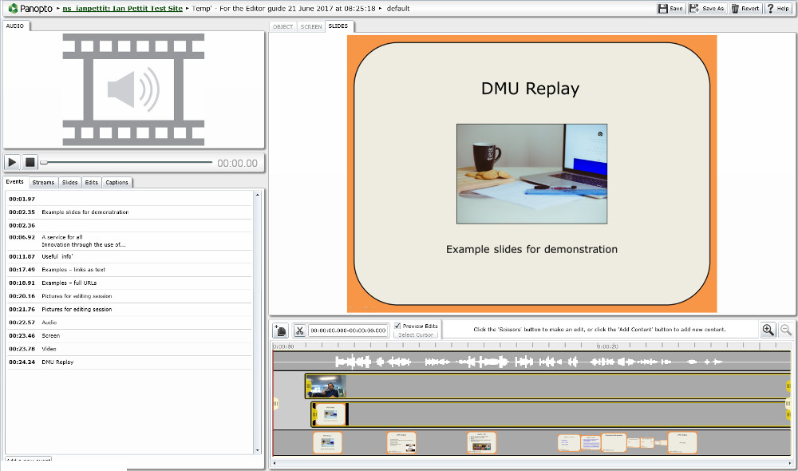
Toward the top left hand portion of the screen there is a window that will provide a preview of the Primary Source if recorded – there is also a pair of buttons to enable us to play/pause and stop the recording whilst editing.
Underneath this window we can see a number of tabs that enable us to edit and manipulate various aspects of the recording and the ‘Events’ that have been automatically generated by the system.
The main, larger window displays a preview of the slides (where recorded) and underneath this is the timeline with a visual representation of the secondary streams that were recorded.
In the example above, slides were recorded along with the screen and the webcam with audio; therefore there are four ‘tracks’ on the timeline.
The Advanced Editor does not display any of the activity that can only be completed in the Basic Editor.
Although this section refers to the ‘Advanced’ Editor, the term ‘Advanced’ relates only to the DMU Replay specific functions. In reality, this editor is quite basic and it would be unrealistic to expect a fully polished/produced final product. There is no provision for adding effects such transitions, audio effects or more traditional video editing techniques. The Advanced Editor is only able to perform rudimentary cuts and the manipulation of aspects that are unique to the nature of DMU Replay recorded videos.
Back to top

Working with Events in the Advanced Editor
1. To work with the Events click on the Events tab
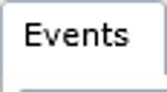
2. To delete an event, move the mouse over the Event and click the Delete button
3. To edit an Event, select the Edit button
When editing the Event we can change the following items:
- Time – this is the time at which the Event appears in the recording;
- Title – this is the wording that appears in the list of contents when the recording is being viewed;
- Searchable Metadata – this represents the key words that are associated with this Event and which will be picked up when viewers search the recording when watching it back; and
- Url – we can add a website address here and when the recording is being watched, the website will be displayed in the DMU Replay viewer at the time of the Event.
We can also delete the Event from this screen, once the desired changes have been made, click the OK button.
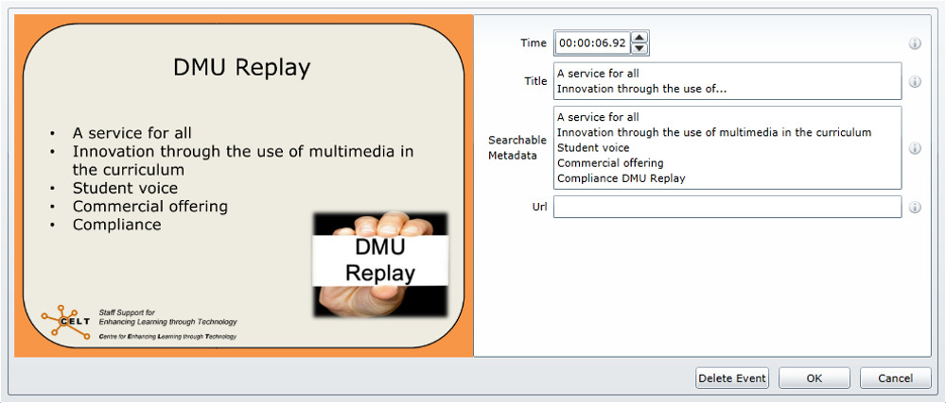
4. To add a new Event, click the Add a new event button
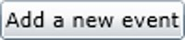
5. The timeline will now be shaded green, click the mouse at the point on the timeline where you need the new Event to appear
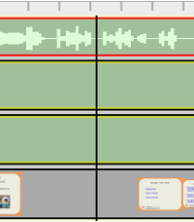
6. The Edit Event window will open and we can now populate the information and click the OK button as described above
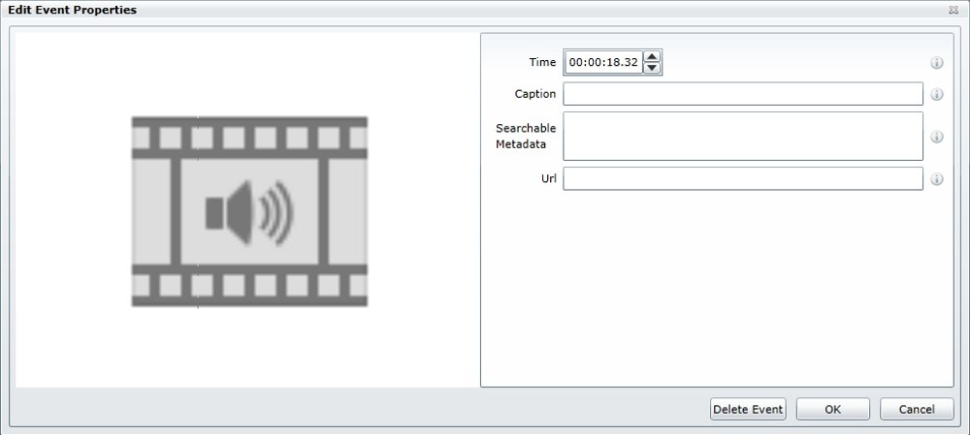
Back to top

Manipulating Streams
There will always be a ‘DV’ stream – in this example, this is the Audio stream. If when recording, a device or camera was recorded using the Primary Source this visual stream will be permanently attached to the audio and become part of the DV stream in the Advanced Editor view. By recording all streams as Secondary Capture Devices we are able to edit and/or remove visual streams without interrupting the audio.
1. Click the Streams tab to display a list of the streams that were recorded
2. To delete a stream click the Delete button next to the stream to be removed
3. To Edit a stream click the Edit button
4. The Edit Stream properties window will be displayed
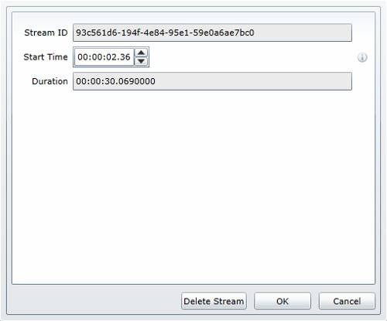
Clicking Edit will open the Edit Stream properties window. Clicking Delete will remove an entire stream from the recording – this removal is permanent.
It is not recommended that the timings are altered here as this will remove the synchronisation between streams.
Back to top

Adding and replacing slides
The Slides tab works in conjunction with the Add content button. Using the Add content button we can add slides or other content but we need to use to Slides tab to pull through any slides we may have imported via Add content.
1. Click on Add content
2. Click on Add a video or presentation and use the Browse button to locate the slides to be imported
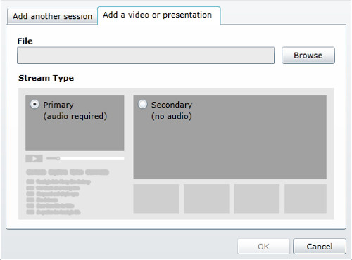
The new slides will be imported and processed – this can take a few minutes.
3. Once the new slides are imported they will appear in the Slides tab. Click on the Add button to place the new slide on the Timeline
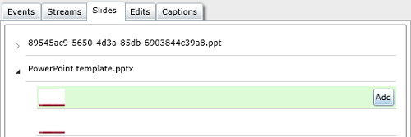
4. Using the Add content button we can also merge two recordings. Click on Add content
5. With Add another session selected, browse for the session that you wish to merge into the active session and click Ok
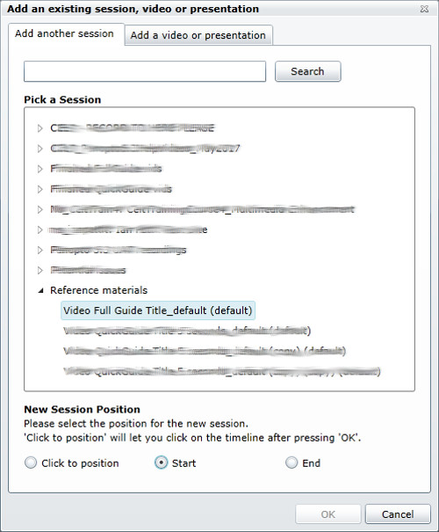
Ensure that the New Session Position is set appropriately. In this example I have set it to Start as I want the new session to play before the existing one. However, we can merge sessions into the end of the current session or we can select Click to position which will provide the opportunity to place the merged session on the timeline using a mouse click.
Back to top

Saving the work
The remaining Edits and Captions tabs can be used to see an alternative view of the slides that have been recorded or the edits that have been made using the Timeline.
The Captions tab enables a text caption to be added to the recording to be displayed at a specific time but it is recommended that any captions related work is completed in teh BAsic Editor as the Basic Editor offers more functionality and is easier to use when working with captions.
Once all of the edits have been made, click the Save button. The recording will re-encode and be temporarily unavailable for viewing whilst the edits are applied. However, even after saving, edits can be reversed due to the non-destructive nature of the Editor.
As the DMU Replay system will re-encode each time the Save button is clicked it is recommended that edits are performed in batches rather than saving each individual change as whilst the re-encoding is taking place further edits cannot be made.
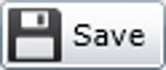
Back to top

Use cases
Using the DMU Replay Editors we can create a number of effects that can help to make our recordings more engaging and ensure that students are watching the correct stream at the correct time.
We can also upload traditional video files into DMU Replay in order to take advantage of the captioning service and augment videos by adding Events, quizzes etc. in the Editor views.
Example 1
This recording was created by recording the Screen and the Document Camera as Secondary Capture Devices. The lecturer displays screen content and then works with mathematical equations whilst using the document camera to show the students his workings. In capturing both of these streams and using the Editor, it was possible to create a switching effect by snipping the Screen and Object (document camera) streams independently.
To demonstrate – here’s a picture of the timeline for this recording, using the Scissors icon, multiple edits were added to each stream but as the audio (DV) stream remained independent the audio plays seamlessly as the visual switches.
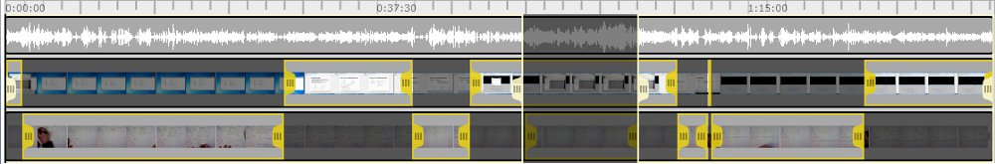
Example 2
In this example, a video that was recorded and produced using a traditional camera and Adobe Premiere Pro has been uploaded to DMU Replay. Events have been added to enable viewers to navigate and search the video as well as being able to use the comment and bookmark tools. There is also an Event with a URL at the end that displays a webpage as the video finishes.
If you wish to explore different ways in which DMU Replay may be able to help with innovation please contact your local ELT Project Officer.

