Add the automatic captions to my DMU Replay recording
1. Navigate to https://panopto.dmu.ac.uk
2. Click the Sign In button
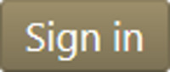
3. Sign in with your usual DMU credentials
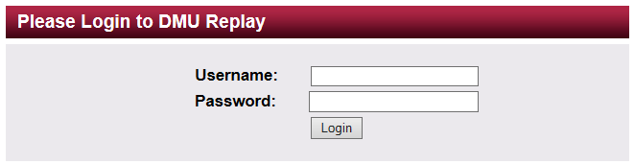
4. Click Browse and locate the Folder in which the recording is located
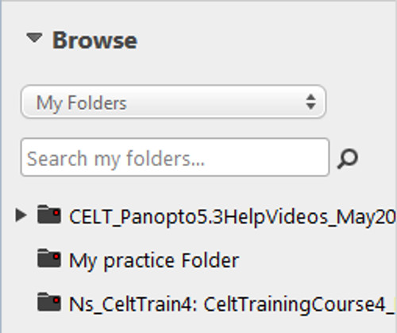
5. Click the Edit icon for the recording
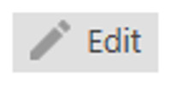
6. Once the Editor has loaded into the browser, click the Captions link
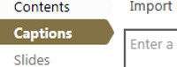
7. Click on Import Captions and select Import automatic captions
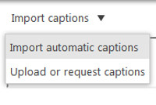
8. Overtype any amendments that may be required
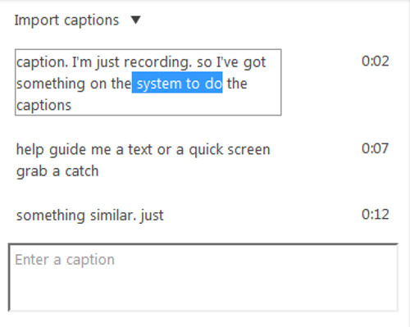
9. Click Publish
If required, the captions file can now be saved and uploaded to Blackboard as a transcript

