What is Turnitin Feedback Studio?

The new Feedback Studio provides a new 'layered' view to the existing Originality Report and GradeMark features of Turnitin. Feedback Studio combines these existing ‘Turnitin Classic’ features into a single set, accessed when you view a student paper. All the original tools that were previously available to check originality to provide feedback on student work are still available.

Feedback Studio has been developed to provide a clearer, simpler interface to check originality and engage in online marking. It is important to note that Turnitin is still accessed in exactly the same way. The assignment inbox and how you access student submissions has not changed. Feedback Studio has been developed to check originality and grade/annotate work more easily.

Opting in or out of Feedback Studio?

The new interface for Feedback Studio looks considerably different from Turnitin Classic, so there should be no doubt which one you are using.
To use the new Feedback Studio, you will see a link at the top of the screen to ‘Try the new Feedback Studio’ when you are viewing a student paper. This will switch you to Feedback Studio:

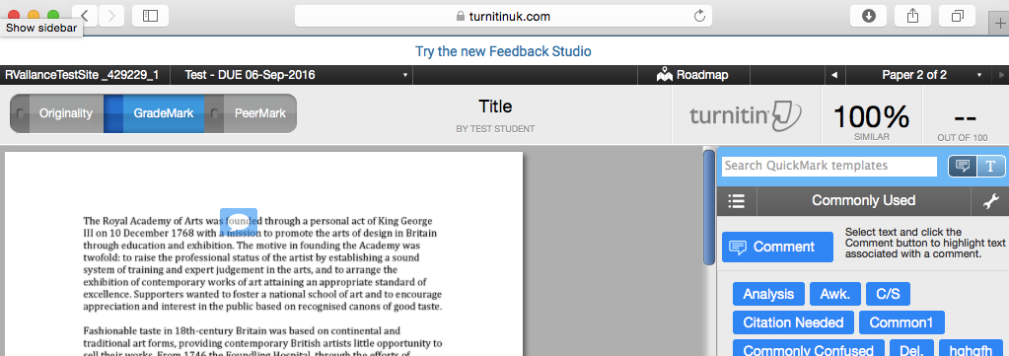

To revert to Turnitin Classic, you will see a link at the bottom of the screen to ‘Revert to Turnitin Classic’. The view will revert to Turnitin Classic:
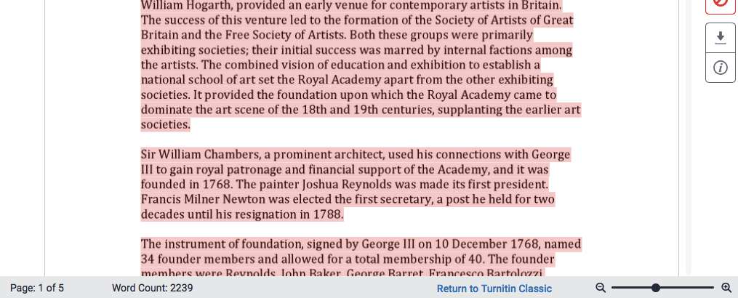

Please note:
1: If you are switching between versions, we recommend that you do not do this whilst you are in grading/providing feedback on student work.

2: If you are using Feedback Studio, the default view for students when accessing papers will be Feedback Studio too.

Timeframe for switch

Turnitin Classic is currently the default view when accessing student papers in Turnitin (via Blackboard). The facility to switch to the new Feedback Studio is available from 13th February 2017. The switch to Feedback Studio will occur during August 2017, before the 2017/18 academic year. From this date, Turnitin Classic will no longer be available. Full, in depth, CELT support guides for using Feedback Studio will be available in March 2017.

We encourage you to try the new Feedback Studio prior to the switch in August 2017. CELT will be running staff development sessions on using the new interface. You can also arrange to spend some time with your ELT Project Officer.

What's different in Feedback Studio?

The following below outlines the key differences in the new Feedback Studio:

1. The user interface has changed. As with Turnitin Classic, you have the ability to view the originality report and ‘GradeMark’ features separately, but with the new Feedback Studio, you can also ‘layer’ these two on top of each other.
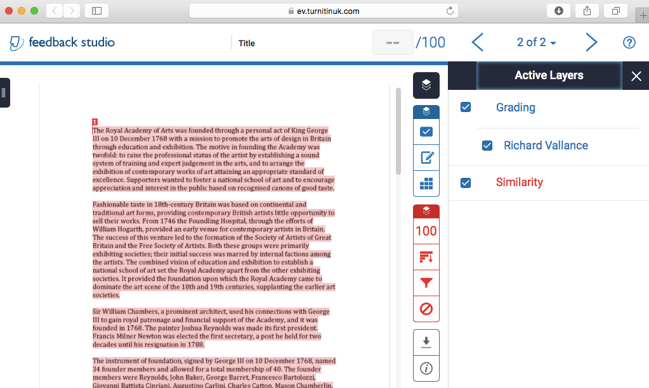

2. In Feedback Studio, you can navigate using the blue (GradeMark/feedback features) or red (Originality) menu buttons. The features available here are similar to that of Turnitin Classic. E.g. the example below shows the Rubric feature:

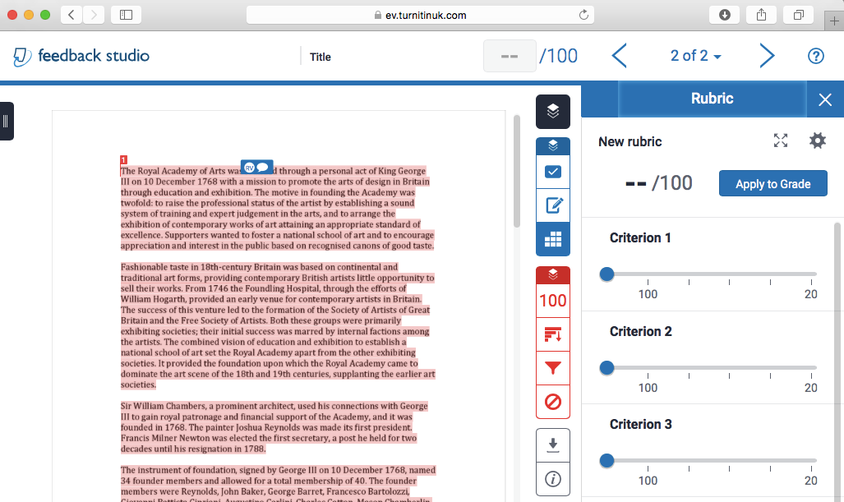

3. The student paper adjusts automatically to the size of your screen. You can still adjust the zoom as before using the slider.

4. Compatibility with mobile devices has improved. Students should be able to see their feedback/grade on smartphones easier.

5. Your QuickMark comments will have your initials next to them. This can be particularly useful for second marking.
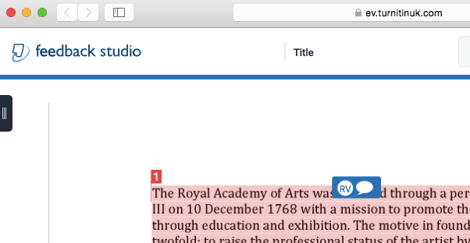

6. You can use text formatting and hyperlinks in QuickMarks, free Text Comments and in the Feedback Summary (formerly called ‘General Comments’).

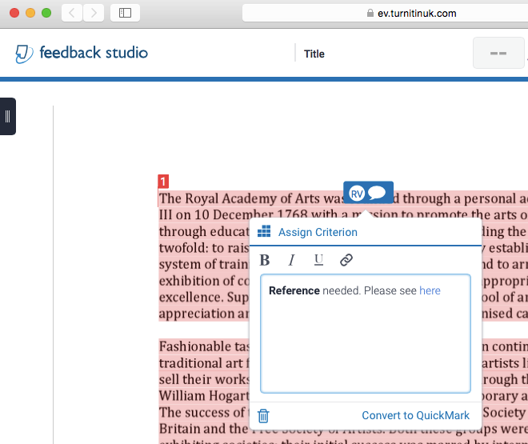

7. The ‘View all Comments / Feedback’ option has been removed. The Submission information now shows the quantity of QuickMarks and Comments.
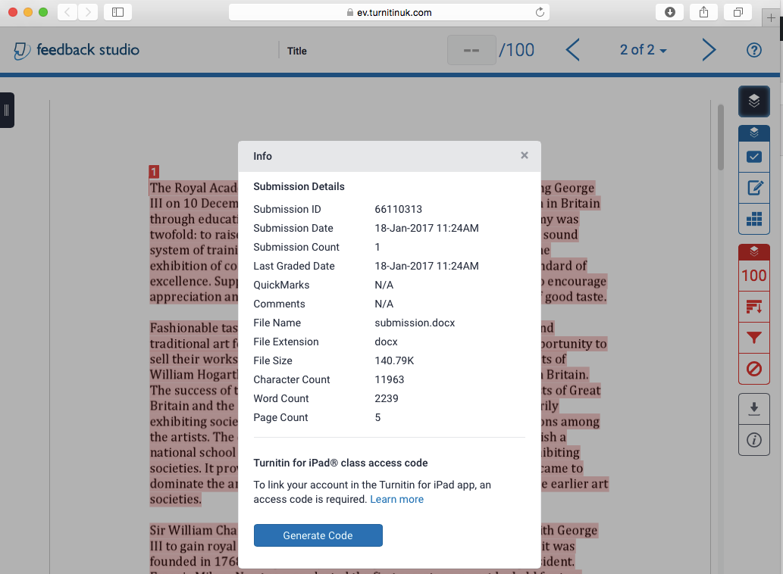

8. The total word count appears at the bottom on the screen on a student paper.

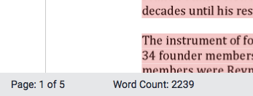

More information

Please see the current Turnitin Feedback Studio for Instructors guide for more detailed information on using Feedback Studio.

The 'question mark' button of the top right of the screen on a student paper also directs you to common guidance information:
