Transfer a video from a camcorder into DMU Replay
1. Connect the camera to the computer using the supplied USB lead
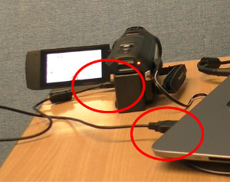
2. Set the camera to ‘PC’ to enable the computer to access the contents
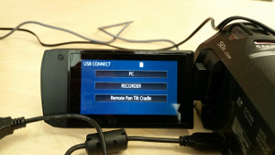
3. Browse to the video by opening the ‘DCIM’ folder followed by the appropriate folder for your recording
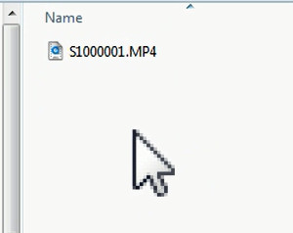
4. Drag the recording from the camera into the DMU Replay system https://celt.our.dmu.ac.uk/upload-a-non-panopto-video/

