Setting up Folders for student feedback
1. Navigate to https://panopto.dmu.ac.uk
2. Click the Sign In button
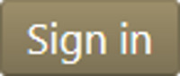
3. Sign in with your usual DMU credentials
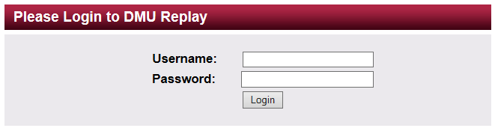
4. Click the Module Folder that the feedback videos relate to
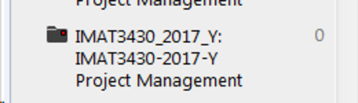

5. Click the Create button followed by New Folder
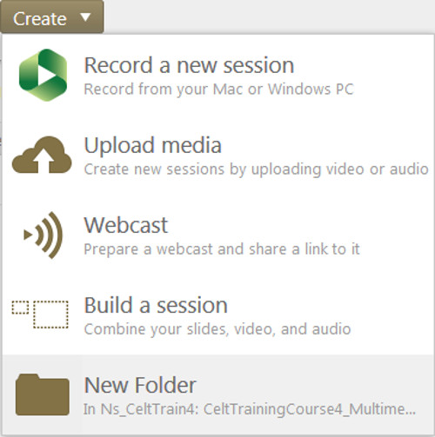
6. Type an appropriate Folder name, remove ‘Inherit permissions from the parent folder’ and click Create Folder
7. Using the Invite People section, add the student by typing their name or pnumber into the first field. DMU Replay will search and suggest as your type
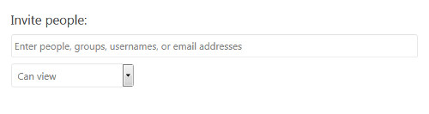
8. Add the student by clicking their name and clicking Save Changes
9. The student will now have Viewer access to the Folder and any content that is recorded or upload to it
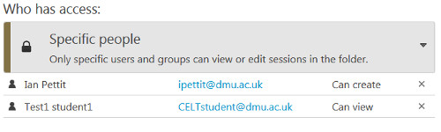
10. Repeat the process for each student (or group of students)
11. You will now be able to either record to the Folder(s) using the DMU Replay software or you could upload an existing video

