Using Microsoft Expression to record your computer desktop screen and audio
Microsoft Expression software works in a similar way to the DMU Replay Software in that it can record things that happen on your computer desktop screen as well as audio. As such it can be used for example, to record a PowerPoint presentation, or a software demo. Where Expression differs from DMU Replay is that it is not integrated into Blackboard. If you make a recording with Expression you would need to upload it to the DMU Replay server and then create a link to it in a Blackboard module shell. The advantages of expression are that you can set it to record regions of the computer screen, whereas with DMU Replay you can only record the full screen. The file that it creates can also be easily imported into video editing software which allows you to create a more professional video resource – such as adding titles, fade effects, overdubbing music/audio, incorporating fixed images, etc. Such things are not possible with the DMU Replay editing software.
The following guide shows how to use Expression to simultaneously record the computer screen and your voice (using your office telephone as the microphone).
Launching the Expression software
1. Open a web browser and navigate to the software portal: https://software.dmu.ac.uk/jukeboxdrm/showStreamit.do
2. If required to, log in using your DMU username and password
3. Launch the Microsoft Expression software
If the software does not appear on your list, contact ITMS (ext 6050) and ask for it to be made available to you.
4. If you try and launch Expression from the player window you will get the following message.
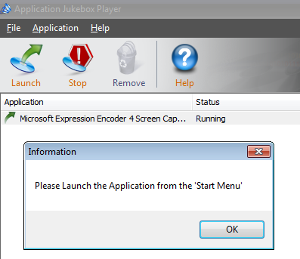
Click OK
5. Click on the windows button (Start Menu) in the task bar and then click All Programmes
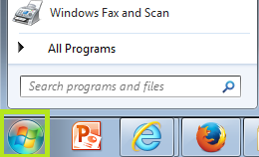
6. Click the Expression folder
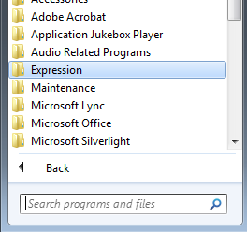
7. Click Expression Screen Capture
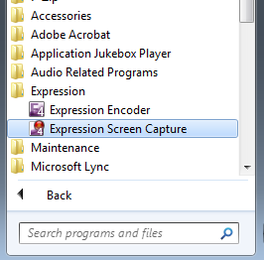
Using the Expression software
1. Click the option button
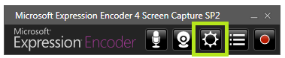
2. Recommended settings:
In the screen tab -
Frame rate: 25fps
Bitrate: 30000
Quality: 100
In the audio tab –
To use the telephone microphone select the Polycom option
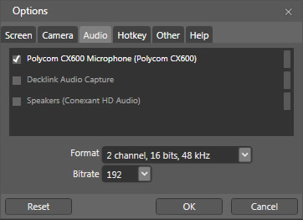
3. Click OK when you have set your Screen and Audio options.
4. If you selected a microphone in the Audio options you will notice that the microphone icon has turned red. This means that the microphone is ready to record.
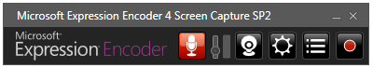
5. To ensure that the volume of the audio recording is high, click on the little audio volume button and drag it all the way to the top.
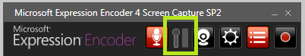
When you speak, you should be able to see colours appear in the volume meter next to the volume button
6. Click the red record button
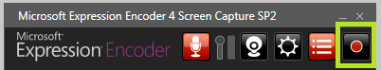
7. Using the black handles on the red region box, select the region of the screen that you want to capture.
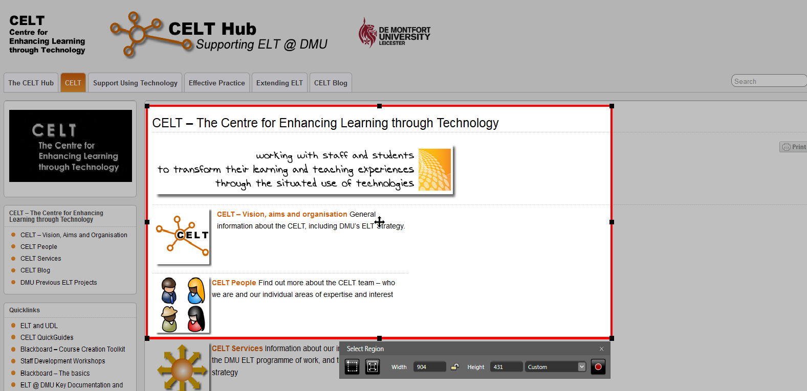
If you want to capture the full screen – select the Full Screen option from the Custom menu
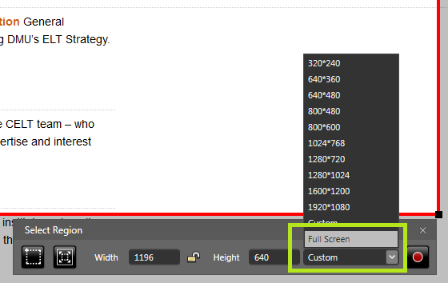
8. Once you have set the region, click the red record button.
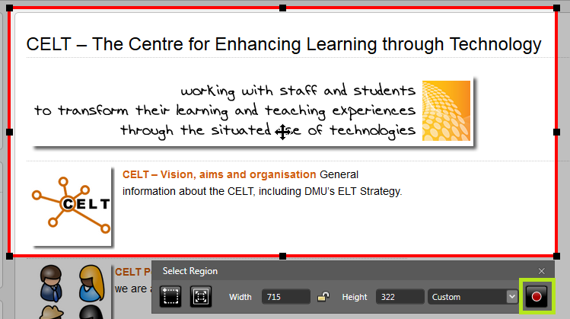
There will be a 3 (three) second countdown and the recording will begin.
Anything that you do on your computer screen and anything that you say will be recorded.
9. To stop the recording. Hold down the Shift+Ctrl+F12 keys on your computer keyboard.
10. You will then be presented with a list of recordings that you have made with expression. The most recent is at the top of the list.
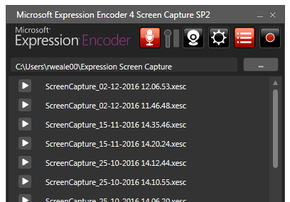
To preview the recording click the little arrow icon to the left of it.
11. The final step is to encode the recording. Click on the title of the recording and then click the Send to Encoder button
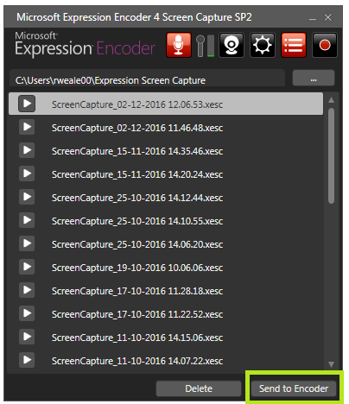
12. Another piece of software will launch automatically. This also allows you to make some simple edits to the recording if necessary.
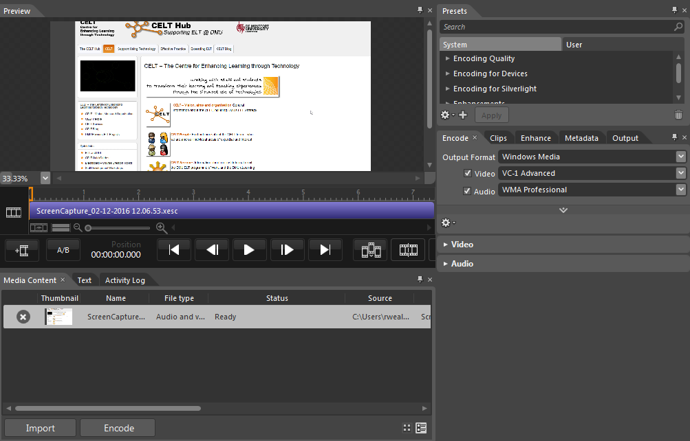
13. You may wish to edit the start and end from the captured content as you will have captured yourself starting the slide show at the beginning and ending stopping the recording at the end. To do this:
Place the orange ‘Playhead’ at the point where you wish to break the video by dragging it with the mouse.
Click the ‘Insert an edit at the Playhead’ button
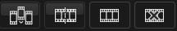
Move the Playhead out of the way and you will see that the timeline is now split where the Playhead was.
Assuming the edit is being made at the start of the video in order to remove, left click to the left of the split and then right click to the left of the split; select Remove clip

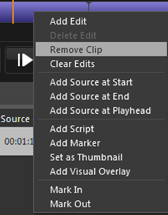

To remove any unwanted footage from the end, repeat but select the section to the right of the split when removing a clip.
14. When you are ready to encode the recording, click the Encode button
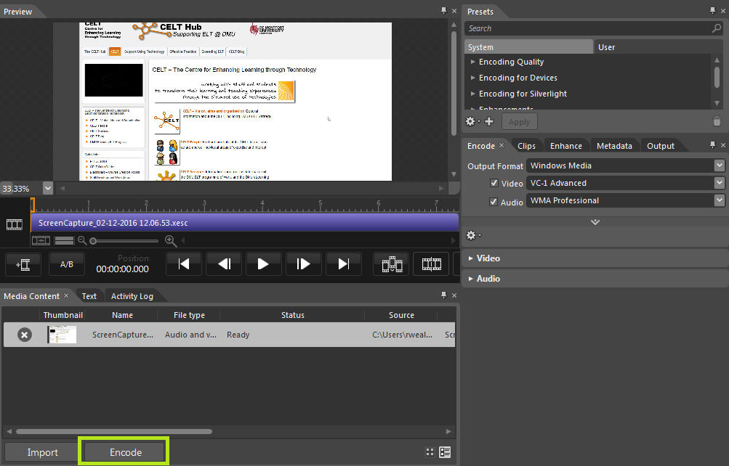
15. A new window will open showing the progress of the encoding – the time it takes to encode depends on the duration of the recording.
16. To locate your encoded recording. Go in to the documents folder on your computer
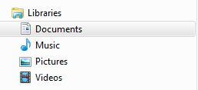
Then open the following folders Expression > Expression Encoder > Output
From the list of recording folders identify the one that you have just recorded and open it.
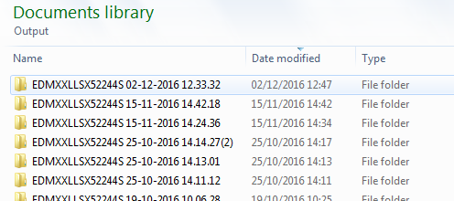
17. Your recording is the .wmv file.
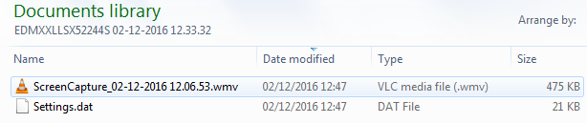
18. If you want this video to be viewed by students in your module. Follow the link below to instructions on how to do this:
https://celt.our.dmu.ac.uk/upload-a-non-panopto-video/

