Share a DMU Replay recording with all staff and students at DMU using a hyperlink
- Navigate to http://panopto.dmu.ac.uk and locate the recording you wish to share
- Hover over the recording and click the Share button
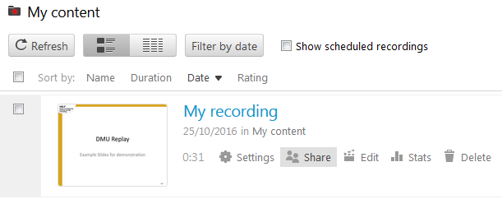
- Click on the Who has access panel
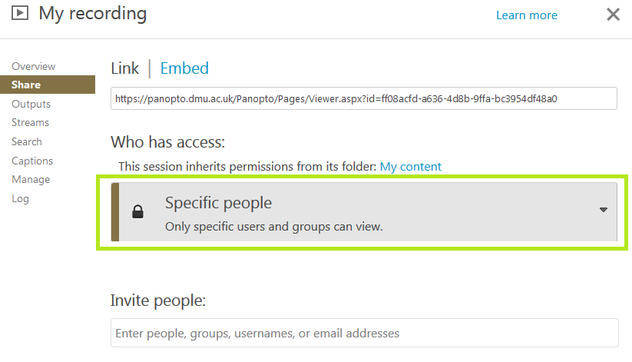
- Then click Anyone at your organization with the link
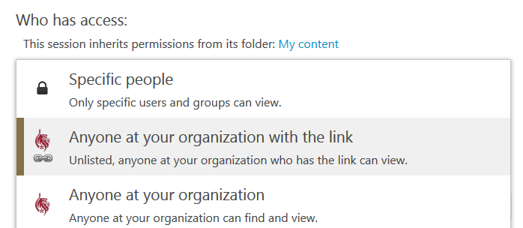
5. Click the Save Changes button
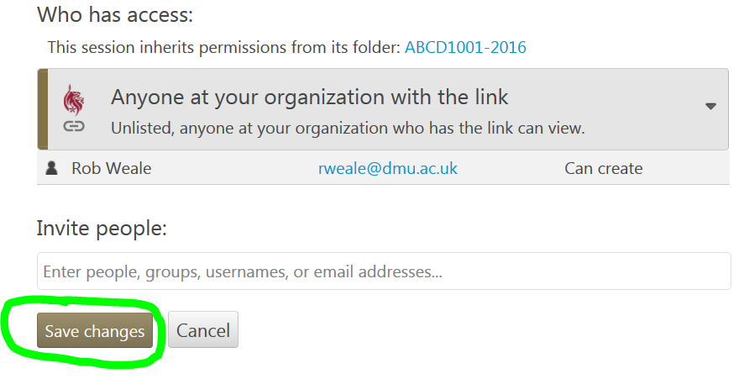
6. The Link url is what you need to send to the people that you want to view the recording
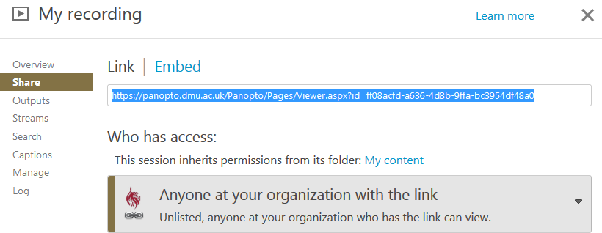
NOTE: any person who is a staff member or student at DMU can use this link to view the recording

