Remove an instructor from a module shell
Only module leaders or programme leaders have the authority to remove instructors from module shells. This task can be delegated by module leaders or programme leaders.
1. Open the Users area in the control panel for the module
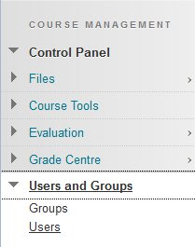
2. From the list of users click on the grey circle icon next to the instructor you wish to remove and select Change User's Role in Course
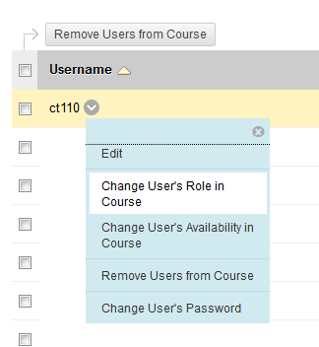
3. Change the role to Student and click Submit
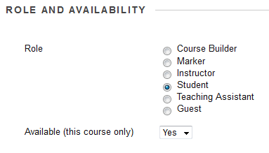
4. Click the grey circle again and select Remove Users from Course
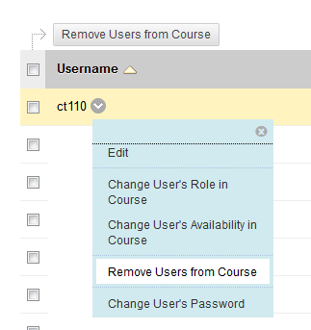
4. Click OK
