Students are not able to view a DMU Replay recording from Blackboard until you have created a link to it. However, students CAN still see a recording for which there is not a link in Blackboard if the recording has been associated with a Blackboard module. They can see it by logging in to panopto.dmu.ac.uk.
Therefore, if you want to completely hide a recording from students and staff until you are ready to release it – follow these guidelines:

Step 1 - Create a private folder for your recordings – only you will be able to view recordings in this folder
1. Navigate to https://panopto.dmu.ac.uk and log in.
2. Click the Create button and select New Folder
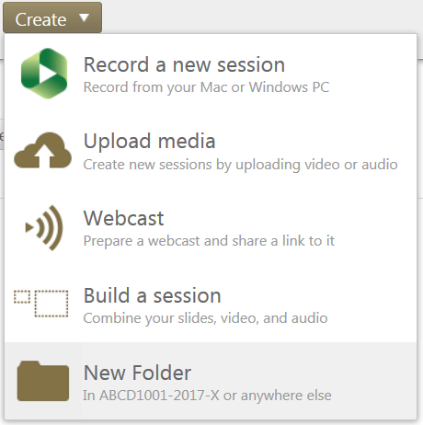
3. A) Give your private folder a name; B) Ensure that the Parent folder is set to : At the top level (Don’t use a parent folder); C) Ensure that the Inherit permissions box remains unchecked; D) Click Create Folder
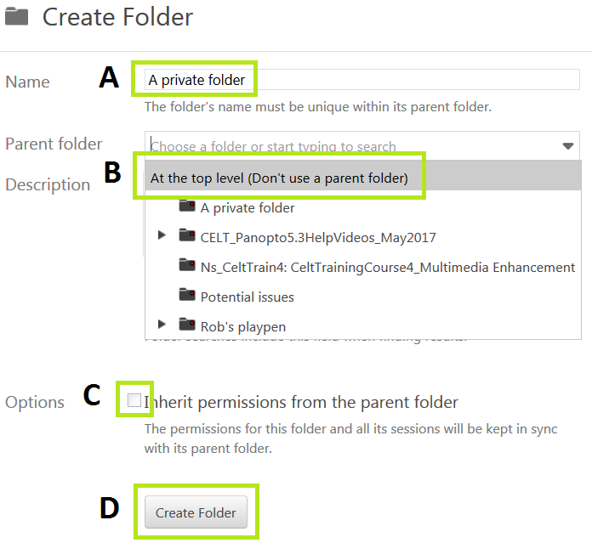
This is the folder that you will set the Panopto software to use when making any private recordings.

Step 2 - Making a private recording accessible in a module
1.Navigate to https://panopto.dmu.ac.uk and log in
2. Locate the recording in your private folder
3. Move your cursor over the recording entry and click the Settings button
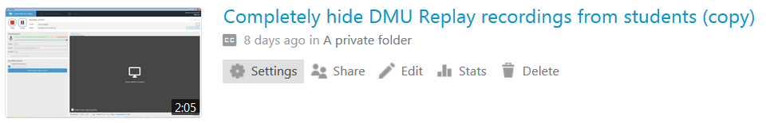
4. Cick Edit next to the Folder entry
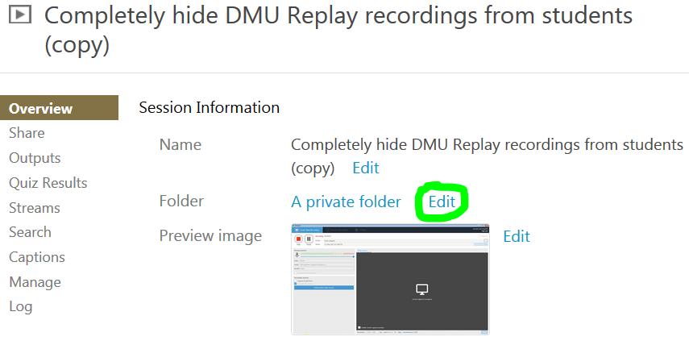
5. Using the drop down menu, click the module that you wish to associate the recording with
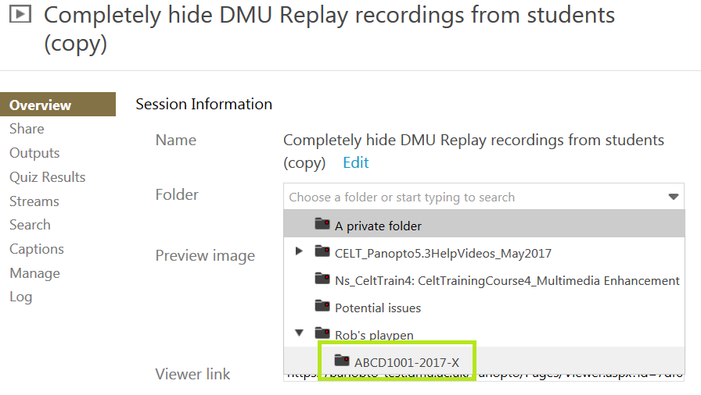
6. Click Save
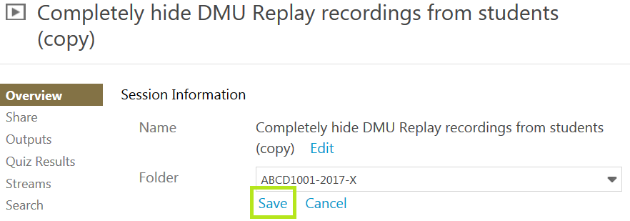

Step 3 - Add a link to the recording in your Blackboard shell, as normal.

