Preventing students from seeing their grades online after the Turnitin Post Date has expired
If you do not wish students to be able to see their grades and feedback for work which has been marked online using Turnitin AFTER THE POST DATE HAS EXPIRED; there are 3 (three) steps to take - all three MUST be done.
Step 1: Hide the asessment column from students in GradeCentre by clicking the grey button at the top of the column and selecting Hide from Students (on/off)
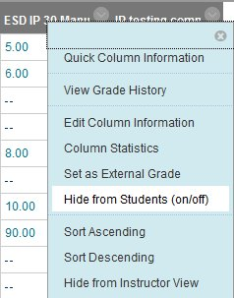
Hidden columns are indicated by a no enrty icon to the left of the column title
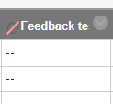
Step 2: If there is a Total and/or Weighted Total column in your GradeCentre, you must also hide these from the student view as they will be able to see a running total of their marks even from columns that you have hidden (as above).
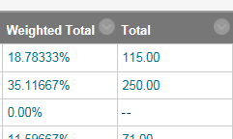
To hide the Total/Weighted Total columns:
In the full GradeCentre, click on the grey button at the top of the Total/Weighted Total column and select Hide from Students (on/off)
Step 3: ONLY DO THIS IF STUDENTS ARE NO LONGER NEEDING TO SUBMIT THEIR WORK.
Hide the Turnitin submission link from students using the adaptive release function. Even with GradeCentre columns hidden students can still access their online grade and feedback for a particualr submission via the Turnitin submission link - by clicking on the View/Complete link.
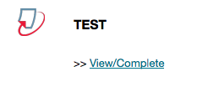
To hide the submission link:
Click the grey button next to the submission title and select Adaptive Release
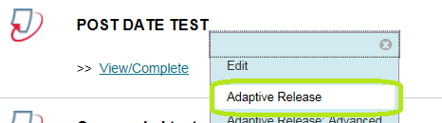
Set the Display Until date to a date/time prior to the current date/time, and then click the Submit button
