DMU Replay – the student view including navigation and search
1. Students will generally access recordings via a link in the Blackboard shell.
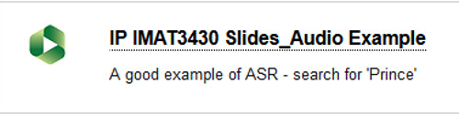
2. Once the recording opens it will play automatically.
3. Students can navigate around the recording and watch different visual streams by using the buttons and thumbnails that appear across the bottom of the screen.
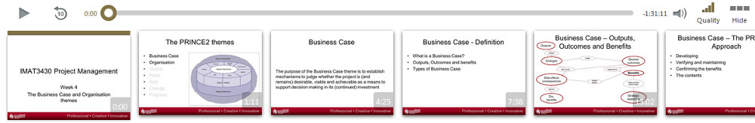
4. If required, click the Closed Captions icon to turn the captions on.
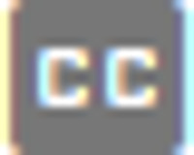
Captions may not always be available for all DMU Replay recordings.
5. Toward the left of the screen students can search and make electronic notes and comments on the recording
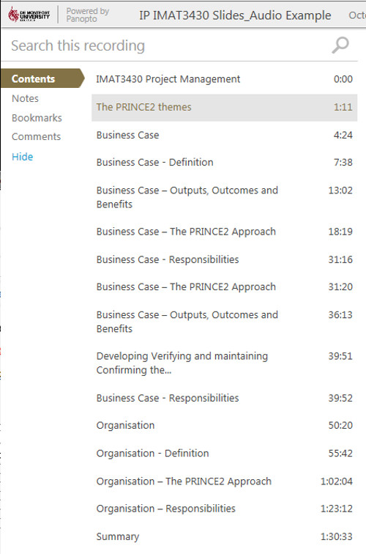
For more information about DMU Replay please visit the Student Support for Learning Technologies web site.

